|  |  |  |
| --- | --- | --- |
|  |  | C:\Users\s.hammad\Desktop\NERC Final Logo.gif |

**Royal Scientific Society**

**National Energy Research Center**



**SUDEP South Project**

**Making Sahab City Green – Green Development at Sahab Municipality**

**Sustainable Energy Action Plan (SEAP) for Sahab City in Jordan**

**Prepared For:**

**Municipality of Sahab**

**Date of Submission: February, 2017**

This document was produced as part of the SUDEP project activities with the active participation of Jordanian National Authorities and the Sahab Municipality. The plan was prepared by Royal Scientific Society/National Energy Research Center who acted as SEAP consultants, with the direct support of CES-MED experts and reviewed by Arch.Haneen Hassouneh the Head of Local Development Unit (LDU) of Sahab Municipality.

Contents

Section I: SEAP Summary 4

1. Background information 4

2. Strategic vision 20

3. Actions on municipal buildings and services 24

4. Awareness campaign 29

5. Action plan on Sahab’s urban area 30

6. Results of action in the SEAP 34

Section II: Overall strategy of the municipality 36

1. Introduction 36

2. Objectives and targets 37

3. Policy and legal framework 40

4. Strategic vision for sustainable energy 41

5. Organization and financial aspects 44

Section III: Baseline emissions inventory 49

1. Considered scope and methodological principles 49

2. Detailed methodology per sector 50

3. Results 56

4. Complete BEI tables 63

Section IV: Sustainable energy action plan (planned actions) 65

1. Summary of the Baseline emissions inventory 65

2. Action plan on municipal buildings and services 67

3. Action plan on Sahab’s urban area 68

4. Energy supply and renewable energy development 70

5. Conclusion 76

6. Sahab SEAP overview 77

ANNEXES 84

ANNEX I – PROJECT FICHES 84

ANNEX II – CITIZENS AWARENESS PROMOTION 86

## Section I: SEAP Summary

### 1. Background information

Sahab city is one of the poorest communities in Jordan with percentage of poverty up to 54%. Its total area is 12 Km², where 75,910 Jordanian Citizens are living within this limited area in addition to another 40,000 Syrian refugees. Spatially, Sahab has the largest two industrial zones in the kingdom; King Abdullah II Industrial Estate which includes 400 factories, and Industrial estate city which includes 50 factories, where almost 20,000 Jordanians and other nationalities work. Sahab has a strategic industrial and commercial location. It is located at a commercial gathering for all surrounding cities and villages. Additionally, it has an international Street connecting the capital with Aqaba in the south and Saudi Arabia and Iraq in the East.

Sahab Municipality was established in 1963. It joined Greater Amman Municipality (GAM) on December, 2006. In 2011, Sahab Municipality became independent on both financial and managerial levels and a municipal council was elected on 2013. An agreement between (GAM) and Ministry of Municipalities Affairs was signed committing GAM to provide Sahab municipality with all needed services and financial support until the end of 2013. Unfortunately, GAM did not fulfill this commitment which put Sahab Municipality in a very difficult situation as it lacked (and is still lacking) the sufficient financial and Human resources support.

|  |  |  |  |
| --- | --- | --- | --- |
| Overall population | 160,000 inhabitants |  |  |
| Municipality area | 12000 acres |  |  |
| Energy consumption | 968.6 GWh / year | Energy per capita | 12.76MWh / year |
| Electricity consumption | 75.7 GWh / year | Electricity per capita | 998 KWh / year |
| GHG emission | 283.8KTon eqCO2/y | GHG per capita | 3.74 ton eqCO2/y |

Table 1: Overview of Sahab energy consumption and GHG emission

Source: Department of Statistics 2016

# Sahab Background

The historic and heritage sites in Sahab can broadly be described as follows:

* Heritage neighborhood. This is the old town center (Gedar Al Balad), which contains several heritage and archaeological sites.
* The Amman–Sahab-Azraq Corridor. This is the historical trail which connects Amman with the important religious site of the Cave of Sleepers with Muwaqqar-Kharaneh-Qsair Amra. It extends to Azraq where the important Roman Fort is located on the commercial road that connects Damascus with the heart of the Arabian Peninsula.
* The Hejaz Railway (located southwest of Sahab City) was originally built to transport pilgrims from the city of Damascus in Syria to Madina in Saudi Arabia. The railway is considered a Heritage Corridor.

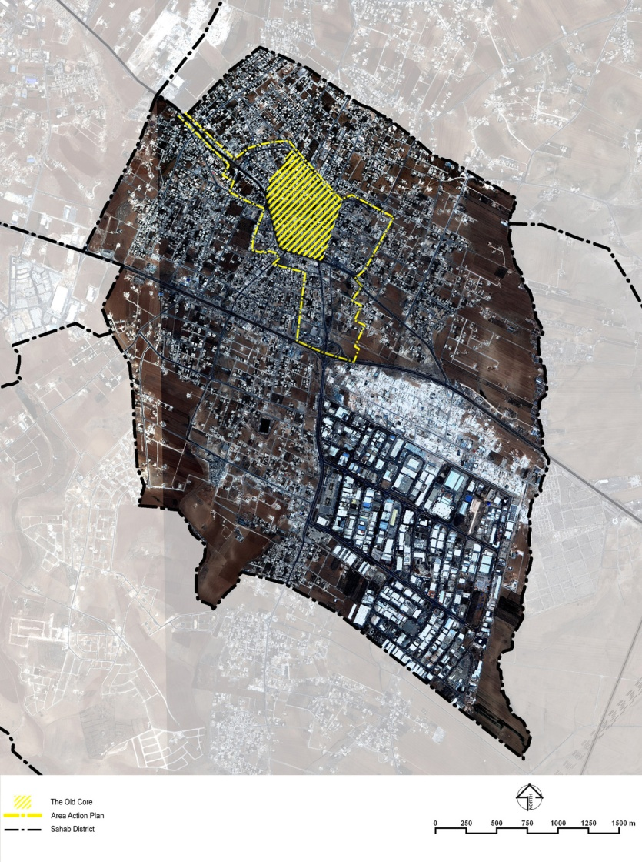

Figure ‎0.1: Boundaries of Sahab District, City of Sahab and City Center ‎.

# Sahab Circumstances

According to Jordanian Municipal Law:

* Municipality is a national institute of financial independence
* Four categories of municipalities according to their size as per population: A, B, C and D
* Municipal rights, obligations and financial commitment are specified according to this categorization
* Municipality Board is set through direct elections every four years and undertakes municipal administration
* Special status and procedures for Greater Amman Municipality (GAM)

**Sahab – municipal structure:**

* Sahab is classified as B-category municipality in Jordan and its organizational structure complies with this category
* Sahab Mayor elected by general vote every four(right) years
* Municipality Council: President and (10) Members, three out of whom are women as elected through the minimum gender quota
* In total (202) employees and (108) cleaning staff

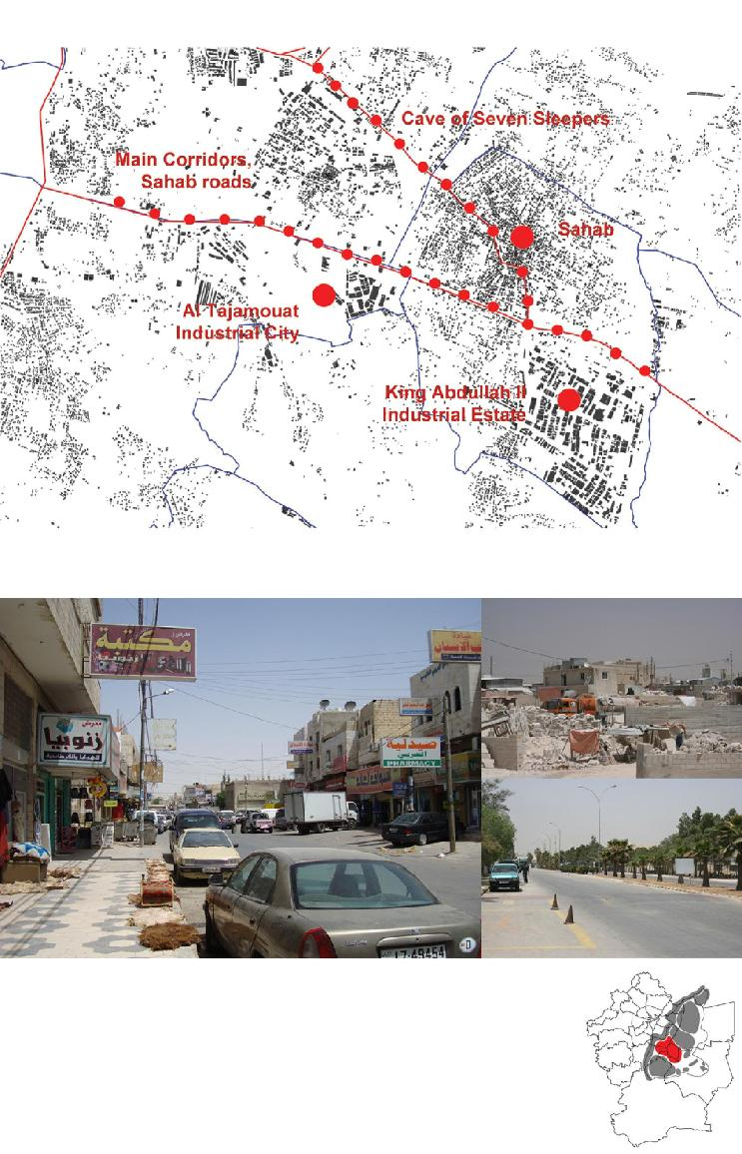

Figure ‎0.1: Area along Sahab Road.

# Sahab – specific challenges

* Lack of urban environment fabric and infrastructure management, including roads, sidewalks, walkways, water supply, and sanitation
* Crowded streets and insufficient public transportation system
* Poor pedestrian connections to new bus station and station itself lacks shelter from rain and sun
* No recreational areas, playgrounds, parks or open public spaces except the bus station
* Pedestrian sidewalks vary in condition or do not exist
* Poor social and cultural image due to absence of social facilities, services and open space
* Environmental degradation and heavy pollution due to industrial activities
* Traffic congestion that slows down business development
* Challenges to social cohesion due to fast population growth, high crime rates and drug use .

# Environmental Issues

The following sub-sections present key environmental considerations that, at this stage, are highlighted for further consideration in a detailed environmental impact assessment study to be conducted at the next development phase of Sahab.

## Consolidation and Relocation of Workshops

Sahab has a multitude of workshops scattered all over the city, including its center, and performing a range of light industrial and manufacturing activities such as car repair and car body shops with painting booths; carpenters and blacksmith shops; electrical appliance repair shops and others. Operating these shops generates traffic congestion, noise, air pollutants and other wastes in addition to causing a significant public health risk. Hazardous, explosive and sometimes toxic materials are stored in these shops which happen to be located, in many cases, just underneath residences and office buildings. Tanks of pressurized oxygen used for welding, liquid pressurized gas cylinders, and fuel tanks are stored in some of these shops.

## Existing Bus Station

Sahab downtown serves as a transportation hub for the entire Sahab District. Residents of Sahab and nearby towns and villages use Sahab as a center point to travel to further destinations. A relatively new bus station serving the entire Sahab district is located on the main street on the eastern edge of Sahab Center. The site is a longitudinal strip with a total area of 7,600 m2. Although the station is conveniently located for its users, it is contributing to traffic congestion on the main street.

## Wastewater Collection and Surface Water Drainage

Currently, there is no wastewater collection system serving the communities living in Sahab. The population relies on cesspits and septic tanks to collect their wastewater. Septage is then allowed to infiltrate into the ground or is collected by septage tankers when the cesspits are filled. The cesspits are usually located in the backyard of residences or very close to the main roads. Common cesspits are made of concrete blocks with openings that allow percolation into the ground. Seepage from cesspits and septic tanks in Sahab constitutes a major health risk and is expected a major source of groundwater contamination.

The South Amman Wastewater Collection and Treatment project is under implementation by the Water Authority of Jordan (WAJ) and will eventually cover the town of Sahab and provide the necessary sanitary services.

Sahab lacks storm water drainage services and although precipitation is relatively low in Sahab, storm water collects in streets and open yards then follows natural slopes into nearby wadis and streams.

## Stone-cutting workshops

There are two groups of stone-cutting and polishing workshops in the Sahab area as shown in () ; one within the Sahab District boundaries located southeast of the city adjacent to the industrial estate; and another smaller group located northwest of the city outside the Sahab city limits. These two areas are a major environmental concern due to their air emissions and aesthetic impact which has turned the area into an environmental disaster.

Although the stone-cutting group of workshops located within the city limits is larger and more densely occupied by workshops, it is the smaller group of workshops that is believed to have a greater environmental impact on Sahab and its residents due to the prevailing northwesterly wind direction in Sahab. The larger group of workshops was formed at its present location about 15 years ago, apparently after moving from another nearby location in Sahab. The workshops currently lease the land from land owners and perform stone cutting, shaping and polishing. Many workshops bring in the big pieces of rock, prepare them for cutting and cut them into smaller pieces.



Figure ‎0.1: Location of stone-cutting workshops ‎.

The operation of workshops generates a significant amount of dust on a daily basis as a result of the cutting processes and from vehicles traveling around the workshops site. Silica particulates, known to cause silicosis with chronic exposure, is found in the particulates originating from the stone itself. The use of water to cool the cutting blades reduces the dust emissions but generates liquid wastes that are not properly collected and treated. The liquid waste is left to collect in open ponds and left to dry thus creating public health hazards.

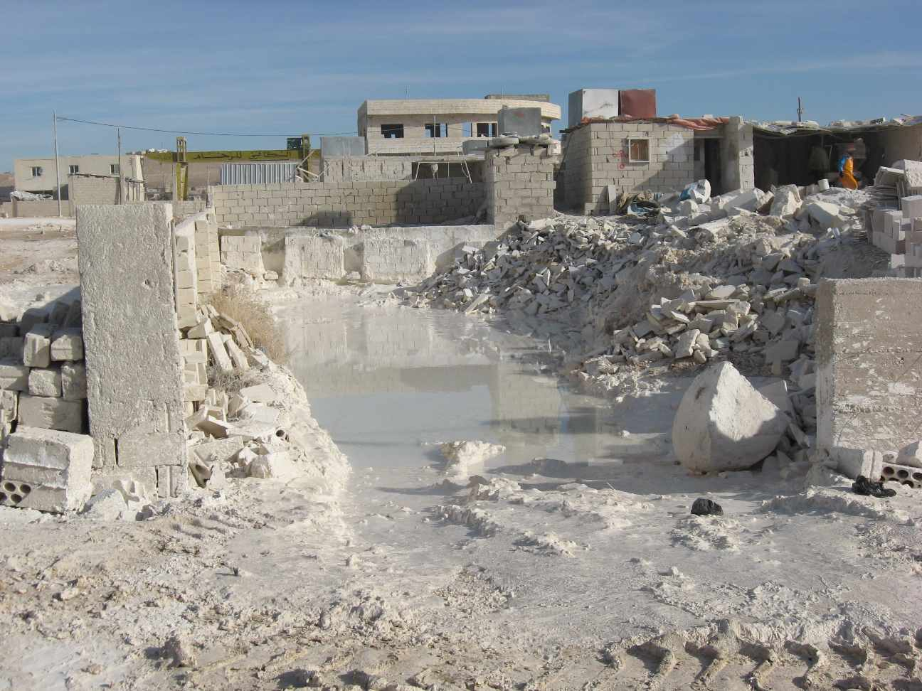

Figure ‎0.2: A Stone-cutting Workshop in Sahab.

## Power

The existing power network consists of 400 V overhead lines (OHL) installed on steel poles and distribution power transformers, the network, which is property of Jordanian Electric Power Company (JEPCO), and power supply for commercial and residential consumers in addition to street lighting.

The existing power network has several crosses over the streets, lack of periodic maintenance, safety is not implemented in many connections, many connections are not well arranged, and some poles are located too close to consumers’ premises.

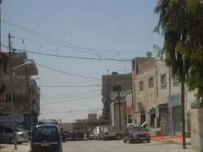

Figure ‎0.3: Many Crosses over the Street.

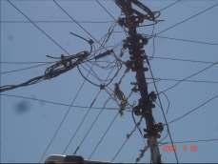

Figure ‎0.4: Lack of Periodical Maintenance.

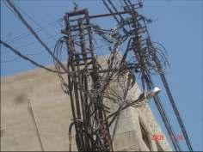

Figure ‎0.5: Many Connections are not Well-Organized.

## Street Lighting

The existing street lighting network consists of High Pressure Sodium (HPS) lighting fixtures fixed on JEPCO steel poles and power supplied through dedicated overhead line installed as a part of power OHL. Street lighting fixtures are supplied by GAM, while they are installed and maintained by JEPCO technical staff.

The following comments were found on the existing lighting network:

* Lack of periodic maintenance works and re-lamping
* Many lighting fixtures are not well-organized
* Lighting fixtures are not identical
* Lighting fixtures are not well distributed and do not achieve acceptable level of illumination and uniformity due to obligations to power columns

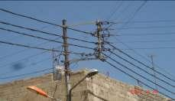

Figure ‎0.6: Lack of periodic maintenance works and re-lamping.

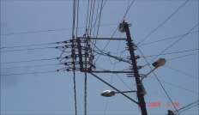

Figure ‎0.7: Lighting fixtures are not identical.

The Sahab-Azraq road is a vital highway in the national road network in Jordan. The road consists of two separate legs that run east from the Hizam/Madaba Road and join in a “V” junction a few kilometers east of the Sahab town center as shown in Figure XX. The road then continues eastwards towards Azraq, and the borders with Iraq and Saudi Arabia. The Northern Leg of the “V” passes through the old Sahab town center while the Southern Leg by­passes Sahab town center and takes most of the heavy traffic heading for the Iraq and Saudi borders.



Figure ‎0.8: Road Network in Sahab Area.

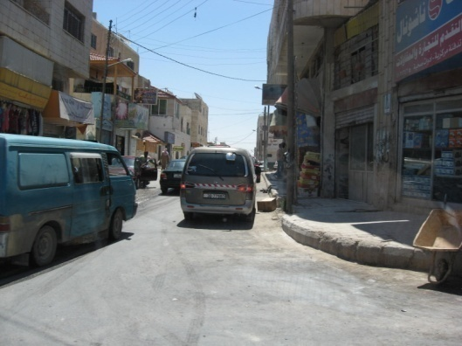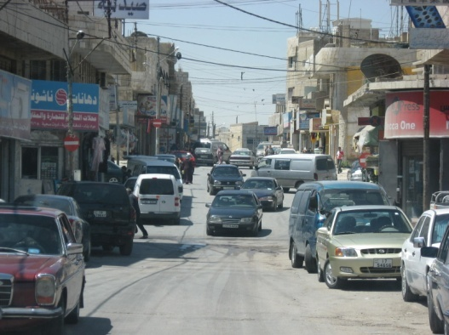

Figure ‎0.9: Narrow Streets in Sahab Center Could Compound Traffic Congestion ‎.

• The vehicles observed in the centre are generally small cars and pick-ups especially around the market area. One of these streets, Prince Hasan, bounding the market also serves the new central mosque. There no apparent provision for car parking, and this road and the nearby branches suffer congestions and illegal parking during the prayer times

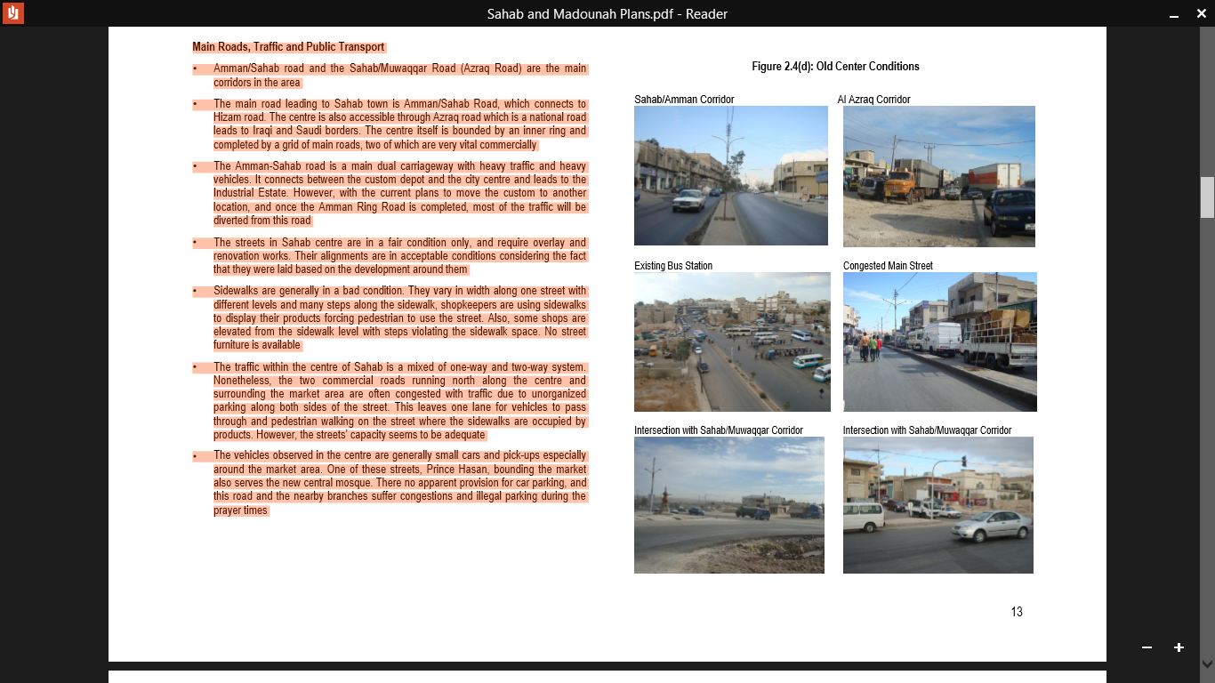

Figure ‎0.10: Old Center Conditions.

• Sahab area is serviced by public transportation (buses and white cars). Three terminals outside East Amman serve Sahab: Raghadan (Amman down town), Wehdat and Zarqa

• The Sahab bus station used to be in the city centre, but currently it has been moved to the centre border, which eased up the traffic congestion

• The centre also is served by internal public lines covering the Sahab area which comprise of buses and white cars

• However, many private vans and cars are working illegally as public transport to different areas within Sahab and Sahab vicinity and competing with the legal public system

• Also, the buses are taxiing and queuing at the main roundabout (Al Shaheed roundabout) to collect passengers rather than waiting in the new bus station— exacerbating the congestion problem at this location

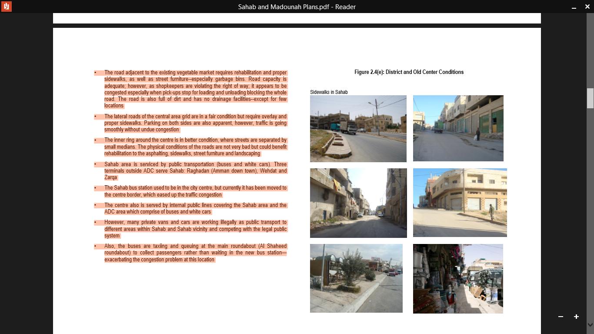

Figure ‎0.11: District and Old Center Conditions.

## Community Facilities

• Some governmental Institutions are located close to the old town centre. Most the public services situated on the west of the centre. The eastern side lacks services

• The existing public market at the old bus station sells a mixture of vegetable and used clothes. It is not organized and has no services such as toilets or canopies

• The existing vegetable market area has poor access for both pedestrian and service car, and poor connection with public transportation. Also it is not sufficient to accommodate the needs for the coming 20 years, and causes traffic congestion in the core

• The commercial area is highly congested and not attractive for pedestrians and for shopping

## Pollution

• The scattered different workshops in residential areas cause noise, dust, and traffic problems

• The existence of workshop shops in residential and commercial areas causes pollution

## Infrastructure

• There no sewage network. However, a new system is currently under construction

• There is no storm water drainage

• Most of sidewalks are violated, in bad conditions or does not exist

• Waste collection is not efficient

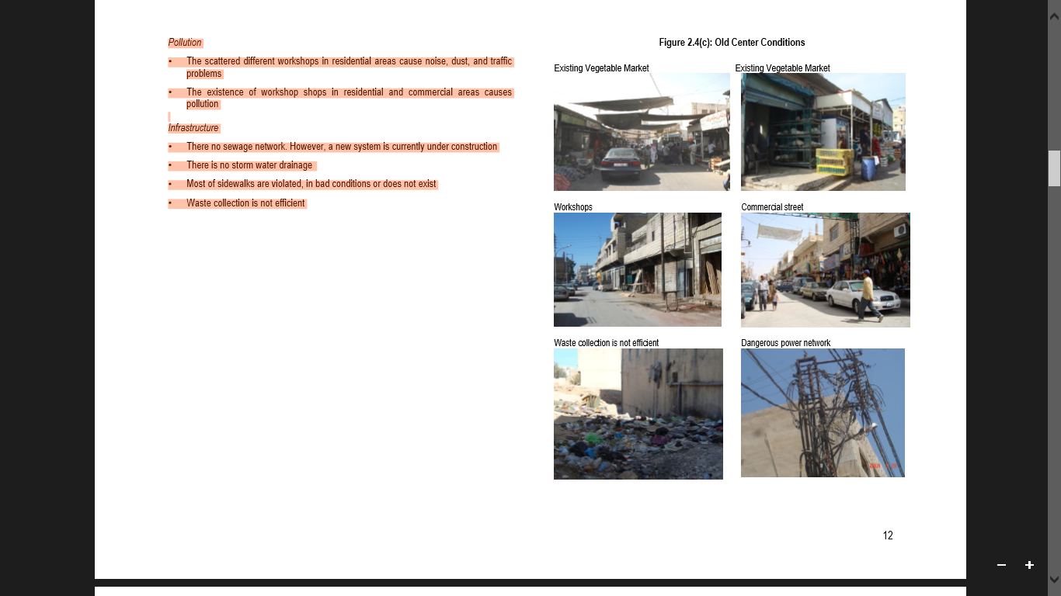

Figure ‎0.12: Old Sahab Center. ‎

## Socio-economic Impacts

Pedestrians in Sahab center mainly walk on the road as the sidewalks are often narrow, in bad condition, or do not exist. Sidewalks are also exploited as commercial space by nearby shops, and are often jammed with selling stalls. The proposed project will enhance pedestrian movement in and around the old city center where there is almost complete absence of usable sidewalks. Improving public safety for the people while traveling and providing pedestrian crossing facilities around the main shopping area will create a safe and pedestrian-friendly city.

There is very little green space in the centre of Sahab with few trees planted along the main roads. There are no public parks or recreational space. Some empty plots are used to dispose of litter and garbage collecting from nearby houses and shops.

## Social Facilities: Existing and Required

The town is serviced with schools, health centre, post office and other communal facilities. There are several mosques in the centre of Sahab. Most of the public services are found from the western side of the old town centre and the eastern part of Sahab is lacking public services. There is also a telecommunications centre in Sahab which provides internet and communications services for the area. However, additional facilities and services need to be provided to meet present and future needs.

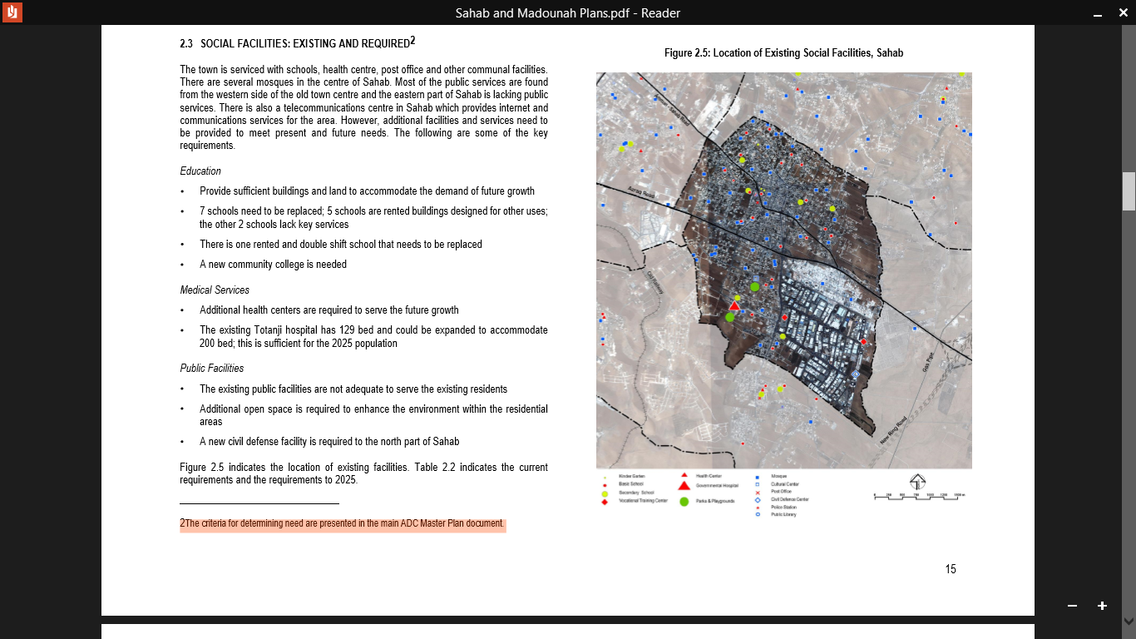

Figure ‎0.13: Location of Existing Social Facilities, Sahab.

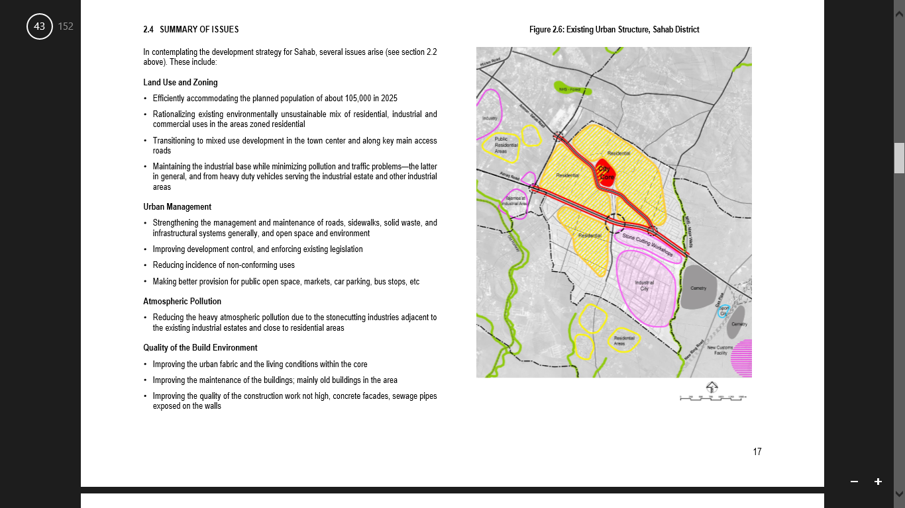

Figure ‎0.14: Existing Urban Structure, Sahab District.

## Main pollution sources in Sahab

## Factory

### -The Sahab Industrial Estate / The King Abdullah II Industrial Estate

The Sahab Industrial Estate is the oldest in the country and largest industrial site in area, and a dominant manufacturing presence in East Amman. Its total area comprises 2.5 million square meters. It was created in 1984. The estate itself is dominated by food industries, engineering, printing, packing and tissue paper, chemical industries and plastics and rubber industries. Sahab gained from the general economic national growth, but seems to have benefited little from the recent boom in Amman. During the 2001-2006 period export from Sahab grew at about the same rate as the growth in national exports. The Sahab estate has no vacant space at the moment, and its growth potential may be limited. Much of the recent export growth has been in the apparel sector.

The King Abdullah II Industrial Estate () accommodates 380 manufacturing companies employing some 14,000 persons. Within the Industrial City of Sahab, there are 78 foreign, Arab and joint-venture industries. The Estate is full and has no more space for expansion. The demand for space has now been redirected to the Industrial Estate in Muwaqqar. Attracted more than 371 industrial companies representing Arab and foreign investments. The total investment in this city (1009.85) million, has provided (14042) jobs and it is the largest industrial city in Jordan.

The industrial area houses several different kinds of industries, from fine pharmaceuticals to heavy metal works. The scale of the area is large, as it is planned for driving with trucks. The heavy traffic is the problem in the area as well as that the lack of services for the truck drivers. The area has its own water treatment plant, electrical substation and fire station.

Land and building facilities are available for purchase or rent at concessionary prices. The Industrial City of Sahab also provides the following privileges to industries operating on their premises:

* Enterprises operating in industrial estates are exempted from income and social services taxes for a period of two years from the commencement of operations.
* Projects operating in industrial estates are exempted from land and building taxes throughout the lifespan of the project.

The city include infrastructure and superstructure integrated, match the highest international standards of industrial cities, making it a model in their design, and comprehensive a wide range of investments, which includes all ten classified industrial sectors. In addition to their occurrence on the highway linking Jordan, Iraq and Saudi Arabia, and its proximity to Queen Alia International Airport.

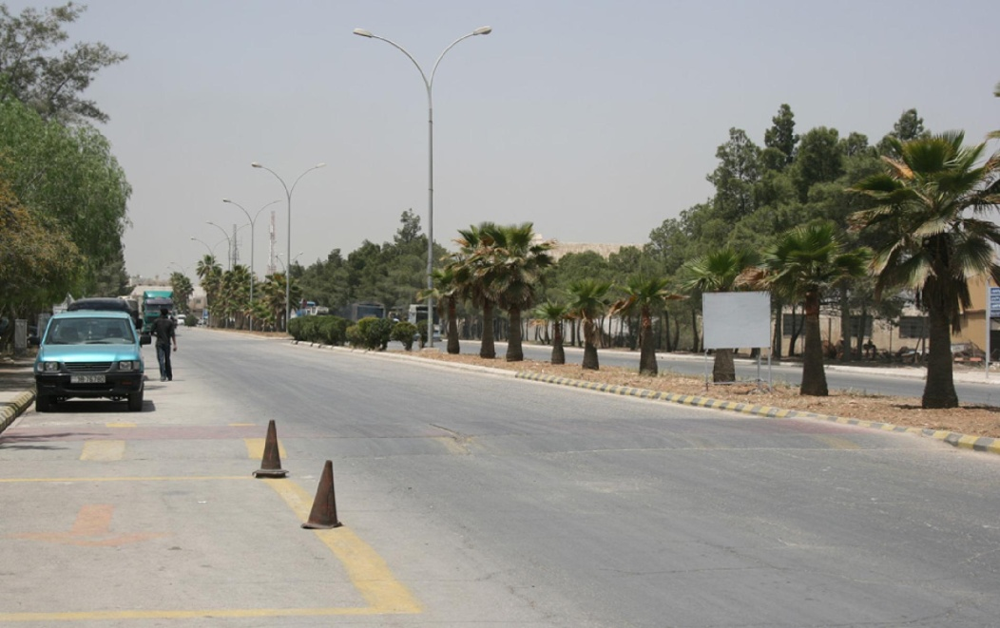

Figure ‎0.15: King Abdullah II Industrial Estate.

### -The Qualifying Industrial Zones (QIZs)/ Al Tajamouat Industrial City

Al Tajamouat is the only Qualified Industrial Zone (QIZ) within the area. The concept of Q125 emanates from a proclamation by President Clinton in 1996 which extended duty-free status to “products of the West Bank, Gaza and Qualifying Industrial Zones”. This created an opportunity for Jordanian manufactures to gain duty-free access to the US market without reciprocal benefits, and was initially available only to Jordan and Egypt.

The QIZs[1] have provided a major boost to the Jordanian economy and account for over half of Jordanian sales in the US market. There are two QIZs located within the zone of influence of the East Amman, Al Tajamouat Industrial City close to Sahab, and the Dulayl Industrial park 18 km east of Zarqa. Three further larger industrial QIZs in the area are at various stages of implementation: Al Mushatta (400 ha) to the south of QAIA and Al Qastal (400 ha) two km north of QAIA and the Hashemite University (150 ha) near Zarqa adjacent to the Zarqa Highway.

The Al Tajamouat Industrial City occupies some 420,000m2 of land along the Sahab/Muwaqqar highway, and houses some 40 factories. The latter are predominantly garment manufacturers from a variety of countries including Hong Kong, Taiwan, USA, Korea, UAE, Oman, Kuwait, India, Pakistan, Bangladesh, Philippines and Jordan, in addition to over 100 local factories and work/trade shops The zone employs approximately 17,000 people. The City also contains a large residential area. It is the industrial complex that seems to have gained most from the growth of export, since the City is dominated by Apparel factories with QIZ status.

Al Tajamouat is Jordan’s first private industrial park, owned and run by a private management company that constructs and markets ready- and tailor- made industrial buildings for medium to light industry, as well as large buildings serviced with industrial infrastructure. Al Tajamouat has attracted investment from several Asian textile and garment companies moving from Dubai to avoid US quotas Al Tajamouat also contains non-QIZ producers.

There are also signs that most of the investments stay within the QIZ, where nearly 100 per cent of raw material is imported. This has led to the conclusion that these zones are contributing very little to the long-term economic development of Jordan. The zones have also not shown evidence of promoting technology transfer to the domestic economy or facilitating industrial upgrading to higher value added export activities. Backward linkages with domestic suppliers are also weak or non-existent .

## Stone quarries- Mining and Quarrying

Mining and quarrying activities in Sahab area used to be extensive, particularly in the North West area where it has left a legacy of environmental pollution and highly scarified landscapes. Mining activities have declined significantly in recent years. Nevertheless the sector continues to be active and is a major source of employment as well as continued environmental pollution. The excavation of phosphates is stopped and only already stored materials are used. However, there are still some active quarries that have benefited from the strong economic development in the Amman area. Half of the demand for gravel in Amman is supplied from Sahab area, and demand is growing. Also, the construction of the new ring road is sure to have increased demand. The largest company employs some 500 workers, and total employment in the sector is estimated at a few thousands. According to a recent study undertaken by Greater Amman Municipality (GAM) - unless major environmental restrictions are placed on the industry - several mining concessions are still valid and mining activities could continue for some 30 years.

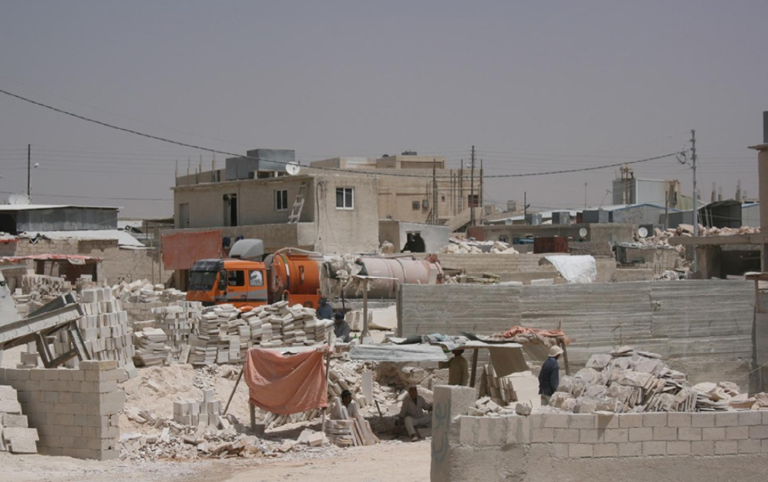

Figure ‎0.16: Building Materials Industry.

## Plastic factory

There is number of plastic factory in Sahab either in Sahab Industry Estate or in Sahab center within the residential area. Which involves the accumulation of plastic products in the environment that adversely affects wildlife habitat, or humans. Plastic pollution can unfavorably affect lands, waterways. Humans are affected by plastic pollution, such as through the disruption of the thyroid hormone axis or hormone levels. Due to the use of chemical additives during plastic production, plastics have potentially harmful effects that could prove to be carcinogenic or promote endocrine disruption.

## Transportation

In 2013, transportation contributed more than half of the carbon monoxide and nitrogen oxides, and almost a quarter of the hydrocarbons emitted into our air.

This air pollution carries significant risks for human health and the environment.

Air pollution from cars and trucks is split into primary and secondary pollution. Primary pollution is emitted directly into the atmosphere; secondary pollution results from chemical reactions between pollutants in the atmosphere.

### 2. Strategic vision

Sahab Municipality wants to be a pilot for the local authorities to address local sustainable development challenges related to the carbon reduction and energy savings. As local resources remain limited compared to current and future needs, the Municipality has to define priorities and strategic goals for the next years to take advantage of available resources, build consensus on the best options and look for partnership to mobilize public and private stakeholders.

Being an important urban center on the eastern part of Amman, Sahab has a special responsibility in maintaining commercial, humanitarian, social and family ties that bind the people of Sahab. Likewise, the city complies with its role as industrial center, where people can find departments and directorates from various public institutions, banks and services.

Last but not least, Sahab still suffers from nuisances and pollutions, mainly originated from the its industrial and handcraft factories. Such problems reinforce Sahab’s determination to be environmentally green with clean air and healthy environment for all its inhabitants. In this logic, the Municipality aims at preserving its natural area, urban agriculture, forest and greener. It also wants to improve sewage drainage and develop a modern waste management system.

#### 2.1. Municipal strategy

The development of a municipal strategy – in consultation with elected officials and other local stakeholders – that is endorsed by the municipal council is critical for the effective implementation of national policy at the local level. The strategy, which comprises quantifiable objectives, is the basis for developing actions and measures for reducing energy consumption and integrating renewable energies in the territory.

The development of the sustainable energy action plan (SEAP) constitutes the basis for implementing the municipal strategy. It requires:

* Strong involvement of local elected officials during all of the phases of the SEAP project in order to direct and ensure a coherent overall municipal policy. Elected officials’ actions must be carried out to inform, educate and train them on national energy efficiency and renewable energy policies.
* The action plan must be developed based on a specific energy situation of the municipality outlined in the baseline emissions inventory (BEI): the sectors that consume energy the most and emit the most greenhouse gases in municipal property as well as other sectors in the municipality.
* Setting up and training of a municipal sustainable energy unit: energy is a transversal issue that touches several levels of municipal services. In order to manage it properly, a team, with well-defined roles and responsibilities, will be created to manage and monitor the action plan, as well as to provide feedback on and evaluation of the implementation process, so as to ensure its efficiency.
* In addition, in order to guarantee the development and efficient implementation of projects, the municipal local authorities must:
* Follow Energy Efficiency and Renewable Energy regulations.
* Define a clear and long-term local energy policy for the municipality.
* Set aside an annual budget, based on the action plan laid out in the SEAP, for energy efficiency (EE) and renewable energies (RE).
* Inform, steer, educate and train municipal employees on an on-going basis.
* Create partnerships with local professionals for Energy Efficiency and Renewable Energies.
* Search for additional funds to complement the municipal budget and financial backing to support the execution of the SEAP (Energy Efficiency and Renewable Energies).
* Develop public private partnerships (PPP).

The public promotion of the local energy efficiency, renewable energy and environmental protection strategy will provide visibility for all local actors and stakeholders that take part as providers or beneficiaries. The regulatory and incentive measures put in place will stimulate the local market, attract national investors and local entrepreneurs to contribute to the development of the market and create local jobs.

#### 2.2. Municipal vision

The municipal vision is based on the strategy and medium to long-term objectives of the municipality, as well as those at the national level. Keeping in mind its specific context, the municipality is developing a strategy consistent with the National energy strategy and the sustainable development needs of the territory.

This strategy is structured around two levers:

* Reduce energy consumption in all sectors through energy conservation and efficiency, in order to provide better services while reducing costs and impacts.
* Promote energy production from locally available renewable resources in order to cover, as much as possible, energy needs from these decarbonized sources.

As energy consumption is dependent on many stakeholders within a given territory, the strategy needs to include all concerned actors. All activities that take place within the territory will be included in the energy consumption reduction and renewable energy promotion measures. These measures also strive to protect the local environment (air, water, soil, waste) and contribute to the protection of the national and global environment (GHG).

Ongoing information and awareness raising actions must lead to the strengthening of energy consumption reduction commitments and the increase in production of local Renewable Energy by actors operating in the territory. These activities include the following sectors:

1. Housing stock (energy conservation and efficiency / renewable energy development).
2. Housing market (mobilization of professionals and expertise).
3. Transport and mobility (planning and reduction of urban traffic).
4. Active mobility (development of a cycling policy and promotion of walking pathways).
5. Mobilization of the local industrial sector.
6. Management and treatment of solid waste and wastewater.
7. Development and integration of renewable energies.
8. Development of a local renewable energy market.

#### 2.3. Municipal objectives

In accordance with the national policy, the Municipality adopted the following strategic objectives within the framework of its sustainable energy development policy:

1. Reinforce and promote energy efficiency in municipal property, public infrastructure and other local activities.
2. Promote the integration of energy efficiency and renewable energy into public and private housing construction projects in the municipality.
3. Integrate the development of energy efficiency and renewable energy into the municipal sustainable development plan (job creation, local energy efficiency and renewable market, market for local services, etc.).
4. Implicate all of the territorial actors in the promotion of energy efficiency and the development of renewable.
5. Develop a sustainable energy action plan (SEAP) for the city.
6. Develop partnerships with all providers that are favorable to the implementation of the SEAP.
7. Reduce energy consumption and GHG emissions by 5% in the Municipality by 2020 (Short term target) and 14% by 2030 (Long-Term Target) to reach the main target of reducing the GHG emissions by 20%.
8. Inform the public about the real cost of energy and make known the incentives and initiatives that encourage energy conservation and efficiency.
9. Create plans for energy conservation and efficiency, renewable energy development and environmental protection communication that target the local population and the socio-professional categories present in the territory of the city.
10. Reduce energy needs during peak periods by managing electricity demand and by changing energy and gas consumption behaviors and habits.
11. Coordinate with the government on the national strategy and energy efficiency and renewable energy action plan, as well as on the review of the municipal sustainable energy action plan.

Among these objectives, the primary objectives of the municipality are to:

* Reduce energy consumption across the board by around 5 to 14%.
* Reduce GHG emissions by 5 % in 2020 and 14% in 2030, compared to the business as usual scenario and using the 2014 baseline with the main target of 20% of reducing GHG emissions.
* Continue efforts to reduce energy consumption and improve efficiency resulting in a continuous trend of improvement of energy intensity (Energy consumption compared to Gross Development Product)
* Improve services (methods and lifestyle) of inhabitants and all stakeholders in order to promote a better quality of life in the city.

To place the issues of the territory into perspective, it is important to note the results of the baseline emissions inventory (BEI) of the municipality:

* Consumption: Transport and industries account for 77% and 12.5% respectively of Sahab’s energy consumption.
* Emissions: Transport, industries, and residential buildings are the largest emitters of greenhouse gases and account for 93% of Sahab’s emissions.
* Emissions from municipal property: Public lighting and water management are the main sources of emissions for municipal assets and represent approximately 0.3% of the city’s overall emissions.

#### 2.4. Implementation of the strategy

In order to implement the strategy, it is necessary to develop a municipal sustainable energy action plan. The SEAP is based on the assessment of all the sources and types of energy consumed and the GHG baseline emissions inventory (BEI).

The action plan must include actions to reduce energy consumption as well as support measures to ensure that the plan is executed according to the set calendar.

The action plan is structured in two parts:

* Actions for municipal buildings and services: presentation of the activities that fall under the direct responsibility of the municipality (the buildings it manages and the services that fall under its authority).
* Actions on the territory of the municipality:
  + - Presentation of the activities that can be put into place independently of municipal actions, but that need to be supported and facilitated by the municipality in order to ensure the coherence of the different projects.
    - Presentation of the main potential actions to create and develop a renewable energy market, as well as the constraints and barriers that must be overcome.

### 3. Actions on municipal buildings and services

**3.1. Municipal buildings**

The municipality owns several buildings and facilities in different locations which include, the municipality main building, the cultural center, the library, Sahab Stadium, Sahab public garden and other public buildings (i.e.: schools and health facilities).

Municipality buildings (without schools and mosques) consume 282 MWh of electricity per year (2014 reference), which represents an annual expense of (JOD 38,915). This consumption comes from lighting, cooling and heating, office equipment, elevators, etc.

In 2015, an investigation was conducted on electricity consumption in some municipality buildings and facilities. This study was a first of its kind focusing on the subject. It highlights the potential of energy saving for the municipality. The report made some practical recommendations in various domains: lighting in offices, heating and cooling, street lighting and electricity grid management. As a follow up for this investigation, a renewable energy and energy efficiency project (SUDEP) has been developed for some municipal buildings, which is funded by the European Union, where street lighting and lighting units retrofitting has been done with annual energy saving of 90 MWh. On the other hand, the municipality has installed on grid total nominal capacity of 78.4 kWp Photovoltaic systems distributed in different municipal buildings, which is producing electrical energy of 122.3 MWh per year.

##### 3.1.1. Short-term actions

More efforts ought to be done in raising staff awareness to adopt new behavior favoring energy conservation: Opening curtains and window shutters during daytime to reduce artificial lighting; Shutting down electric equipment at the end of working time or when not in use; Controlling temperature (at 23°C) to limit heating / cooling energy consumption. This can be done without significant investment, spreading recommendations to everyone in municipality services: leaflets, meetings, official notices, posters, “save energy” stickers, Facebook, twitter, radio, TV, etc.

It would be interesting to promote a competition between services / units to invite all workers from the Municipality to make efforts to save energy. The best performing service would be granted an “energy saver/ climate saver” diploma… and would get a special gratification.

Lighting in buildings represents around 25% of electricity consumption in municipality buildings. Some efforts has been made to switch to efficient bulbs, however there is still no tight control of lighting and no automatic device to turn it off after a certain time or when there’s nobody in a room.

Installing Motion sensors for lighting consumption reduction/PRIORITY ACTION #1

To help reducing energy consumption at the municipality building, it is possible to install motion sensors in offices to turn the lights off during the un-occupied periods. This will reduce the lighting consumption by around 20% in key areas, with an overall cost of less than JOD 7,555 and a return on investment of two years, as cost saving will reach JOD 3,652 / year[2]*. On the other hand, it is worth mentioning that the saving achieved from implementing lighting retrofitting for municipality buildings has reached 30.8 MWh per year, which represents a saving of 10.9% of the total electrical municipality building consumptions that can be added to the other energy savings.

Cooling and heating: Electricity consumption for heating and cooling represents 27% of the overall consumption in municipality buildings, using split AC/Heater reverse units with no central control system for temperature. The recommended setting temperature limits are as followed: not less than 23°C in summer, and not more than 22°C in winter. These limits are also set according to public health and comfort recommendations specifying that the gap between outside and inside temperature should not exceed 7 to 8°C. Currently, it appears that the actual temperature settings for the existing ACs are higher than the recommended settings, which rises the energy consumption for space heating and cooling. Accordingly, proposing central control system for temperature setting at 23°C as a standard all along the year controlled by a thermostat would result in a 42% reduction in electricity consumption for heating and cooling. As the necessary investment is low (less than JOD 5,000) the return on investment is very short: 7.3 months!!![3]*

Electric equipment: So far, office electric equipment (computers, copiers, printers, etc.) is basic. Reduction in consumption could come, on the short term, from a more rigorous management to turn off any when not in use, and on the longer term, from switching to more energy efficient units.

This set of short-term measures could lead to a 27% reduction in electricity consumption of municipality building, in less than two years, reducing expenses by 11,686 JOD/ year.

##### 3.2.2. long-term actions

On the long term, energy consumption could be further reduced through two mechanisms:

* Replacing old equipment by more energy efficient ones.
* Renovating old building with adoption of low carbon technologies - improved insulation, double glazing or low emitting windows, central heating cooling systems, efficient lighting.

Obviously, the design and construction of new buildings should follow more stringent rules and new requirements allowing better energy performance for public buildings.

#### 3.3. Street lighting

Street lighting in Sahab consumes 323 MWh of electricity per year (2014 reference), which represents an overall annual cost of JOD 34,238. Street lighting represents almost 17.3% of the electricity consumed by Sahab municipality facilities and services, so it’s worth improving the energy efficiency of the street lighting system.

##### 3.3.1. Short-term actions

The Municipality launched different pilot projects to explore ways to improve street lighting efficiency. One of the projects was installing 40 new lamps on the main street of Sahab city. The result appears to be interesting offering a 44% reduction of energy consumption compare to classical lamps. That means saving JOD 4,990 per year ensuring a R.O.I of less than two years considering the high cost of lamps (JOD 200 per unit). Over a longer period of time (12 years as the guaranteed life time of LEDs) the investment will generate significant budget saving, which will allow for additional investment capacities. Such a move is very important considering that street lighting represents 17.3% of the overall municipality energy bill.

Based on these different experiments, the Municipality plans to expand the replacement process of old lamps by more efficient solutions. However, the main difficulty comes from LED lamps costing 6 to 7 times more than classical devices.

It would be good to conduct a first assessment of this programme at the end of 2016, in order to assess energy consumption reduction resulting from these new technologies and evaluate cost saving during the entire life time of the new equipment proposed.

The budget saved could be then dedicated to upgrading street lighting overtime.

##### 3.3.2. Long-term actions: structural upgrading of the street lighting system

###### *Revolving fund to replace HPS lamps / PRIORITY ACTION #2*

From initial investigations, and whatever will be the technical solution, replacement of old lamps by modern technologies (HPCF or LED), appears to be very cost effective.

The Municipality looks for a 50 K€ financial support to feed in a revolving fund dedicated to old lamps replacement. The Electrical department, managing street lighting, will set up a specific budget monitoring mechanism and put aside financial resources preserved due to more efficient lamps replacing, step by step all devices. Resources saved will be invested again in lamp replacement. This set up could ensure full replacement over time (in seven years if replacement by LED, and even less if part of the lamps would be replaced by HPCF lamps instead of LED) ensuring at the same time replenishment of the initial investment fund.

The detailed process for this revolving fund is detailed in the priority action fiche.

*Street lighting strategic plan*

A street lighting strategic plan identifying areas of differentiated usage, where lighting ought to be then adapted to the actual needs per specific area.

* Main roads, avenue and city entrances where high intensity lighting should be necessary at least between sunset and midnight and before sunrise. Note that lighting intensity could be easily reduced, even in these areas between midnight and few hours before sunrise.
* Secondary streets, where lighting intensity is reduced, should ensure safety while allowing low energy consumption.
* Moving sensors should be installed in specific areas (parks, narrow streets, pedestrian areas, etc.) to light up when people are around and avoid lighting when nobody is there.

Such an improvement in urban planning and street infrastructures linked with a tighter management of public demand should lead to a better lighting system, which combines qualitative lighting and reduced energy consumption. This evolution will require a combination of technical solutions (moving sensors, midnight automatic reduction, etc.) and social dialog to improve acceptance of different approaches (i.e. reduced lighting after midnight, appropriate lighting in narrow streets, parks, etc.). A possible work plan could unroll as follows:

1. Organize public consultation to ensure proper acceptance of the new lighting system proposal and collect ideas to continue improving the plan.
2. Define the appropriate technical solutions for each type and design a program taking into account priorities per type of areas (for example, identifying one specific block of streets, places and avenues where the new lighting system would be implemented as a show case for the rest of the city).
3. Implement the plan step by step, organizing all along the implementation process, a control and assessment mechanism – including public participation – to continuously improve the system based on performance assessment of the option adopted. Such monitoring must measure energy consumption reduction and highlight what it means in budget cuts.

#### 3.4. Solid waste management

The solid waste issue has gained significant attention in recent years, not only due to its environmental impacts, but also for its social and economic consequences. The Municipality service operates trucks with compactors (on the city perimeter). This service collects 19,702 tons of solid waste per year in the district, which equals to 0.71 kg per capita per day.

Waste composition breakdowns as follows: 60 to 62% bio-waste, 27% carton and plastic and the remaining part (11 %) being a mix that cannot be recycled. The amount of waste collected goes every day to the transfer point and then to the Ghabawi sanitary landfill servicing the eastern part of Amman.

##### 3.4.1. Short-term actions

The Municipality is committed to work on reducing waste to be collected as the major solution to reduce energy consumption generated by waste management. Municipality aims to reduce the total amount of waste transferred to the landfill area using part of the bio-waste to produce compost as well as separating carton for recycling. By 2020, the Municipality aims at diverting 30% of waste to compost avoiding GHG emission from landfilling.

The Municipality will continue developing public awareness to reduce waste generation and promote recycling and waste separation. The idea is to draw experience from the pilot project to then be extended to the entire city.

##### 3.4.2. Long-term actions

As the follow up of the pilot project mentioned above, it would be good to promote the recycling business, which would stimulate the separate collection and ultimately reduce the amount of waste going to landfill. The Municipality is committed to follow a step-by-step approach to do so.

It is also important to define what would be the best use of collected bio-waste. Ideally this product could be mixed with sludge from wastewater treatment to produce methane in a bio-digester. However, such a project should be designed at district level to reach the appropriate scale for a good technical and financial efficiency of the project.

Biogas recovery from Gabawi landfill is another option to produce energy from domestic waste.

#### 3.5. Other services and long-term responsibilities

##### 3.5.1. Sustainable urban planning

The Municipal Council, by defining how urban development will shape, has a very important role to play on the long term of the climate and energy performance of the entire city. A dense city, where services are easily reachable; and where people can live close to where they work will result in decreasing mobility demand, meaning less cars, less traffic congestion, less GHG emissions. On the contrary linear extension along the entry roads will impose long commuting distance between living places and working places or services.

A strategic development plan should promote specific areas for industrial development, greenery and recreation, specifying for each of these areas the type of road infrastructure, street lighting, water management and waste collection services, which will be organized to cope as closely as possible with the demand and avoid wastage of space, energy and water.

##### 3.5.2. Skills and expertise development

Availability of a local authority staff presenting the adequate skills and expertise in terms of technical knowledge (energy efficiency, renewable energies, efficient transport) or project management (data management, financial forecasting and investment planning, communication skills, green public procurement, etc.) need to be developed everywhere in Sahab. Sahab Municipality is looking to improve its staff experience and to implement the good knowledge for serving the city and surrounding, and expect to improve its team experience.

### 4. Awareness campaign

##### 4.1. Current situation

It is not only good to raise awareness among Municipality staff for them to make necessary efforts to promote energy conservation in their daily work, but it is also important to continue developing awareness programme among citizens and stakeholders in Sahab.

Many plans have been already implemented in Sahab: leaflets, TV programmes, posters, articles in the local newspaper, Facebook pages, etc. There is no specific team in charge of public awareness, thus such are carried on and coordinated by the technical teams dealing with energy, waste and water. Although awareness remains important, these people consider that it is very hard to assess the impact of awareness campaigns.

##### 4.2. Possible actions

As local population and local stakeholders are always in need for additional mobilization in the field of energy conservation and renewable energy development, it would be good to develop a strategic road map to raise awareness among all stakeholders in Sahab.

This could be done through the following actions:

* Spreading information and training material (posters, brochures, stickers, etc.) to remind everyone of the importance of energy saving as a driver to save money as well to contribute to a cleaner environment.
* Develop an annual event “Energy festival” where best practices could be demonstrated and innovative projects celebrated. Such a festival could be promoted through a large advertising campaign mobilizing all traditional media but also social networks online.
* Unroll specific awareness campaigns among specific target groups, for example through the development of a network of “Positive energy schools” that would produce more energy than they actual consume, with a combination of energy conservation / energy efficiency measures and the development of Solar PV on schools’ roofs to generate electricity. Teachers should be engaged in such programmes to use all the potential of the technical development as support for training students.

Raising awareness should also be seen as a tool to push citizen to take ownership of the energy issues, engage in energy conservation efforts or participate in renewable energies take off. In doing so, they can actively contribute in the implementation of the local sustainable energy strategy, that will reduce dependency on conventional energy sources and will improve local economy.

Note: Results of awareness activities are specifically noticed in sectors (municipal building, residential buildings and mobility) where these activities will be developed.

### 5. Action plan on Sahab’s urban area

#### 5.1. Residential and tertiary buildings

The residential and tertiary building sector is one of the main sectors in terms of energy consumption (10% with 97.4 GWh/year) and GHG emissions (12.2% with 34.6 ktCO2eq/year).

The electricity used in residential and tertiary buildings is purchased from the distribution companies, with average electricity costs of 0.071 JD / KWh for residents. The average consumption per household reaches 450 KWh/month, meaning a JOD 32 budget per month (JOD 384 /year).

Solar heating (for water) is not widely spread in Sahab: around 11.3% of dwellers are equipped with such devices (compare to 11.6% in Jordan) based on the Department of statistics 2014.

Liquid gas is also used in housing mainly for cooking.

##### 5.1.1. Short-term actions

It is necessary to raise public awareness on energy issues inviting inhabitants to reduce their consumption and as a consequence, cut their energy bill. However, the margin for improvement remains pretty low. People care about their expenses and they naturally tend to control their energy consumption.

Public awareness should then concentrate on simple actions that inhabitants can implement with good results in energy budget cuts:

* Tighter control of temperature at home: usually homes are too hot in winter and too cold in summer. A reasonable heating/cooling temperature can result in 20 to 30% cut in energy consumption.
* Promoting energy efficient cooling/heating devices, as the one on the market are not good enough. People buy cheap equipment without taking the higher level of energy consumption into account, which results in a higher “global cost” over a certain period of time.
* Promoting behavioral changes at home: turning off lights, proper management of refrigerator, replacing classical bulbs with efficient devices, etc.

Public awareness could be stimulated through practical demonstration of efficient equipment and responsible behavior backed by actual cost saving for the household.

##### 5.1.2. Long-term actions

On the longer term, the municipality plans to work in two complementary directions:

* Improving energy performance in new buildings.
* Promoting a renovation programme targeting less energy efficient buildings, where basic retrofitting work could improve comfort while reducing energy consumption.

###### *Energy efficient rules for new buildings*

The Municipality is willing to promote energy high-performance recommendations for any new building to be constructed. This will be done through developing new local building regulations and codes that will make it compulsory to reach a certain level of energy efficiency in all new buildings. However, Sahab authorities want to lead the development of energy high-performing buildings and will look for any innovation in that sense.

###### *Retrofitting existing building*

Even if there a lot of new buildings in Sahab, it is important to consider that the biggest gain in energy consumption would come from improved energy performance in existing buildings.

To design and implement an adequate retrofitting plan for housing and tertiary buildings, the Municipality should engage in the following steps:

* Assess the needs though detailed mapping of housing registered average consumption, date of construction, location, etc.
* Train small local companies, which will have the flexibility to work in different type of conditions while performing adequate retrofitting programmes that result in significant reduction of energy consumption.
* Develop a partnership with a bank acting as a “third party investor” that will support the investment (for example through a process where the bank will cover the cost of a loan from some of the savings allowed by the refurbishment programme).
* Promote retrofitting programme to selected targets offering the best potential in return on investment and elaboratie on these showcases.

The main constraints of such a plan will be the mobilization of appropriate resources to fund renovation programmes, as in many cases house owners will not have the ability to invest at the appropriate level. This is why such a programme requires a partnership with the municipality, which will offer the guarantee that retrofitting will result in actual cuts in the energy bill and the bank providing necessary funds for engaging the retrofitting process. Such a plan should include adoption of efficient cooling/heating devices. It could also include the installation of solar PV to contribute to renewable electricity production.

#### 5.2. Transport

Transport is one of the key concerns to be addressed, as this sector is a significant domain of energy consumption and the first GHG emitter (with around 195,900 tons CO2 equivalent / year).

Transportation in the city depends on private cars, shared taxi, private taxi and the same for outside the city with larger buses and shared taxis.

Awareness is very low among bus and taxi drivers regarding energy saving. There are no real incentives to improve transport efficiency.

##### 5.2.1. Actions already planned

The Municipality already started a plan for reducing GHG emissions by planting about 100,000 trees with type of (Melia Azedarach) in the main streets by the end of 2016 year (according to the available data from Sahab municipality), which reduces about 593 ton CO2[4]**that will be added to the overall CO2 reduction target.

***5.2.2. Long-term actions***

The Municipality will work in two directions to start addressing impact of transport in the city:

* Retrofitting the Taxis cars with Hybrid cars.
* Designing a Sustainable Urban Mobility Plan.

***5.2.3. Retrofitting the Taxis cars with Hybrid cars***

As taxi and private cars are the main existing cars in Sahab region with around 50% of Sahab fleets and daily gasoline consumption of 87000 Liters, there is a good potential to make a strategic retrofitting for these cars with more efficient ones. Through previous studies of some of Hybrid cars types, it was noted that the normal cars go a distance of (5-10) km per liter, while the hybrid cars go a distance of (16-19) km per liter.

Sahab aims to replace the existing Taxi cars with Hybrid cars with expected Gasoline saving of more than 50% and hence CO2 emissions reduction.

This project can be carried out by one of the following ways:

##### Supporting funds, which contributes in replacing the existing taxi cars with hybrid cars to encourage the taxi cars owners with organized work.

##### providing a legislative framework that supports exemptions for replacing taxis with Hybrid cars.

##### The time frame for the project:

Depends on the amount of possible support supplied within period of (12) years, which is the operating lifetime of taxi cars (according to Deletion of public vehicles system).

##### 5.2.4. Designing a Sustainable Urban Mobility Plan

Ideally, a city is committed to reduce energy consumption and GHG emission would design and implement a sustainable urban mobility plan (SUMP), which could entail the following:

* Integrating transport and city planning policies, while prioritizing public transportation and active modes of mobility for people and low emission modes for goods.
* Supporting the development and improvement of integrated public transport systems to make them more attractive to local inhabitants.
* Developing incentives as well as regulation measures in order to control the use of private motor vehicles and to make other modes a more attractive choice.
* Developing communication and participation strategies involving the public, with the aim of facilitating behavioral changes.
* Promoting active modes of transport, especially walking and cycling, in particular by providing safer conditions for the users.
* Implementing a common methodology to measure GHG emissions, report on them and monitor all other benefits deriving from the development of sustainable urban mobility.
* Long-term transformation of the transport system will also require additional investment:
* To improve roads quality in the city.
* To implement a more efficient management of the overall traffic, while promoting more collective transports.
* To promote the replacement of fleet and switch to more efficient vehicles.

#### 5.3. Industry

Sahab city includes one of the largest industrial areas in Jordan named (King Abdullah II Industrial City), where there are more than 750 factories and handcraft workshops with various industries, many of which can be defined as energy intensive and high emitters.

The industry is one of the main contributor in energy consumption (with 121 GWh/year or 12.5% of the total) and in GHG emissions (with 15.5% and 43.8 ktCO2eq/year).

##### 5.3.1. Short-term actions

Three options could be implemented on the short term to prepare a more interesting long-term impact:

* Get a better understanding of the energy demand, energy consumption and the GHG emission of the industry in Sahab, in order to build a comprehensive action plan on a robust analysis of the sector.
* Raise awareness among business owners to invite them to think about any change they could do to reduce their own energy consumption or to sell products and services that will help their clients to reduce their own energy consumption.
* Raise awareness among the business sector on the benefit of developing renewable energy solutions, which will support this development.

##### 5.3.2. Long-term actions

Depending on the detailed understanding of energy consumption from the industry, it will then be possible to define more precise actions to be implemented on the long term.

#### 5.4. Agriculture and forestry

The Municipality considers agriculture as one of the small components of its economic development and is willing to support this sector.

##### 5.4.1. Possible actions

* Raising awareness among farmers to promote behavioral changes that would help reduce energy consumption
* Promotion of sophisticated irrigation system (drip irrigation) to reduce water needed and thus reduce energy consumption
* Develop a comprehensive plan to collect green waste and animal manure to potentially combine with bio-waste to feed in the compost production unit, which could be directed later to a bio-digester that could be developed in the city (see waste treatment).

### 6. Results of action in the SEAP

Three documents complete the action plan (see below):

* The census and quantification table of all of the actions.
* The results in terms of energy consumption reductions (as well as the production of renewable energies).
* The results in terms of GHG emissions reductions (as well as the production of renewable energies).

Even though certain actions cannot be detailed, the implementation of different actions will enable the municipality to reach a 5% reduction in GHG emissions, compared to the BAU, by 2020 and to reach the 14% reduction in GHG emissions, compared to the BAU by 2030.

The total amount of avoided emissions, excluding the knock-on effect (or only the actions included in the action plan), corresponds to 53,295 tCO2eq/year. The knock-on effect is noticeable mainly for the pilot projects, which can be reproduced by other local actors and thus generate additional GHG emissions reductions.

## Section II: Overall strategy of the municipality

### 1. Introduction

The sustainable energy action plan (SEAP) is a strategic document and an operational tool. It defines a global framework with quantifiable objectives to be reached by 2030, based on an emissions reference inventory and a detailed assessment of energy consumption. Before providing a detailed account of the concrete measures undertaken to reduce greenhouse gas emissions and promote the development of sustainable energy, it is essential to describe the overall municipal strategy and its connection with the national energy transition and climate change mitigation policies.

As a first step, the National Road Map for the Hashemite Kingdom of Jordan launched in 2011 shall contribute to achieve legal and regulatory convergence for future large scale deployment of renewable energy, solar and wind energy in particular in the Mediterranean Partner Countries (MPs). The Official RE national target 2020 is 10% from Renewable energies (RES) by 2020, the Legal Provisions for National Targets is the law N° 3 of 2010 renewable energy & energy efficiency law and law n° 64 for the 2002 general electricity law.Other programs specifically target energy efficiency is the Ministry of Energy’s National Energy Efficiency Action Plan (NEEAP).

The Jordanian governments’ energy sector policy has been expressed in the energy strategy 2007-2020 with three global main objectives:

* Provide a reliable source of energy for the country, at the lowest possible cost.
* Increase the utilization of indigenous resources and renewable energies in order to increase energy supply security.
* Improve the efficiency use of energy in order to reduce oil imports, postpone the need for new investment in production facilities and reduce the emission of Greenhouse and toxic gases to the environment.

More particularly, the strategy aims to reach the target of 20% improvement in energy efficiency by the year 2020. However, this strategy has to be operationalized through short and midterm action plans with concrete and feasible energy efficiency measures. For that reason, in 2011, Jordan has developed its first National Energy Efficiency Action Plan (NEEAP) for the period 2012-2014 according to the framework of the Arab Energy Efficiency Directive of the League of Arab States. Through this Directive, the Arab countries are requested to set EE target and assign an existing or a new public entity to draw a National Energy Efficiency Action Plan (NEEAP). The public sector should lead by example (exemplary role) and power utilities should provide services or contribute to implementing EE measures. An annual progress report should be submitted to the LAS showing the achieved savings.

Today any local authority can adopt incentives for energy efficiency and development of renewable energy sources according to the regulations already in place. Local authorities can also develop information tools to stimulate the local or regional market for energy efficiency and renewable energy development in their city.

### 2. Objectives and targets

#### 2.1. At the national level

At the national level, there are many initiatives, programs and projects that have been implemented by governmental and non-governmental organizations, institutions and the private sector. They are summarized as follows:

***2.1.1. General Renewable energy policy***

Regarding Renewable Energy, the Government has underlined its commitment to reach the ambitious targets by issuing the RE and Energy Efficiency Law on 17th April 2012. With this law, for the first time in Jordan, unsolicited or direct proposal submission is allowed, where investors have the opportunity to identify and develop renewable grid‐connected electricity production projects such as wind parks, solar systems or others on their own and propose these to the Ministry of Energy and Mineral Resources. As a result, by the end of 2015, 1082 MW renewable energy projects have been in the pipeline (constructed, under construction or under development), 565 MW of which are from PV and 517 MW are from wind.

The legal framework in Jordan applicable to renewable energy projects has been developed in detail in the recent years. The main legal texts are:

* Law No. 64 of 2003, the General Electricity Law.
* Law No. 13 of 2012, Renewable Energy & Energy Efficiency Law.
* By‐Law No. 10 of 2013, tax exemption for RE and EE.
* Regulations 3579 and 3583 on transmission for RE.
* Regulations developed by the Electricity Regulatory Commission.

***2.1.2. Sustainable Energy National Road Map for the Hashemite Kingdom of Jordan***

In systematic terms the road map is comprised of the following three chapters:

* Chapter 1: assesses the degree of preparedness of Jordan’s legal and regulatory framework conditions relevant to future large-scale deployment of renewable energy with specific emphasis on solar and wind energy. The assessment will take up the systematic structure and findings collected by benchmark reports drafted for previous project task. It will also qualify the preparedness of Jordan’s relevant legal framework in three groups (basic, advanced, mature). In terms of issues to be assessed, the Jordan’s legal framework foresees and permits the use of Private Public Partnership (PPP) schemes to finance large scale deployment of envisaged projects.
* Chapter 2: defines a set of recommendations for changes in Jordan’s legal and regulatory framework conditions that would contribute significantly to the legal and regulatory convergence for future large scale deployment of renewable energy (solar and wind energyparticularly) in the MPs as well as Jordan’s legal and regulatory preparedness for such projects in the future.
* Chapter 3: further defines an indicative implementation schedule and the national lead institutions that would be competent to implement the recommendations proposed.

***2.1.3. The Jordanian governments’ energy sector policy***

The Jordanian governments’ energy sector policy has been expressed in the energy strategy 2007‐2015 and can be summarized in two ways:

* Provide a reliable source of energy for the country at the lowest possible cost.
* Achieve the strategic goals and satisfy the energy needs for the country's development plans.

The policy requires increasing the utilization of indigenous energy resources and the related technologies as an integral element within the Jordan's energy mix. Improvement in the efficiency of energy use and encouragement of renewable energy utilization will reduce oil imports, postpone the need for new investment in production facilities such as oil refineries and power station and reduce the emission of toxic gases to the environment. The 2007‐2015 strategy aims at promoting the development of renewable energy and energy efficiency. In this regard, the energy strategy has included a target of20% improvement in energy efficiency by 2020.The strategy has adopted also an ambitious renewable energy target to capitalize on local resources, and has targeted a contribution rate of 10% by 2020 of the country’s energy needs. As consequence, the target installed RE capacity by 2020 was fixed at 1850 MW from which 1200 MW wind,600 solar PV 50 MW from waste. The 2007‐2020 strategy has aimed also to reach a share of 30% of households equipped by solar water heater by 2020.

A new strategy of the energy sector2015‐2025is currently under approval by Jordan Government aiming at:

* Securing the electricity supply of the country.
* Securing the supply of natural gas of the country on the period 2015‐2025.
* Promoting of the use of renewable energy.
* Promoting of the use of shale oil of electricity generation.
* Introducing of nuclear energy to produce electricity.

**2.1.4. Current RE/EE restructuring initiatives and achievements**

With the successful completion of these projects, it can be expected that Jordan achieves its target of 10% RE in 2020.

|  |  |
| --- | --- |
| RE ACHIEVEMENTS IN 2015 (MEMR ANNUAL REPORT) | |
| 1. Solar energy   * Completed construction of 10 MW IPP PV project 10 MW in Mafraq. * Two PV solar power plants to generate 5 MW electricity in Azraq implemented. * 12 photovoltaic projects with a capacity of 200 MW in ma’an have achieved financial closure and are expected to be operated by 2016.   •  •4PV PROJECTS WITH200 MWMOUS SIGNED  •CONTRACT FOR 103 MW PV PROJECTSIGNED, PLANNEDFOR2017 |
| 2. Wind energy   * •IPP project 117 MW in Tafilah commercially operated in September 2015. * •66 MW EPC contract in Ma’an expected to be operated in Q4 2016. * •Five wind projects with total capacity of 320 MW purchase power agreements signed for completion by end 2018. |
| 3. Small-scale renewable energy system   * 38 MW of grid-connected PV systems installed in different sectors (households, commercial and industrial enterprises, government institutions, schools, etc.) |

#### Box 1: Renewable energy achievements in 2015

#### 2.2. At the local level

The SEAP is a road map for municipalities to integrate energy efficiency and renewable energy development into their short and medium-term objectives with an overall target of reducing greenhouse gas emission in order to manage the consequences of climate change. The Municipality aims at cutting GHG by 14% in 2030 on the basis of 2014 emissions’ level compared to the business as usual scenario. Membership in the Convention of Mayors of the European Union provides leverage for the transmission of knowledge and good practices. It also operates as a forum to learn from the past experiences of other municipalities that have implemented SEAP.

Participation in the CES-MED project enables municipalities to:

* Conceive, develop and refer to SEAP by sector, including energy efficiency in public and private buildings, public lighting, etc. It also enables municipalities to specify which investments will be undertaken in order to reach consumption reduction objectives (within a publicly known schedule) and to calculate financial profitability (cost-benefit approach).
* Have access to a trained and mobilized team in the domain of sustainable energy.
* Have access to reference documents, developed according to a reference methodology that facilitate the exchange of experience with other countries in the region and the EU.
* Share and acquire experiences as well as actively participate in international discussions, supported by the EU with southern and eastern EU countries on renewable energy and GHG emissions reductions at the local level by having access to a platform such as the Convention of Mayors.
* Replicate successful projects implemented by other municipalities.
* Search for climate change adaptation and sustainable development funding from international backers.

### 3. Policy and legal framework

##### 3.1. Building sector

The Green Building Development in Jordan will lay the foundation for a green building code and encourage the implementation of eco-sustainable infrastructure, using environmentally friendly materials and deploying renewable energies. It will also benefit the infrastructure sector in terms of improved architectural quality, reduced energy consumption, better quality of life, health and security. The future of Jordanian sustainable energy supply is a concern that unites developed and developing countries. Although the political focus has largely been fixed on the issue of energy security rather than on sustainability and the environment, science and public opinion are having an impact on longer term thinking. Our global reliance on fossil fuels may still remain, but the desire to apply a more sustainable and resource efficient approach has taken shape and is rapidly gathering momentum. In this context, countries and trading blocs around the world are developing energy efficient mechanisms across particular sectors, one of which is the buildings and construction sector. Data on the building sector reveals an intense and often wasteful use of scarce resources. Buildings account for 40 % of global energy use, 40 % of waste products, 12 % of potable water and 38 % of all global GHC emissions. As buildings are physical structures with long life spans, the potential for savings in this sector is enormous. Improvements in both new and existing buildings are needed to tackle pressure on resources. The Ministry of Public Works and the Jordan Housing Developers Association (JHDA) have been working on developing a draft law that regulates the housing sector to guarantee providing quality residential units at reasonable prices. JHDA President said that the volume of investments in the housing sector stands at $15 billion.

Regarding the energy demand situation, the analysis of the useful energy consumption shows a high share of hot-water consumption. Kerosene is used extensively in most of the households and represents 34% of the final energy used. The electricity consumption in Jordan is driven by a large stock of electrical appliances. The experience gained with the methodology shows important socioeconomic interactions. The energy policy analysis reveals the need for government intervention to promote solar water-heaters.

The new guidelines have been developed over a two-year period in partnership with sustainable development experts and the different disciplines of the construction industry.

##### 

##### 3.2. Awareness raising actions

Awareness and communication are indispensable tools for the dissemination of good practices to help reduce energy consumption on a day-to-day basis. The MEMR and NERC through Europe Aid and US Aid Projects developed campaigns all across on this issue. However, municipalities concerned with energy management on their territory and benefiting from a direct connection with their constituencies are the right institutions to develop awareness activities.

### 4. Strategic vision for sustainable energy

#### 4.1. Guiding principles for the municipal strategy on sustainable energy

The Municipality adopted certain fundamental principles that aim to integrate sustainable development into all decision-making processes related to local development. The Municipality systematically considers these principles when taking into consideration future action programmes and their energy implications.

* Ensure the optimization of energy consumption and the integration of renewable energy development into all on-going activities and projects taking place in the territory in order to reduce fossil-based energy consumption.
* Include energy consumption reduction and renewable energy development in the city’s development vision.
* Utilize energy cost-benefit analyses in on-going and future projects.
* Set an example in terms of responsible energy management, especially by promoting concrete energy efficiency and conservation initiatives, research and innovation as well as infrastructure development.
* Partnerships: encourage individual, private sector and NGO participation in the development and management of energy resources and renewables in the municipality.
* Educate and inform the local population and actors about the new municipal vision in favor of energy efficiency and renewable energy development.

#### 4.2. Municipal vision and objectives

##### 4.2.1. Municipal vision

The municipal vision is based on the strategy of medium to long-term objectives of the municipality, as well as those at the national level. Keeping in mind its specific context, the municipality is developing a strategy consistent with the national energy strategy and the sustainable development needs of the territory.

This strategy is structured around two levers:

* Reduce energy consumption in all sectors through energy conservation and efficiency, in order to provide better services while reducing costs and impacts.
* Promote energy production from locally available renewable resources in order to cover as far as possible energy needs from these de-carbonized sources.

Obviously, this strategy will help the Municipality reduce its dependency on energy imports, and decreasing its financial needs to fund these imports respectively. The strategy will also generate additional resources in the municipal territory through energy production from local and renewable resources.

As energy consumption is dependent on many stakeholders within a given territory, the strategy needs to include all of the concerned actors. All of the activities that take place within the territory will be included in the energy consumption reduction and renewable energy promotion measures. These measures also strive to protect the local environment (air, water, soil, waste) and contribute to the protection of the national and global environment.

The municipality will develop a SEAP that includes short and medium-term actions to reduce the consumption of energy and to increase the production of renewable energy in its territory.

In conformity with current regulation, the Municipality wants to promote a mix of incentive and coercive measures. These measures are in accordance with the municipal code and public policies that favor local development and the protection of energy resources and the environment. Doing so, the Municipality is participating in the reduction of greenhouse gas emissions and taking action to adapt to the impacts of climate change.

On-going information and awareness raising actions must lead to the strengthening of energy consumption reduction commitments and the increase in production of local renewable energy by actors operating in the territory. These activities include the following sectors:

1. Housing stock (energy conservation and efficiency/ renewable energy development).
2. Housing market (mobilization of professionals).
3. Transport and mobility (planning and reduction of urban traffic).
4. Active mobility (development of a cycling policy and promotion of walking pathways).
5. Mobilization of the local industrial sector.
6. Management and treatment of solid waste and wastewater.
7. Development and integration of renewable energies.
8. Development of a local renewable energy market.

##### 4.2.2. Municipal objectives

In accordance with the national policy, the Municipality adopted the following strategic objectives within the framework of its sustainable energy development policy:

1. Reinforce and promote energy efficiency in municipal property, public infrastructure and other local activities.
2. Promote the integration of energy efficiency and renewables into public and private housing construction projects in the municipality.
3. Integrate the development of energy efficiency and renewable energy into the municipal sustainable development plan (job creation, local energy efficiency and renewables market, market for local services, etc.).
4. Implicate all of the territorial actors in the promotion of energy efficiency and the development of renewables.
5. Develop a sustainable energy action plan (SEAP) in the city.
6. Develop partnerships with all of the providers that are favorable to the implementation of the SEAP.
7. Reduce energy consumption and GHG by 14% in 2030.
8. Inform the public about the true cost of energy and make known the incentives and initiatives that encourage energy conservation and efficiency.
9. Create energy conservation and efficiency, renewable energy development and environmental protection communication plans that target the local population and the socio-professional categories present in the territory of the city.
10. Reduce energy needs during peak periods by managing electricity demand and by changing energy and gas consumption behaviors and habits.
11. Coordinate with the government on the national level in regards to the energy efficiency and renewable energy action plan, as well as on the review of the municipal sustainable energy action plan.

The primary objectives of the municipality are:

###### *Short-term objectives 2020*

* Reduce energy consumption across the board by around 20%.
* Reduce GHG emission along with the main target by 20%, compared to the business as usual scenario and using the 2014 baseline.

###### *Medium and long term objectives 2030*

* Continue efforts to reduce energy consumption and improve efficiency resulting in a continuous trend of improvement of energy intensity (Energy consumption compared to Gross development product).
* Continue reducing GHG emission with the objective of containing GHG per capita below 1,8 tons or less on the long term as a significant contribution to global efforts to combat climate change, in application of the Paris Agreement adopted at COP21.
* Improve services to inhabitants and all stakeholders in order to promote a better quality of life in the city.

#### 4.3. Implementation of the strategy

The strategy’s implementation requires the creation of a municipal SEAP based on detailed energy consumption and greenhouse gas emissions inventories. The action plan will contain consumption reduction measures and put in place a set of supportive mechanisms to ensure that actions are implemented according to the agreed timeframe.

### 5. Organization and financial aspects

#### 5.1. Local and national coordination

The municipality should build relationships with regional actors that have a role to play in the exploitation, study and analysis, management and use of energy resources within the territory. These include various public institutions and administrations, local agencies and organizations, industries, public and private enterprises, universities and research centers and civil society actors (NGOs, neighborhood councils, etc.).

#### 5.2. Organizational structures created to implement the SEAP

In order to implement the SEAP, the municipality should create a sustainable energy activity unit. The unit will be in charge of all municipal energy related questions. This unit is directly connected with the Strategic planning unit in order to ensure that the sustainable energy strategy is deeply embedded in the strategic development plans the city will follow.

##### 5.2.1. Constitution of the sustainable energy team

The implementation of the municipal sustainable energy policy requires the mobilization of human resources in order to develop and revise the sustainable energy action plan (SEAP). In addition, it will be critical to develop sustainable energy projects, assemble financial packages and establish partnerships and accompany the project at the political, technical and administrative level. Taking into account the existing political, technical and communication skills available within the municipality, members of the sustainable energy team will be selected during the first stages of the SEAP’s implementation. Those with the knowledge, professional skills and the desire to participate may be designated as team members.

The estimated workload per person to ensure the project’s success: Team members must be available during working hours. To maintain a reasonable workload, all new or additional tasks allocated to members must be balanced by delegating existing tasks to other colleagues.

Team stability is a condition for the longevity and continuity of the SEAP’s implementation: The replacement of any team member may affect the implementation process and diminish overall team capacity through lost experience and time spent finding a replacement. In order to prepare for a replacement, any departure from the team must be planned for by training and reinforcing the skills of future members.

Project stability: To support the project development, its permanent improvement and refinement, the team will identify external actors with specific expertise, such as university researchers, companies or NGOs that could help strengthening the dynamic of the SEAP.

The implication of specialized university researchers can contribute to the development of projects through studies and the integration and transferability of new technologies. The sustainable energy team also contributes to the understanding of and gives visibility to energy management in municipal property and buildings. The team must ensure the coherence of the overall municipal policy and all energy and renewable energy management actions.

Team missions include:

* Educating users about the implementation of the municipal policy on sustainable energy management.
* Training the technical personnel in charge of the service and ensuring the maintenance of renewable energy facilities.
* Communicating the results of implemented actions to municipal personnel and inhabitants.

The energy team’s role also includes:

* Tracking energy consumption in municipal buildings, identifying problems and proposing solutions by reviewing how buildings are used and whether they require renovations.
* Ensuring the maintenance of facilities.
* Working on the interaction between users and facilities.
* Listening to users and considering them as partners since they are first hand observers of what occurs in buildings.
* Carrying out technical studies and developing requirements specifications in order to choose materials best suited for buildings and overall energy efficiency.

##### 5.2.2. Appointment of the elected official tasked with energy

Among municipal elected officials, it is critical that there will be an elected official in charge of sustainable energy. This sends a strong political signal of the municipality’s political will to local, regional and national authorities and gives political visibility to energy management at the international level (Convention of Mayors and other partners).

The elected official in charge of energy is appointed to:

* Demonstrate the political will of the municipality.
* Give political visibility to energy management.
* Provide direction to facilitate the development of partnerships with national and international backers.
* Manage transversal issues related to the energy transition.

Through the dynamism of the elected official in charge of energy and the sustainable energy team, energy management must progressively occupy a greater role in the different sectors that fall under the municipality’s responsibility.

The officials must work in collaboration with other elected officials and with the technical head of energy. They is a spokesperson for all subjects related to energy policy and municipal property, which must be attentive to municipal personnel and users and provide momentum for the SEAP’s implementation.

They also ensure the:

* Creation of inter-thematic connections and the integration of energy management into all municipal projects and actions.
* Facilitation of information sharing (completed tasks, projects, etc.) among different services, municipal departments and external actors.
* Communication with diverse audiences on energy management.

##### 5.2.3. Role of the municipal council

The principle responsibilities of the municipal council are:

* Directing policy by setting priorities and objectives for the municipal energy policy.
* Integrating the action plan into the budget planning process and prioritizing/ensuring its implementation.
* Validating the completion of the actions and managing the budget.
* Adapting the objectives and action plans to the evolution of the projects as well as human and financial capacity (budget).
* Proposing new actions and integrating them into the action plan.
* Delegating and assigning tasks to implement the SEAP.

#### 5.3. Involvement of stakeholders and citizens

The municipality has adopted a participative approach during the elaboration phase of the SEAP. In addition, its implementation phase engages all of the stakeholders, including: institutions, agencies and organizations, professional organizations, socio-economic actors, NGOs, local councils, etc. The consultation and exchange meeting contributes to and enhances the SEAP by incorporating stakeholders’ opinions, criticisms and propositions. Stakeholder participation is a measurement of the SEAP’s successful implementation.

To ensure to success of project implementation within the framework of the sustainable energy strategy, certain capacity reinforcement and awareness-raising actions for different sectors of the local population must be carried out. These include:

* Lectures: organizing and facilitating a series of conferences and lectures given by professionals and experts. These meetings are meant for a diverse audience: local authorities, enterprises and the public. The main objective is to educate local actors and encourage them to take action.
* Workshops: holding thematic workshops on sustainable energy (energy consumption reduction, energy efficiency and renewable energies) that enrich municipal personnel’s knowledge on the subject and, thus, facilitate the implementation of SEAP.

#### 5.4. Citizen awareness promotion plan

The elaboration of the «Citizen awareness promotion plan» is meant to educate and inform the municipal population and actors. It allows all actors to be involved in and contribute to the SEAP’s implementation.

It could encompass several actions, including:

* The creation of a permanent municipal information point.
* The organization of an open house.
* The publication of articles in local and regional newspapers.
* The distribution of brochures and posters.
* The distribution of an information letter that includes current events on sustainability as well as local success stories.
* Information on national energy policies and local implications.
* The prevailing energy conditions in the municipality.
* The state of progress of the different actions implemented within the framework of the sustainable energy strategy and the SEAP.
* Successful projects in national and foreign municipalities, notably in municipalities that are members of the Convention of Mayors.

Facilitating a local skills network: The municipality’s information and awareness raising actions contribute to demand creation in the sustainable energy market. To create supply, similar actions that support the local economic fabric should be undertaken.

To promote the local economy, the municipality will organize meetings to exchange with different socio-economic actors. As part of its SEAP and sustainable development strategy, these meetings enable the municipality to ensure that the supply of skills within its territory responds to existing or future demand. The elaboration of a regional skills directory (municipality and neighboring territories), which includes the renewable energy and energy efficiency sectors, gives visibility to the skills and actors present in the territory.

#### 5.5. Budget

In its annual budget, the municipality should undertake certain sustainable energy priority actions and initiate communication campaigns that inform and educate all of the stakeholders. Access to national and international financing will help assure the SEAP’s success by tapping into funds that support the implementation of its activities.

#### 5.6. Foreseen financing sources for the investments within the action plan

##### 5.6.1. Financing of the national EE programme and renewable energies

Municipalities can get direct access to funding agencies but also can count on the support of additional resources coming from funding agencies through the Municipal Development and Lending Fund that connect the MoM and MoPiC negotiated supports with municipalities presenting specific projects.

Jordan has received good levels of aid. The international community, including international NGOS, offers aid to Jordan. Entities that provide aid to the Jordan can be categorized in several groups: Arab nations, the European Union, the United States, Japan, international institutions (including agencies of the UN system), European countries and other nations. Some of international funding agencies include:

* The World Bank
* The Islamic Development Bank (IDB)
* The United Nations Development Program
* The Arab Fund for Social and Economic Development
* The European Commission (EC)
* The United States Agency for International Development (USAID)
* The French Development Agency (AFD)
* The Kreditanstalt fur Wiederaufbau (KFW)
* The German Technical Cooperation (GIZ)
* The Japan International Cooperation Agency (JICA)

###### *Application and awarding process*

Each grant has a unique set of requirements and application process. Generally, however, the first step includes the submission of concept notes and after an initial agreement, the beneficiaries submit a full proposal. Most often, grants are awarded based on the number of people who will benefit from as well as the sustainability and lasting impact of the proposed project.

##### 5.6.2. Financing the SEAP

The municipality must identify all of the potential funding sources for the investments to be made within the framework of the SEAP. One of the principle issues for a successful strategy is the municipality’s ability to finance ambitious energy management and renewable energy projects.

The traditional systems of public and private funding may not be able to adapt to the new projects that come out of the SEAP. As a result, new and innovative finance mechanisms will be needed. It will be necessary to innovate by mixing loans, subsidies, third party financing, cooperative solutions and funds.

Guaranteeing the funding of the SEAP’s actions is the most critical step. The municipality cannot finance the entirety of its SEAP in its annual budget and will have to turn towards external funding at the national and international level. There are additional benefits to attracting external funding, including:

* The involvement of various actors in the SEAP’s implementation helps to create a local, or even regional sustainable energy market that the actors can participate in as suppliers, installers and beneficiaries.
* The engagement of local actors is a gage for the socio-economic integration of sustainable energy.
* The cooperation with international backers gives more visibility to local actions and attracts greater investment and funding in case of success. It also encourages local deciders to support the projects and actions undertaken in the framework of the SEAP.

## Section III: Baseline emissions inventory

### 1. Considered scope and methodological principles

#### 1.1. Some orders of magnitude

To apprehend the results of this Baseline Emissions Inventory (BEI), it is useful to know the main orders of magnitude in the world and in Jordan.

* World human GHG emissions: 50 billion tCO2eq/year
* Jordan GHG emissions in 2014: 16.4 million tCO2eq/year
* Jordan GHG emissions per capita: 2.46 tCO2eq/capita/year

#### 1.2. Methodological principles of the inventory

The methodological principles of an inventory are as follows:

* Emissions are assigned to energy consumers.
* Inventories must be addible: For example, if all localities of the governorate make their inventory, the sum of inventories equals the governorate inventory**.**
* A recent reference year: 2014, to describe a territory evolving rapidly.

#### 1.3. Calculation method

The BEI is a calculation, not a measure. In order to get a complete consumption and emissions inventory, we used several statistical data from reliable sources (electricity distribution, building surface, energy bills for municipal buildings, etc.) on which calculation hypothesis were applied when necessary (energy costs, unitary consumption of buildings, etc.) to obtain energy consumptions (all sectors) and non-energetic emissions (waste, water, agriculture).

***Calculation principle of the inventory***

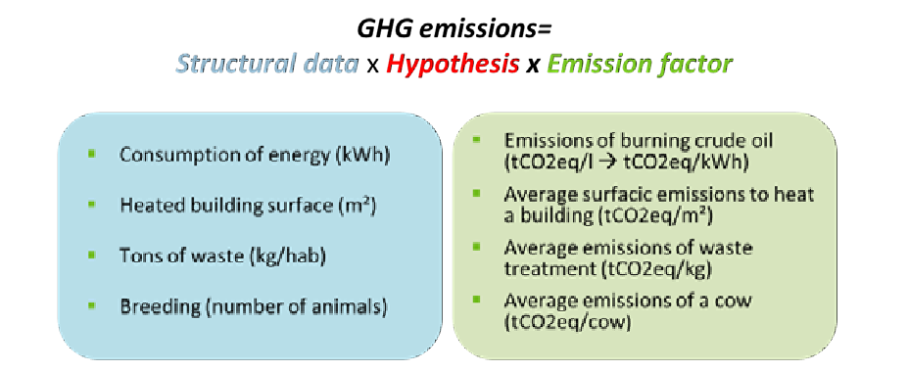

Figure 1: Calculation principle of the inventory

This simplified calculation approach is with the following various uncertainties:

* Structural/Activity data: low uncertainty
* Hypothesis: medium to high uncertainty
* Emission factors: low to medium uncertainty

#### 1.4. Considered scope

Building this BEI, we have judged necessary to include the following sectors, but we couldn’t find sufficient hypothesis or structural data on stroke out topics:

Compared to the Convention of Mayors recommendations for SEAPs:

* Have been taken into account: non-energetic and energetic GHG emissions for waste management, energetic GHG emissions for water and wastewater management (pumping, treatment, etc.), because Sahab is planning actions on both topics.
* Have not been taken into account: Non-energetic emissions of industrial activities, refrigerant leakage of buildings and vehicles, sewage sludge of wastewater treatment since information on these topics wasn’t sufficient and not mandatory to be included in the BEIs.

It is important to understand what are called tertiary buildings, namely all buildings that are neither residential, nor industrial or agricultural: stores, offices, hospitals, transport buildings, sport buildings, leisure, and other private services.

### 2. Detailed methodology per sector

The methodological targets was adapted to Sahab according to what has been described in the last chapter. This part explains details on the methodology used to build the first Sahab BEI. An Excel file has been created in order to collect and work on data provided by the municipality or obtained from the Department of Statistics(DOS), describing each source, year of reference and calculations made.

#### 2.1. Common data sets

##### 2.1.1. Population statistics

In 2014, the population of localities governed by Sahab municipality services was 75,910 inhabitants (According to DOS statistics 2014). Thus, about 1.14% of the kingdom population lives in Sahab perimeter.

##### 2.1.2. Employment statistics

* The DOS offers two different data sets on employment with an important difference:
* Number of employed persons among the population in the national Statistical Yearbooks on Population, Buildings, Housing and establishment for all governorates. The numbers correspond to inhabitants of a locality who have a job wherever this job is actually located or not.
* Number of employed persons in the Private Sector, Non-Governmental Organization Sector and Government Companies inside the locality, delivered in national Statistical Yearbooks. Since we need this information to estimate the consumption of tertiary and industrial building of the locality, we use the following dataset.

|  |  |  |  |  |  |  |
| --- | --- | --- | --- | --- | --- | --- |
|  | Number of Employed Persons (Private, NGO, Gov) | | | | | |
| Public sector | Private Sector | Mining and quarrying | Manufacturing | Construction | Total |
| Sahab (2014) | 15,713 | 34,235 | 290 | 9,150 | 1,380 | 10,820 |

##### Table 2: Consumption estimations in Sahab

##### 2.1.3. Energy demand in Jordan per sector and type of energy

One of the key reports used for making these BEI is the Energy Balance report made by the Ministry of Energy and mineral resources for 2014. One of its tables describes energy consumption in TJ/year or in sectorial units (kg, MWH, etc.) by energy (Solar, Electricity, Gasoline, Kerosene, Diesel, Oils, LPG, Wood and charcoal) and sector (Mining, Manufacturing industry, Construction, Road transport, Households, and Internal trade and services).

|  |  |  |  |  |  |  |  |
| --- | --- | --- | --- | --- | --- | --- | --- |
|  | Solar | Electricity | Gasoline | Kerosene | Diesel | LPG | Heavy fuel oil |
| Consumer | MWh/y | MWh/y | 1000ltr/y | 1000ltr/y | 1000ltr/y | tons/y | tons/y |
| Municipal Buildings |  | 698 |  |  | 10 |  |  |
| Households | 750 | 24,856 |  | 260 |  | 3430 |  |
| Internal trade & servises |  | 11,120 |  |  |  | 637 |  |
| Street lighting |  | 323 |  |  |  |  |  |
| Agriculture |  | 460 |  |  |  |  |  |
| Water |  | 790 |  |  |  |  |  |
| Manufacturing |  | 37,500 |  |  | 4,887 | 170 | 2836 |
| Road transport |  |  | 32,343 |  | 43,438 |  |  |
| Total | 750 | 75,747 | 32,343 | 260 | 48,335 | 4,237 | 2,836 |

Table 3: energy consumption in TJ/year or in sectorial units

We will often refer to this table in the following chapters, usually by calling a consumption ratio per capita or employee for a given energy and sector from Ministry of Energy and mineral resources report on Energy Demand 2014.

For example, to estimate LPG consumption in Sahab, the following formula can be used:

*Ratio = LPG Jordan 2014 / Pop Jordan 2014 = 45.3 kg/capita/year*

LPG Jordan 2014: Consumption of LPG for households in 2014 = 301 million kg/year

Pop Jordan 2014: Population of Jordan in 2014 = 6650000 inhabitants This figure is then multiplied by the city population in 2014.

##### 2.1.4. Emissions factors of energy consumption (IPCC, UNFCCC)

Emission factor for energy combustion used in the BEI to convert consumption in GHG emission come from IPCC Guidelines 2006 [5], using default values provided. In this report, a distinction is being made for different activity sectors, but also between stationary and mobile combustion. Considered gases are CO2 (Carbon dioxide), N20 (Nitrous Oxide) and CH4 (Methane).

Since the territorial inventory method consists in assigning emissions of the whole energy production chain to the consumers, emission factors were added for upstream emissions (extraction, refining, production and transport of energy). These factors come from 2006 UNFCC publication[6]. For electricity, the emission factor is the one provided by the GHG Protocol, via a tool to calculate GHG emissions of purchased electricity[7]. The emission factor is the Jordanian one, and is equal to (560 gCO2eq/kWh), since all electricity consumed in the city comes from Jordan producers. It includes all upstream emissions, such as transport and losses. For other fossil fuels, all average emission factors are resumed in the following table:

|  |  |
| --- | --- |
|  | *gCO2eq/kWh* |
| Electricity | 560 |
| LPG | 230 |
| Diesel | 270 |
| Gasoline | 250 |
| Kerosene | 260 |
| Other fossil fuel | 285 |

#### Table 4: Emission factors in Jordan

#### 2.2. Residential buildings

In Jordan, households consume various type of energy for their homes: Electricity, Liquid gas, Kerosene (rarely Diesel), solar thermal. The municipality provided yearly consumption per energy sources. Some values seem consistent compared to households’ energy surveys conducted by DOS, some are not and had to be put aside. The following table shows what information was provided and judged consistent or not, and what method was used to estimate lacks:

|  |  |  |  |
| --- | --- | --- | --- |
|  | Value provided | Method | Final value |
| Electricity | 24,856 MWh/y | Consistent | 24,856 MWh/y |
| Liquid gas | Not provided | National Ratio per capita | 43,494 MWh/y |
| Diesel and Kerosene | Not provided | 2,527 MWh/y |
| Solar energy | 750 MWh/y | Consistent | 750 MWh/y |

Table 5: Methods for checking energy values

In case a value could not be used or wasn’t provided, estimation was made using a ratio per capita, built out of MEMR report on Energy Demand 2014, and the population of Jordan in 2014.

Refrigerant leakages in residential buildings have not been considered in these BEI.

#### 2.3. Tertiary buildings and public lighting

Tertiary buildings are composed of two different categories: municipal buildings and other buildings. In fact, we call tertiary building every building which is not a dwelling, nor an industrial company or dedicated to agriculture. It is composed of: shops, office building, administration, hotels, restaurants, transport building, health buildings, sport center, cultural building, leisure buildings, etc.

Energy consumption for all energies has been provided for municipal buildings and public lighting. All data was kept as such.

|  |  |
| --- | --- |
|  | Consumption |
| Municipality buildings | 282MWh/year |
| Schools | 366MWh/year |
| Trading buildings | 8,255 MWh/year |
| Private Buildings | 1,482MWh/year |
| Masjids | 50 MWh/year |
| Public lighting | 323MWh/year |
| Other Buildings | 1,383 MWh/year |

Table 6: Energy consumption in Sahab

For other types of energies, consumption has been estimated using a ratio of consumption per capita extracted from MEMR report on Energy Demand 2014 (Internal trade + Services).

|  |  |  |  |
| --- | --- | --- | --- |
|  | Value provided | Method | Final value |
| Liquid gas | Not provided | National Ratio per capita | 8,074 MWh/y |
| Diesel | Not provided | 5,850 MWh/y |

Table 7: Methods for checking energy values

Refrigerant leakages of tertiary buildings have not been considered in these BEI.

#### 2.4. Industry

Sahab City has the largest two industrial Zones in the kingdom; King Abdullah II Industrial Estate which includes (430) factory, and Industrial estate city which includes (50) factory.For industrial sector, the value of electricity consumption of (37.5 GWh/y) was provided and considered consistent. For other types of energies, consumption has been estimated using a ratio of consumption per capita extracted from DOS report on 2014 (which is the ratio of number of industrial employees in Sahab with total Jordan industrial employees) which equals to 0.022.

|  |  |  |  |
| --- | --- | --- | --- |
|  | Value provided | Method | Final value |
| Electricity | 37,500 MWh/y | Consistent | 37,500 MWh/y |
| Liquid gas | Not provided | National Ratio per capita for industrial employees | 2,149 MWh/y |
| Diesel | Not provided | 48,869 MWh/y |
| Heavy Fuel Oil | Not provided | 32,289 MWh/y |

Table 8: Methods for checking energy values

Non-energetic emissions have not been considered in the BEI.

#### 2.5. Transport

Fleet fuel consumption (diesel and gasoline) was calculated based on an actual vehicles inventory conducted from the municipality for all Sahab city Entrances and exists. Table below shows the fuel consumptions and CO2 emissions for the transportation sector in Sahab City.

|  |  |  |  |  |  |  |  |  |  |  |
| --- | --- | --- | --- | --- | --- | --- | --- | --- | --- | --- |
| Description | Total | Type of Vehicle | | | | | | | | |
| Scooters, Motorcycles | Taxi, Passengers Cars | Hybrid Cars | Pick-up | Small Bus | Coaster Bus | Coach Bus | 2-axle Truck | Larger trucks |
| Total Cars (using electronic and Human counters) | 136,297 | 22 | 66,333 | 7,462 | 21,925 | 13,438 | 4,570 | 629 | 9,905 | 8,657 |
| Percentage of cars according to car type | 100.00% | 0.02% | 49.90% | 5.61% | 16.49% | 10.11% | 3.44% | 0.47% | 7.45% | 6.51% |
| Total Cars that have extra time in Sahab region | 1,952 | 0 | 924 | 67 | 245 | 229 | 109 | 22 | 209 | 147 |
| Lit/km ( @ 50 km/hr) |  | 0.048 | 0.1 | 0.047 | 0.12 | 0.098 | 0.16 | 0.04 | 0.13 | 0.39 |
| Lit/hr ( @ 50 km/hr) |  | 2.4 | 5 | 2.35 | 6 | 4.9 | 8 | 2 | 6.5 | 19.5 |
| fuel type |  | Gasoline | Gasoline | Gasoline | Diesel | Diesel | Diesel | Diesel | Diesel | Diesel |
| driving time within Sahab Region plus stops (hr) |  | 0.25 | 0.25 | 0.25 | 0.25 | 0.25 | 0.25 | 0.25 | 0.25 | 0.25 |
| Type's total fuel consumed (Lit/day) |  | 13 | 84,070 | 4,423 | 33,255 | 16,742 | 9,358 | 325 | 16,435 | 42,918 |
| Annual Gasoline consumed (1000 Lit/year) | 32,305 | 5 | 30,686 | 1,615 |  |  |  |  |  |  |
| Annual Diesel consumed (1000 Lit/year) | 43,447 |  |  |  | 12,138 | 6,111 | 3,416 | 119 | 5,999 | 15,665 |
| CO2 Emission Factor (kg CO2/Lit fuel) |  | 2.33 | 2.33 | 2.33 | 2.7 | 2.7 | 2.7 | 2.7 | 2.7 | 2.7 |
| CO2 emissions per day (Ton CO2/day) | 527.61 | 0.03 | 195.88 | 10.31 | 89.79 | 45.20 | 25.27 | 0.88 | 44.37 | 115.88 |
| Annual CO2 emissions (Ton CO2/year) | 192,577 | 11 | 71,497 | 3,762 | 32,773 | 16,499 | 9,222 | 321 | 16,197 | 42,296 |
| Total Emissions in Jordan for transportation Sector (Ton CO2/year) | 5,468,000 |  |  |  |  |  |  |  |  |  |
| Contribution of Sahab on CO2 emissions for Transportation Sector | 3.52% |  |  |  |  |  |  |  |  |  |

Table 9: Fuel consumptions and CO2 emissions for the transportation sector in Sahab City

#### 2.6. Waste management

The Municipality service collects 19,702 tons of solid waste per year in the district, which equals to 0.71 kg per capita per day.

According to Jordanian statistics, waste composition breakdowns as follows:

|  |  |
| --- | --- |
| Waste type | % of mass |
| Glass | 2% |
| Plastic | 16% |
| Metal | 2% |
| Paper and cardboard | 11% |
| Organic waste | 62% |
| Other | 7% |

Table 10: Waste composition in Jordan

In Sahab, 100% of waste is landfilled without methane capture. Then, an equivalent emission factor of CO2 for landfilling waste without CH4 capture is applied, based on published 2012 Guidelines to Defra / DECC's GHG Conversion Factors. The equivalent CO2Emissions for the different land filled wastes are as follows:

|  |  |
| --- | --- |
| Waste type | kg CO2eq /ton waste |
| Paper & Cardboard | 553 |
| Organic waste | 570 |
| Other waste | 63 |

#### Table 11: CO2Emissions for the different land filled wastes

#### 2.7. Water management

The municipality has provided electricity consumption for water management: 790 MWh/y in 2014. This value is considered consistent, since it comprises pumping, production and wastewater treatment.

#### 2.8. Agriculture

The municipality has provided the electricity consumption for the agricultural sector, which reached 460 MWh/year for 2014.

### 3. Results

#### 3.1. Energy consumption

The total energy consumption (final energy) for Sahab city perimeter is estimated to be 968.6 GWh/year in 2014, which corresponds to about 12.76 MWh/person/year (equivalent to 7.8 barrel of oil per year per person). The following table and pie chart shows distribution among sectors:

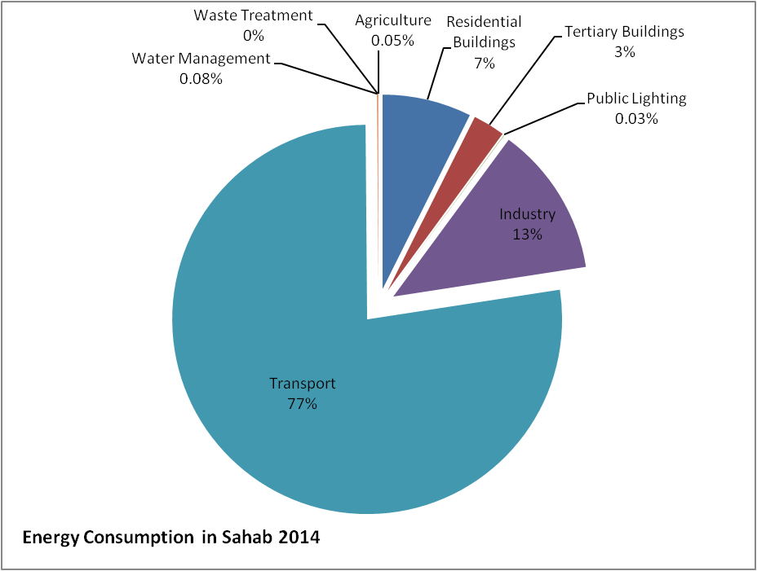

Figure 2: Energy consumption in Sahab 2014

If we look more precisely at consumption per energy and sectors, we realize that the main energy demand sources are fuels for transport and electricity and fuels for industries, followed by residential buildings.

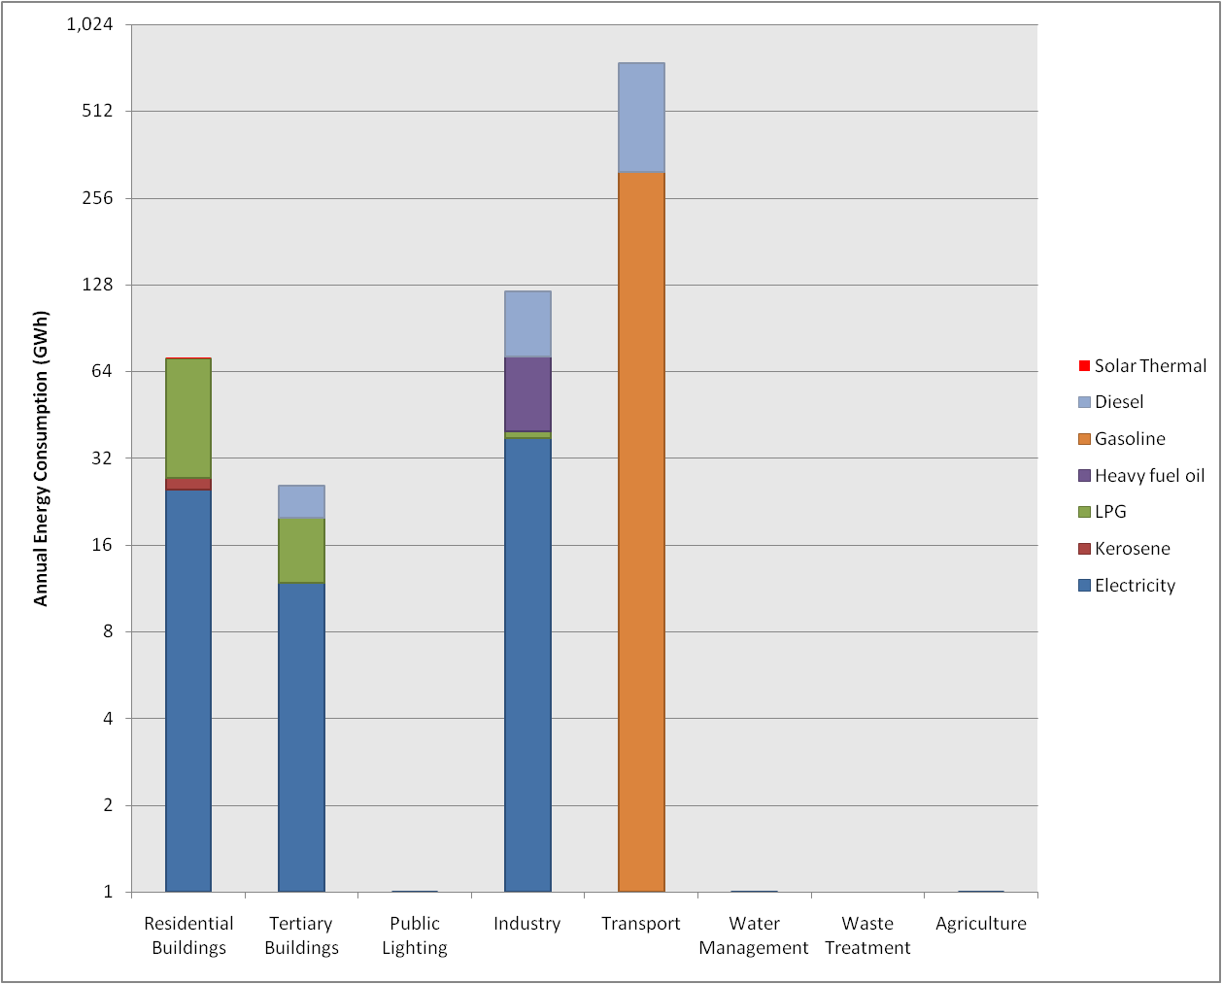

##### Figure 3: Energy consumption per sector and per energy in Sahab (2014)

|  |  |  |  |  |  |  |  |  |
| --- | --- | --- | --- | --- | --- | --- | --- | --- |
|  | Solar | Electricity | Gasoline | Kerosene | Diesel | LPG | Heavy fuel oil | Total |
| Consumer | GWh/yr | GWh/yr | GWh/yr | GWh/yr | GWh/yr | GWh/yr | GWh/yr | GWh/yr |
| Residential Buildings | 0.75 | 24.86 |  | 2.53 |  | 43.49 |  | 71.63 |
| Tertiary Buildings |  | 11.82 |  |  | 5.85 | 8.07 |  | 25.74 |
| Public Lighting |  | 0.32 |  |  |  |  |  | 0.32 |
| Industry |  | 37.50 |  |  | 48.87 | 2.15 | 32.29 | 120.81 |
| Transport |  |  | 314.45 |  | 434.38 |  |  | 748.83 |
| Water Management |  | 0.79 |  |  |  |  |  | 0.79 |
| Waste Treatment |  |  |  |  |  |  |  | 0.00 |
| Agriculture |  | 0.46 |  |  |  |  |  | 0.46 |
| Total (GWh/yr) | 0.75 | 75.75 | 314.45 | 2.53 | 489.10 | 53.72 | 32.29 | 969 |

##### Table 11: energy consumption per sector and per energy in Sahab (2014)

#### 3.2. GHG emissions

Global GHG emissions of Sahab city are estimated to be 283.8ktCO2eq/year in 2014, which corresponds to about 3.74 tCO2eq/person/year.

The distribution of GHG emissions among sectors is as presented in the graph below. Municipal buildings consumptions are here included under tertiary buildings, although it is detailed in the dedicated chapter (cf. zoom on municipal assets) and in the BEI Excel file.

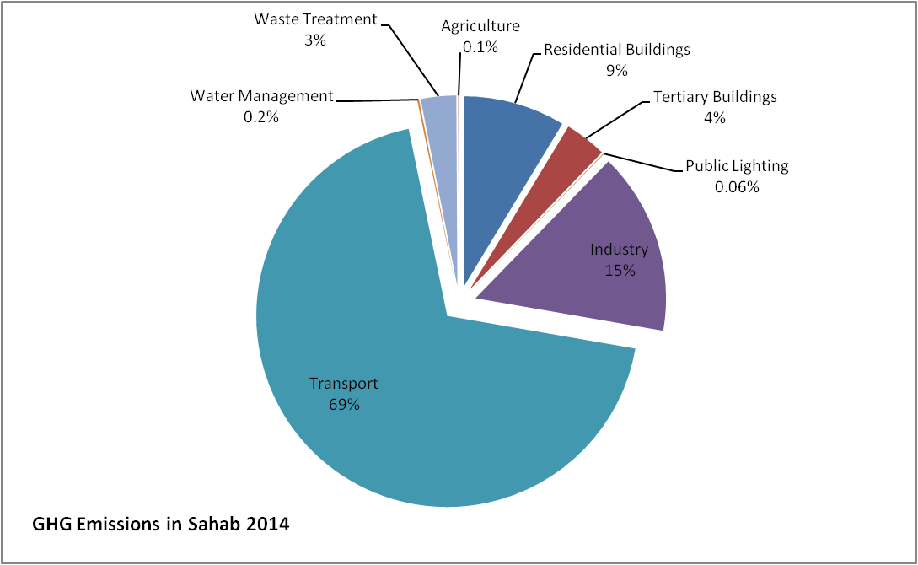

Figure 4: GHG emissions in Sahab 2014

Emissions comprise combustion (IPCC Guidelines 2006) and upstream emissions for producing and delivering energy (UNFCC Guidelines). For the emission factor for electricity the Jordan value is used, which is (560 gCO2eq/kWh).

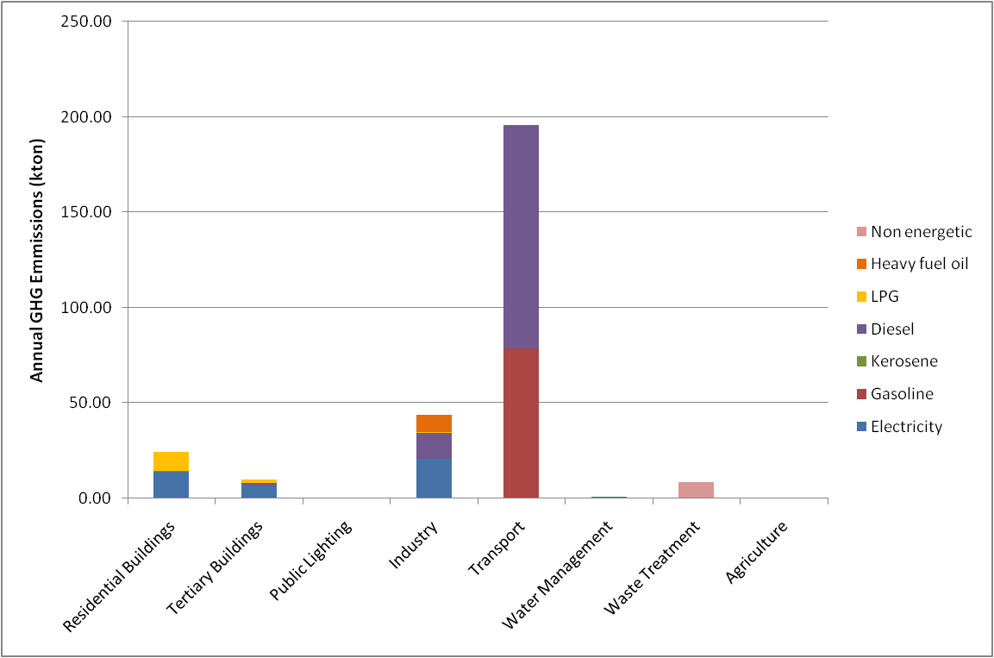

Figure 5: GHG emissions per sector and per energy in Sahab (2014)

|  |  |  |  |  |  |  |  |  |
| --- | --- | --- | --- | --- | --- | --- | --- | --- |
|  | Electricity | Gasoline | Kerosene | Diesel | LPG | Heavy fuel oil | Non energetic | Total |
| Consumer | kton CO2/y | kton CO2/y | kton CO2/y | kton CO2/y | kton CO2/y | kton CO2/y | kton CO2/y | kton CO2/y |
| Residential Buildings | 13.92 |  | 0.66 |  | 10.00 |  |  | 24.58 |
| Tertiary Buildings | 6.62 |  |  | 1.58 | 1.86 |  |  | 10.05 |
| Public Lighting | 0.18 |  |  |  |  |  |  | 0.18 |
| Industry | 21.00 |  |  | 13.19 | 0.49 | 9.20 |  | 43.89 |
| Transport |  | 78.61 |  | 117.28 |  |  |  | 195.90 |
| Water Management | 0.44 |  |  |  |  |  |  | 0.44 |
| Waste Treatment |  |  |  |  |  |  | 8.50 | 8.50 |
| Agriculture | 0.26 |  |  |  |  |  |  | 0.26 |
| Total (kton/yr) | 42 | 79 | 1 | 132 | 12 | 9 | 9 | 283.80 |

Table 12: GHG emissions table per sector and per energy in Sahab (2014)

#### 3.3. Zoom on municipal assets

The energy consumption of Sahab municipality belongings (buildings, public lighting, and water management) is 1.81 GWh/year, about 2.4% of the total consumption of the city. The following chart shows the distribution of consumption and costs among different services of the city. Costs have been estimated using average energy costs (0.138JOD/kWh for electricity), where the total GHG emissions (except waste treatment) are 1.01 ktCO2eq/year.

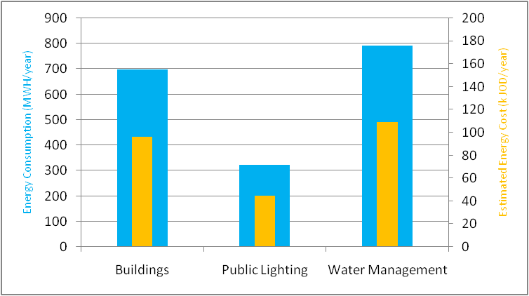

Figure 6: Energy consumption of municipal assets in Sahab (2014)

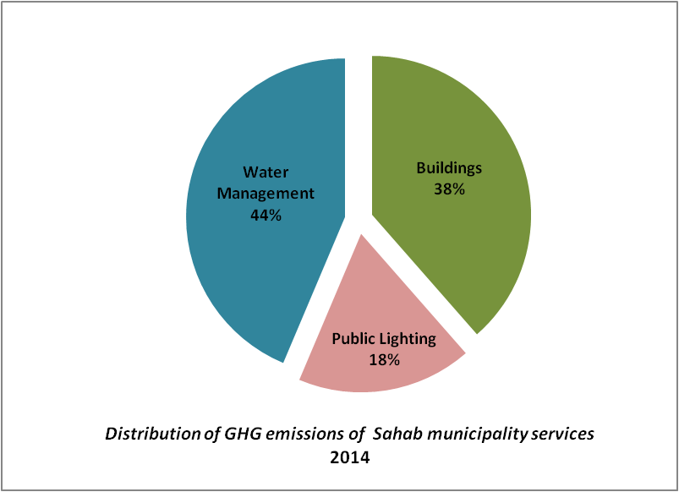

Figure 7: Distribution of GHG emissions of Sahab’s municipality services 2014

|  |  |  |  |
| --- | --- | --- | --- |
|  | Consumption | Costs | GHG emissions |
|  | *MWh/year* | JOD/year | tCO2eq/year |
| Municipal buildings | 698 | 96,324 | 391 |
| Public lighting | 323 | 44,574 | 181 |
| Water management | 790 | 109,020 | 442 |
| Total | 1,811 | 249,918 | 1,014 |

Table 13: Consumption, costs and GHG emissions of municipal assets in Sahab (2014)

#### 3.4. Business-as-usual scenario (BAU)

The BAU factor for Jordan GHG emissions assessment was applied for this plan, which is how GHG emission will evolve in Sahab as imagined. According to the Jordan National Green Growth plan 2016, Jordan’s emissions grow by 2% a year, supposing an increase of 37% of GHG emissions on all sectors by 2030, in which GHG emissions in Sahab will reach a total of about 388.8kton eqCO2/year in 2030.

Table with BAU factor in Jordan

|  |  |  |  |  |  |  |  |  |  |
| --- | --- | --- | --- | --- | --- | --- | --- | --- | --- |
| BAU factor for Jordan | 2014 | 2016 | 2018 | 2020 | 2022 | 2024 | 2026 | 2028 | 2030 |
| 1.37 | 1.32 | 1.27 | 1.22 | 1.17 | 1.13 | 1.08 | 1.04 | 1.00 |

Table 14: BAU factor throught the years in Jordan

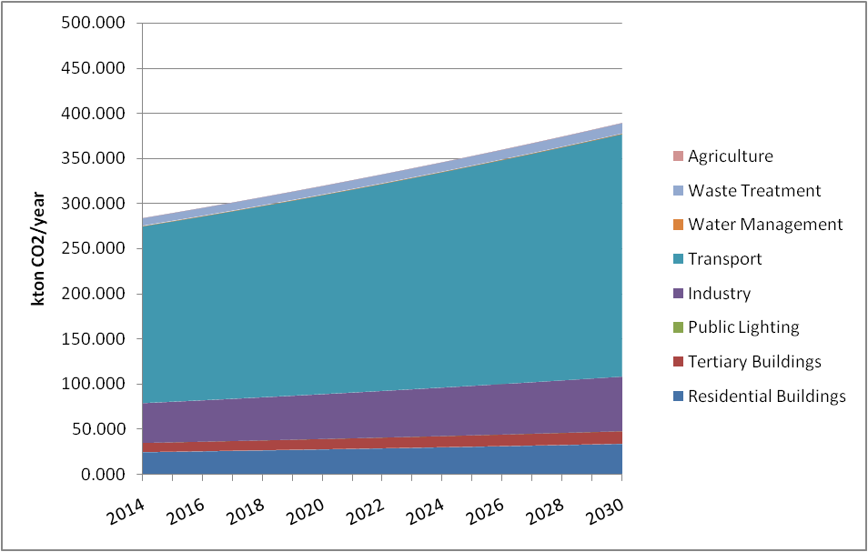

Figure 8: BAU trend scenario for Sahab GHG emissions 2014-2030

### 4. Complete BEI tables

|  |  |  |  |  |  |  |  |  |  |
| --- | --- | --- | --- | --- | --- | --- | --- | --- | --- |
| Sector | | Electricity | Liquid gas | Diesel | Gasoline | Kerosene | Heavy Fuel Oil | Solar thermal | Total |
| Non- municipal | Tertiary buildings | 10,007 | 8,074 | 5,750 |  |  |  |  | 23,831 |
| Residential buildings | 24,856 | 43,494 |  |  | 2,527 |  | 750 | 71,627 |
| Industry | 37,500 | 2,149 | 48,869 |  |  | 32,289 |  | 120,807 |
| Agriculture | 460 |  |  |  |  |  |  | 460 |
| Transport |  |  | 434,383 | 314,446 |  |  |  | 748,829 |
| Total | 72,823 | 53,717 | 489,002 | 314,446 | 2,527 | 32,289 | 750 | 965,554 |
| Municipal assets | Municipal buildings | 1,811 |  | 100 |  |  |  |  | 1,911 |
| Public lighting | 323 |  |  |  |  |  |  | 323 |
| Waste |  |  |  |  |  |  |  | 0 |
| Water | 790 |  |  |  |  |  |  | 790 |
| Total | 2,924 |  | 100 |  |  |  |  | 3,024 |
| Total | | 75,747 | 53,717 | 489,102 | 314,446 | 2,527 | 32,289 | 750 | 968,578 |

Table 15: Energy consumption in MWh EF/year in 2014

|  |  |  |  |  |  |  |  |  |  |
| --- | --- | --- | --- | --- | --- | --- | --- | --- | --- |
| Sectors | | Electricity | Liquid gas | Diesel | Gasoline | Kerosene | Heavy Fuel Oil | Non-energetic | Total |
| Non- municipal | Tertiary buildings | 5.60 | 1.86 | 1.55 |  |  |  |  | 9.01 |
| Residential buildings | 13.92 | 10.00 |  |  | 0.66 |  |  | 24.58 |
| Industry | 21.00 | 0.49 | 13.19 |  |  | 9.20 |  | 43.89 |
| Agriculture | 0.26 |  |  |  |  |  |  | 0.26 |
| Transport |  |  | 117.28 | 78.61 |  |  |  | 195.90 |
| Total | 40.78 | 12.35 | 132.03 | 78.61 | 0.66 | 9.20 |  | 273.64 |
| Municipal assets | Municipal buildings | 1.01 |  | 0.03 |  |  |  |  | 1.04 |
| Public lighting | 0.18 |  |  |  |  |  |  | 0.18 |
| Waste Management |  |  |  |  |  |  | 8.50 | 8.50 |
| Water Management | 0.44 |  |  |  |  |  |  | 0.44 |
| Total | 1.64 |  | 0.03 |  |  |  | 8.50 | 10.16 |
| Total | | 42.42 | 12.35 | 132.06 | 78.61 | 0.66 | 9.20 | 8.50 | 283.80 |

Table 16: GHG emissions in ktCO2eq/year in 2014

## Section IV: Sustainable energy action plan (planned actions)

### 1. Summary of the Baseline emissions inventory

#### 1.1. Energy consumption

The total energy consumption (final energy) for Sahab city perimeter is estimated to be 968.6 GWh/year in 2014, which corresponds to about 12.76 MWh/person/year. This is equivalent to 7.8 barrel of oil per year per person. Distribution among sectors is as follows.

|  |  |
| --- | --- |
| Sector | GWh/yr |
| Residential Buildings | 71.63 |
| Tertiary Buildings | 25.74 |
| Public Lighting | 0.32 |
| Industry | 120.81 |
| Transport | 748.83 |
| Water Management | 0.79 |
| Waste Treatment | 0.00 |
| Agriculture | 0.46 |
| Total (GWh/yr) | 968.58 |

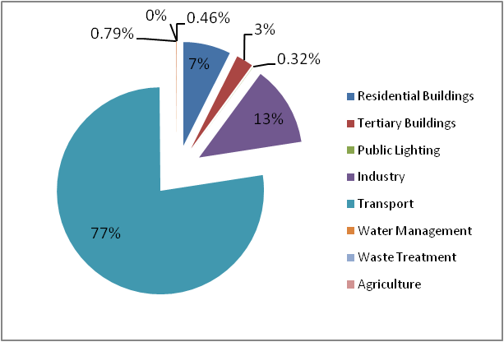

Figure 9: Energy consumption sectors share

#### Table 17: Energy consumption sectors

Note: Municipal buildings consumptions are included here under tertiary buildings. One can find the details in the dedicated chapter of the BEI document.

#### 1.2. GHG emissions

Global GHG emissions of Sahab city are estimated to be 283.8 ktCO2eq/year in 2014, which corresponds to about 3.74 tCO2eq/person/year.

|  |  |
| --- | --- |
| Sector | kton CO2/y |
| Residential Buildings | 24.58 |
| Tertiary Buildings | 10.05 |
| Public Lighting | 0.18 |
| Industry | 43.89 |
| Transport | 195.90 |
| Water Management | 0.44 |
| Waste Treatment | 8.50 |
| Agriculture | 0.26 |
| Total (kton/yr) | 283.80 |



Figure 10: GHG emissions in Sahab 2014

Table 18: GHG emissions in Sahab 2014

#### 1.3. Business-as-usual scenario

The BAU factor for Jordan GHG emissions assessment was applied for this plan, which is how GHG emission would evolve in Sahab. According to Jordan National Green Growth plan 2016, Jordan’s emissions grow by 2% a year supposing an increase of 37% of GHG emissions on all sectors by 2030, which total GHG emissions in Sahab would reach 388.8 kton eqCO2/year in 2030.



Figure 11: BAU trend scenario for Sahab GHG emissions 2014-2030

### 2. Action plan on municipal buildings and services

As its first priority, the Municipality Council is committed to act on its direct scope of responsibility: municipal buildings and services (street lighting, water distribution, sanitation, waste management). Through such a commitment, being exemplary on its own perimeter, the Municipality Council will be able to promote the mobilization of all stakeholders inviting them to reduce their energy consumption and contribute to the development of renewable energy capacities. This commitment to act on its own perimeter also constitutes a field for investigation to test actions and assess results in order to design appropriate recommendation to be proposed to citizens, companies and citizen groups that will have to act to promote the local energy transition.

**2.1. Municipal buildings**

***2.1.1. Current status***

Please refer to section one of the report, part 3.1.

##### 2.1.2. Expected results

|  |  |  |  |  |  |  |  |  |  |  |
| --- | --- | --- | --- | --- | --- | --- | --- | --- | --- | --- |
| Energy in MWh/year | Situation in 2014 | | Cut expected | | Situation in 2020 | | Cut expected in 2030 | | Situation in 2030 | |
| GHG in tCO2eq/year | Energy | GHG | Energy | GHG | GHG (BAU) | Cut / BAU | Energy | GHG | GHG (BAU) | Cut / BAU |
| All municipality buildings | 282 | 157.92 | -56.2 | -31.5 | 193 | -16.3% | -76.8 | -43.0 | 216 | -20% |
| Staff awareness campaign |  |  | -11.4 | -6.4 |  | -3.3% | -32.0 | -17.9 |  | -8% |
| sensor systems in buildings |  |  | -14.1 | -7.9 |  | -4.1% | -14.1 | -7.9 |  | -4% |
| Switch to LED Lighting |  |  | -30.7 | -17.2 |  | -8.9% | -30.7 | -17.2 |  | -8% |

#### 2.2. Street lighting

##### 2.2.1. Current status

Please refer to section one of the report, part 3.3.

##### 2.2.2. Expected results

|  |  |  |  |  |  |  |  |  |  |  |
| --- | --- | --- | --- | --- | --- | --- | --- | --- | --- | --- |
| Energy in MWh/year GHG in tCO2eq/year | Situation in 2014 | | Cut expected in 2020 | | Situation in 2020 | | Cut expected in 2030 | | Situation in 2030 | |
| Energy | GHG | Energy | GHG | GHG (BAU) | Cut / BAU | Energy | GHG | GHG (BAU) | Cut / BAU |
| Street lighting | 323 | 181 | -45 | -25 | 221 | -11.5% | -104 | -58 | 248 | -24% |
| Expand LED deployment  (priority 2) |  |  | -21 | -12 |  | -5.3% | -59 | -33 |  | -13% |
| Street lighting strategic plan |  |  | -11.5 | -6.5 |  | -2.9% | -32.3 | -18.1 |  | -7% |
| Installed 40 LED street lighting units |  |  | -12.9 | -7.2 |  | -3.3% | -12.9 | -7.2 |  | -3% |

#### 2.3. Solid waste management

##### 2.3.1. Current status

Please refer to section one of the report, part 3.4.

##### 2.3.2. Expected results

|  |  |  |  |  |  |  |
| --- | --- | --- | --- | --- | --- | --- |
| Energy in MWh/year  GHG in tCO2eq/year | Situation in 2014 | | Cut expected in 2030 | | Situation in 2030 | |
| Energy | GHG | Energy | GHG | GHG (BAU) | Cut / BAU |
| Solid waste  management |  | 8,500 |  | 2,550 | 11,645 | 22% |
| Waste separation and recycling, reducing waste to landfill by 30% with improving waste management through better monitoring of the collect process |  |  |  | 2,550 |  | 21.90% |

### 3. Action plan on Sahab’s urban area

Beyond its direct scope of responsibility (on buildings and services), the Municipality council is committed to mobilize all stakeholders acting in its boundaries. It is only through the overall commitment of residents, shops, businesses, local groups, farmers, etc. that significant reduction in energy consumption and development of renewable energy will be achieved.

#### 3.1. Residential and tertiary buildings

##### 3.1.1. Current situation

##### Please refer to section one of the report, part 5.1.

##### 3.1.2. Expected results

|  |  |  |  |  |  |  |  |  |  |  |
| --- | --- | --- | --- | --- | --- | --- | --- | --- | --- | --- |
| Energy in MWh/year  GHG in tCO2eq/year | Situation in 2014 | | Cut expected in 2020 | | Situation in 2020 | | Cut expected in 2030 | | Situation in 2030 | |
| Energy | GHG | Energy | GHG | GHG (BAU) | Cut / BAU | Energy | GHG | GHG (BAU) | Cut / BAU |
| Residential & tertiary buildings | 97,369 | 34,634 | -4,550 | -2,146 | 42,254 | -5.08% | -12,746 | -6,011 | 47,449 | -12.67% |
| Awareness to reduce consumption |  |  | -3,325 | -1,710 |  | -4.05% | -9,314 | -4,791 |  | -10.10% |
| Housing renovation plan |  |  | -965 | -343 |  | -0.81% | -2,702 | -961 |  | -2.03% |
| New construction rules |  |  | -261 | -93 |  | -0.22% | -730 | -260 |  | -0.55% |

#### 3.2. Transport

##### 3.2.1. Current situation

Please refer to section one of the report, part 5.2.

##### 3.2.2. Expected results

|  |  |  |  |  |  |  |  |  |  |  |
| --- | --- | --- | --- | --- | --- | --- | --- | --- | --- | --- |
| Energy in MWh/year | Situation in 2014 | | Cut expected in 2020 | | Situation in 2020 | | Cut expected in 2030 | | Situation in 2030 | |
| GHG in tCO2eq/year | Energy | GHG | Energy | GHG | GHG (BAU) | Cut / BAU | Energy | GHG | GHG (BAU) | Cut / BAU |
| Transports | 748,829 | 195,895 | -43,750 | -11,185 | 238,992 | -5% | -145,835 | -37,284 | 268,376 | -14% |
| Retrofitting the Taxis cars with Hybrid cars |  |  | -22,409 | -5,602 |  |  | -74,696 | -18,674 |  | -7% |
| Sustainable urban mobility plan |  |  | -21,342 | -5,583 |  |  | -71,139 | -18,610 |  | -7% |

#### 3.3.Industry

##### 3.3.1. Current situation

##### Please refer to section one of the report, part 5.3.

##### 3.3.2. Expected results

|  |  |  |  |  |  |  |  |  |  |  |
| --- | --- | --- | --- | --- | --- | --- | --- | --- | --- | --- |
| Energy in MWh/year  GHG in tCO2eq/year | Situation in 2014 | | Cut expected in 2020 | | Situation in 2020 | | Cut expected in 2030 | | Situation in 2030 | |
| Energy | GHG | Energy | GHG | GHG (BAU) | Cut / BAU | Energy | GHG | GHG (BAU) | Cut / BAU |
| Industry | 120,807 | 43,891 | -4,312 | -1,567 | 53,547 | -2.9% | -12,079 | -4,389 | 60,131 | -7.3% |
| Awareness among business holders |  |  | -4,312 | -1,567 |  | -2.9% | -12,079 | -4,389 |  | -7.3% |

#### 3.4. Agriculture and forestry

##### 3.4.1. Current situation

Please refer to section one of the report, part 5.4.

***3.4.2. Expected results***

Impacts are to be considered as marginal.

### 4. Energy supply and renewable energy development

As energy demand continues to grow, energy conservation, energy efficiency and development of renewable sources are key challenges to be taken in Sahab. The objective of the Municipality is to reduce electricity consumption and develop renewable electricity production in order to minimize its dependency on the electricity grid, where in summer time and due to intense use of air conditioners, there are cuts in electricity delivery rotating from one area to the other. As a matter of fact, some citizens are equipped with diesel generators to compensate when the grid doesn’t supply them.

#### 4.1. Solar PV development

There are many opportunities to develop solar PV and it would be very efficient to promote a comprehensive plan for Sahab targeting different objectives and stakeholders: Municipality buildings and other public buildings and residents and private investors. Taking into account the fact that the cost of PV installations is going down and considering the pretty high cost of electricity in Jordan, return on investment is now getting attractive (5 to 6 years).

##### Solar PV on all public buildings and available public spaces / PRIORITY ACTION #3

The plan is to develop solar PV units connected to the grid wherever possible and appropriate. A rough inventory demonstrates that close to 50,000 square meters could be equipped only using buildings roofs. This includes Municipality buildings, schools, university, hospital, marketplace, bus terminal, etc.

If only 50% of this surface would be equipped with a 2.5 MW capacity, the system will produce close to 3.9 GWh per year and will ensure a pay back over 5 years, especially knowing that the municipality has installed around 78 kW PV systems on its buildings in 2015.

Assumptions:

* Cost of a 1KW unit = JOD 1000. Annual production 1600 KWh / installed KW
* Assumptions: KWh purchased at 0.259 JOD.
* Various options could be proposed to exploit this PV potential.
* Negotiate a 3.2 Million € loan to install 605 KW/ year over 4 years. In the fourth year and beyond, the Municipality will produce 3,775 MWh annually and generate revenues of 1.25 Million€ per year from reducing electricity imports. The Municipality will be able to reimburse the initial investment after 9 years as explained in the table.

|  |  |  |  |  |  |  |  |  |  |  |
| --- | --- | --- | --- | --- | --- | --- | --- | --- | --- | --- |
|  | Year0 | Year1 | Year2 | Year3 | Year4 | Year5 | Year6 | Year7 | Year8 | Year9 |
| Investment | 775,640 | 775,640 | 775,640 | 775,640 |  |  |  |  |  |  |
| Installed Capacity/year kW | 0 | 605 | 605 | 605 | 605 |  |  |  |  |  |
| Total Installed capacity kW | 0 | 605 | 1,210 | 1,815 | 2,420 | 2,420 | 2,420 | 2,420 | 2,420 | 2,420 |
| Production in kWh | 0 | 943,800 | 1,887,600 | 2,831,400 | 3,775,200 | 3,775,200 | 3,775,200 | 3,775,200 | 3,775,200 | 3,775,200 |
| Revenues in € | 0 | 166,980 | 333,960 | 500,940 | 667,920 | 667,920 | 667,920 | 667,920 | 667,920 | 667,920 |
| Cumulated revenues | 0 | 166,980 | 500,940 | 1,001,880 | 1,669,800 | 2,337,720 | 3,005,640 | 3,673,560 | 4,341,480 | 5,009,400 |

Table 19: Energy consumption and renewable energy investment for a 9-year plan

* Negotiate a 500,000 € subsidy to install 800 KW in 2 years. The production of year n-1 will be then invested to install as much capacity as possible, growing from 35 KW in year 3, and up to 175 KW in year 10. In this process, after 10 years, the Municipality will save 349K€ (in year 10) from reduction in electricity import and will be able to continue developing solar PV units at a good pace to reach 2.42 MW installed in year 15 without any additional support. By then (after 15 years) Sahab will be able to produce up to 3.9 GWh per year from solar PV as explained in the following table.

|  |  |  |  |  |  |  |  |  |  |  |
| --- | --- | --- | --- | --- | --- | --- | --- | --- | --- | --- |
|  | Year1 | Year2 | Year3 | Year4 | Year5 | Year6 | Year7 | Year8 | Year9 | Year10 |
| Capacity Installed kW /year | 200 | 400 | 35 | 75 | 120 | 125 | 130 | 140 | 145 | 150 |
| Total Capacity in kW | 200 | 600 | 635 | 710 | 830 | 955 | 1,085 | 1,225 | 1,370 | 1,520 |
| Investment in € | 256,410 | 512,821 | 44,872 | 96,154 | 153,846 | 160,256 | 166,667 | 179,487 | 185,897 | 192,308 |
| Initial Subsidy | 200,000 | 300,000 |  |  |  |  |  |  |  |  |
| Production in kWh |  | 312,000 | 936,000 | 990,600 | 1,107,600 | 1,294,800 | 1,489,800 | 1,692,600 | 1,911,000 | 2,137,200 |
| Production in € |  | 55,200 | 165,600 | 175,260 | 195,960 | 229,080 | 263,580 | 299,460 | 338,100 | 378,120 |
| Net Income in € |  | 55,200 | -93,303 | 79,106 | 42,114 | 68,824 | 96,913 | 119,973 | 152,203 | 185,812 |
| Cumulated net income | 0 | 55,200 | -38,103 | 41,004 | 83,117 | 151,941 | 248,854 | 368,827 | 521,030 | 706,842 |

Table 20: Sahab energy plan

* Pass a deal with a private company that will invest and pay a rent to the municipality for using the roofs. The Municipality will buy the electricity produced reducing its dependency on the electricity grid. This model is probably easier to manage for the municipality but it will not provide as much resources on the long run as the previous one.

##### Solar PV for residents and private owners / PRIORITY ACTION #4

The plan is to develop solar BOT on-grid PV units in every possible place and residents are invited to contribute to this development. Through this process, residents will benefit from additional income after the payback period (PBP), which is the transfer year from the developer to the resident and they will become energy producers along with energy consumers.

|  |  |  |  |  |  |  |  |
| --- | --- | --- | --- | --- | --- | --- | --- |
| Assumptions: |  |  | JOD | kWh/yr | Prod. (JOD) | Prod. (€) | PBP |
| Cost of a 1kW unit=1000 JOD | Cost | 5kWp | 5,000 |  |  |  |  |
| Annual production= 1600 kWh/ installed kW | Production | 5kWp |  | 8,000 | 576 | 738 | 8.68 |
| kWh purchased at average of 0.072 JOD |  |  |  |  |  |  |  |

The economic model could be as follows: The investor (Developer) installs a large scale PV unit in each available and suitable area on the responsibility of the Municipality. He sells the electricity produced to the Municipality. After a year, the investment has been paid back and the Municipality gets additional revenue from its production unit. Additionally, the energy production plays a major role in reducing the CO2 and keeping the area clean and green.

Different options could be proposed to develop this process:

* The municipality proposes residents to invest and install 5KW units on their roof. The electricity produced goes to the Municipality (or the Electricity company, which will have set up for this purpose). After 5 years, the total value of electricity produced will match the initial investment and the PV unit will get transferred to the residents, who will then will get incomes from the electricity sold to the Municipality. In this system, the financial balance will remain the same for the Municipality. It covers the initial investment and receives in return electricity, which will not be bought from the electricity company generating an economy equivalent to the initial investment. When the PV unit gets transferred to the residents, the electricity will be bought from them and not from the electricity company, reducing their dependency on the grid.
* The municipality invites residents to share the investment. In that case the resident will cover part of the investment and will then get parts of the revenue from the production as soon as the PV unit gets installed. The pay pack period remains more or less the same or could be slightly longer depending on the way the investment. The overall economy of the system remains the same. However, one can consider that sharing the investment with residents will push them to get more ownership of the energy issue and become then more conscious on the benefit of energy conservation and efficiency.
* The municipality passes a deal with a bank that will offer attractive loans to residents. The Municipality offers its guarantee to secure the loan, as it commits to buy all the electricity produced. This mechanism could allow a faster development of PV units.

If the Municipality sets up a 1 million € fund to be engaged over a 4-years period of time, it will allow itself to install 195kWp over 4 years reaching 780 kWp installed in the fourth year. In this set up, the Municipality will avoid 112K€ imports of electricity from grid every year and will be able to reimburse the initial 1 million € required to set up the revolving fund after 9 years. If the investment gets split between the Municipality and residents the amount of units possibly installed every year would grow according to the share of investment covered by residents.

|  |  |  |  |  |  |  |  |  |  |  |
| --- | --- | --- | --- | --- | --- | --- | --- | --- | --- | --- |
|  | Year0 | Year1 | Year2 | Year3 | Year4 | Year5 | Year6 | Year7 | Year8 | Year9 |
| Investment (€) | 250,000 | 250,000 | 250,000 | 250,000 |  |  |  |  |  |  |
| Installed Capacity/year kW | 195 | 195 | 195 | 195 |  |  |  |  |  |  |
| Total Installed capacity kW | 195 | 390 | 585 | 780 | 780 | 780 | 780 | 780 | 780 | 780 |
| Production in kWh | 0 | 304,200 | 608,400 | 912,600 | 1,216,800 | 1,216,800 | 1,216,800 | 1,216,800 | 1,216,800 | 1,216,800 |
| Revenues in € | 0 | 28,080 | 56,160 | 84,240 | 112,320 | 112,320 | 112,320 | 112,320 | 112,320 | 112,320 |
| Cumulated revenues | 0 | 28,080 | 84,240 | 168,480 | 280,800 | 393,120 | 505,440 | 617,760 | 730,080 | 842,400 |

Table 21: Sahab proposed plan

Such a mechanism will also require a proper maintenance unit to be set up in order to ensure that PV units are producing at their full potential offering the shortest payback period possible. This will obviously generate jobs and more business around the development of solar PV.

#### 4.2. Solar thermal systems for residents and private owners/*PRIORITY ACTION #5*

Solar heating is not widely used for covering the needs of households. Where around 11.3% of Sahab houses use solar water heaters, 66.3% of them use electric water heaters for domestic uses. This means that there is a good potential for installing more solar water heaters for residents. The plan is to install solar water heaters (200 Lit/day storage tank) instead of the electric water heaters in every possible place. Residents are also invited to contribute to this development.

|  |  |  |  |  |  |  |  |
| --- | --- | --- | --- | --- | --- | --- | --- |
| Assumptions: |  |  | JOD | kWh/yr | saving (JOD) | Prod. (€) | PBP |
| Cost of a SWH (200 Liter) =435 JOD | Cost | 200 Lit/day | 435 |  |  |  |  |
| Annual Saving= 1200 kWh/ year | Saving | 200 Lit/day |  | 1200 | 86 | 110 | 5.0 |
| kWh purchased at average of 0.072 JOD |  |  |  |  |  |  |  |

Different options could be proposed to develop this process:

* The municipality invites resident to share the investment. In that case the resident will cover part of the investment and will then get parts of the revenue from the savings as soon as the SWH gets installed. The pay pack period remains more or less the same or could be slightly longer depending on the way the investment gets shared. The overall economy of the system remains the same. However, one can consider that sharing the investment with residents will push them to get more ownership on the energy issue and been then more conscious on the benefit of energy conservation and efficiency.
* The municipality passes a deal with a bank that will offer attractive loans to residents. The Municipality offers its guarantee to secure the loan, as it commits the electricity savings. This mechanism could allow a faster development of SWHs.

If the Municipality sets up a 1 million € fund to be engaged over a 12years’ period of time, it will allow itself to install 358 SWHs each over 5 years reaching 1789 SWHs installed in the fifth year. In this set up, the Municipality will save 109K€ of electricity from grid every year and will be able to reimburse the initial 1 million € required to set up the revolving fund after 12 years. If the investment gets split between the Municipality and the residents, the amount of units possibly installed every year would grow according to the share of investment covered by residents.

|  |  |  |  |  |  |  |  |  |  |  |  |  |  |
| --- | --- | --- | --- | --- | --- | --- | --- | --- | --- | --- | --- | --- | --- |
|  | Year0 | Year1 | Year2 | Year3 | Year4 | Year5 | Year6 | Year7 | Year8 | Year9 | Year10 | Year11 | Year12 |
| Investment (K€) | 200 | 200 | 200 | 200 | 200 |  |  |  |  |  |  |  |  |
| Installed SWH/year | 358 | 358 | 358 | 358 | 358 |  |  |  |  |  |  |  |  |
| Total Installed SWHs | 358 | 716 | 1,073 | 1,431 | 1,789 | 1,789 | 1,789 | 1,789 | 1,789 | 1,789 | 1,789 | 1,789 | 1,789 |
| Saving in MWh | 0 | 236 | 472 | 708 | 945 | 1,181 | 1,181 | 1,181 | 1,181 | 1,181 | 1,181 | 1,181 | 1,181 |
| Revenues in K€ | 0 | 22 | 44 | 65 | 87 | 109 | 109 | 109 | 109 | 109 | 109 | 109 | 109 |
| Cumulated revenues K€ | 0 | 22 | 65 | 131 | 218 | 327 | 436 | 545 | 654 | 763 | 872 | 981 | 1,090 |

Table 22: Sahab energy plan

Such a mechanism will also require a proper maintenance unit to be set up in order to ensure that SWHs are producing at their full potential offering the shortest payback period possible. However, Solar heating could also be used in some industries, shops restaurants, etc. that need hot water. Modern equipment is allowing a good performance to match specific industrial needs.

This component of the plan could then:

* Identify specific need of the industry related to heat and hot water requirement.
* Identify technical solutions to match these needs with solar heating devices.

#### 4.3. Other renewable energy sources

* Develop pilot projects to promote these new usages.
* The programme should also explore other options to produce energy, among which one can mention the following:
  + - Processing waste into energy: If the Municipality develops separate waste collection, then bio-waste could be processed into a digester (to produce methane and then electricity), and non-recyclable material could be used as fuel in specific units.
    - Shallow geothermal source, pumping heat from underground (to produce heating/cooling with a small addition of electricity).

##### 4.3.1. Expected results

|  |  |  |  |  |  |  |  |  |  |  |
| --- | --- | --- | --- | --- | --- | --- | --- | --- | --- | --- |
| Energy in MWh/year  GHG in tCO2eq/year | Situation in 2014 | | Cut expected in 2020 | | Situation in 2020 | | Cut expected in 2030 | | Situation in 2030 | |
| Electricity | GHG | Energy | GHG | GHG (BAU) | Cut / BAU | Energy | GHG | GHG (BAU) | Cut / BAU |
| Electricity supply & renewable energy | 36,674 | 20,537 |  | -3,456 | 25,056 | -13.79% |  | -3,456 | 28,136 | 12.28% |
| Solar PV in public buildings |  |  | 3,775 | -2,114 |  | -8.44% | 3,775 | -2,114 |  | 7.51% |
| Solar PV for households & private buildings |  |  | 1,216 | -681 |  | -2.72% | 1,216 | -681 |  | 2.42% |
| Solar water heaters instead of the Electric heaters for resident & private buildings |  |  | -1,180 | -661 |  | -2.64% | -1,180 | -661 |  | 2.35% |

In 2014, 100 % of electricity came from the grid where it has produced a significant carbon load: 0.56 tCO2 eq / kWh. When locally produced, electricity from PV can replace electricity from grid. The carbon load per KWh will go down to 0 reducing GHG emission on electricity consumption.

### 5. Conclusion

The current action plan will result in achieving a 5% reduction in GHG emission compared to the business as usual scenario 2020 and achieving 14% GHG reduction compared to the business as usual scenario 2030, where CO2 emissions would reach 388,737 tCO2eq/year in 2030. Such a plan allows Sahab to be in line with the Covenant of mayor commitments. The following tables in part 7 of this section propose a synthesis of this action plan.

### 6. Sahab SEAP overview

|  |  |  |  |  |  |  |  |  |  |  |  |  |  |  |
| --- | --- | --- | --- | --- | --- | --- | --- | --- | --- | --- | --- | --- | --- | --- |
|  |  | **Situation in 2014** | | **Cut expected** | | **Situation in 2020** | | **Cut expected in 2030** | | **Situation in 2030** | | **Economy** | | **Time frame** |
| **Title / Type of action /Content** | | **Energy** | **GHG** | **Energy** | **GHG** | **GHG (BAU)** | **Cut / BAU** | **Energy** | **GHG** | **GHG (BAU)** | **Cut / BAU** | **Cost Investment** | **Return €/y** |  |
| **Municipal building** | | 282 | 158 | -27 | -15 | 193 | -7.97% | -77 | -43 | 216 | -19.87% |  |  |  |
| **1** | Staff awareness campaign to reduce energy consumption (light, cooling/heating, equipment) Assumption: 20% efficiency gain through appropriate behaviour promoted by awareness campaign |  |  | -32 | -18 |  | -9.30% | -32 | -18 |  | -8.28% | 7K€/y | 8 K€/y | Starts 2016 |
| **2** | Switch to LED lighting and sensor systems in 100% of buildings (5 unit x 1000sqm x 4K€) |  |  | -16 | -9 |  | -4.65% | -45 | -25 |  | -11.60% | 10K€ | 3.6 €/y | Starts 2017 |
| **3** | Energy rehabilitation programme Improved insulation and EE in heavy equipment | Still to be defined | | | | | | | | | | | | |
| **Street lighting** | | 323 | 181 | -45 | -25 | 221 | -11.5% | -104 | -58 | 248 | -24% |  |  |  |
| **4** | Expand LED deployment based on lessons learned from the pilot project |  |  | -21 | -12 |  | -5.3% | -59 | -33 |  | -13% | 50K€ | 8.5K€ /y | Starts 2016 |
| **5** | Street lighting strategic plan |  |  | -11.5 | -6.5 |  | -2.9% | -32.3 | -18.1 |  | -7% | 50K€ | 4.5K€/y | Starts 2016 |
| **Solid waste management** | |  | 8,500 |  |  |  |  |  | 2,550 | 11,645 | 22% |  |  |  |
| **6** | Waste separation and recycling, reducing waste to landfill by 30% with improving waste management through better monitoring of the collect process |  |  |  |  |  |  |  | 2,550 |  | 21.90% |  |  | Starts 2017 |
| **Residential and tertiary buildings** | | 97368.754 | 34634.462 | -4550.19 | -2146.04 | 42254.04 | -5.08% | -12,746 | -6,011 | 47,449 | -12.67% |  |  |  |
| **12** | **Public awareness unit** |  |  | -3,325 | -1,710 |  | -4.05% | -9,314 | -4,791 |  | -10.10% |  |  |  |
| action to promote energy consumptions Assumption: the unit will generate 30 % saving in electricity consumption in 50 % of private households and tertiary buildings. |
| **13** | **Housing renovation plan** |  |  | -965 | -343 |  | -0.81% | -2,702 | -961 |  | -2.03% |  |  |  |
| Promote renovation plan to reduce energy consumption at home / Train local companies to develop expertise / Develop partnership with a bank to support funding for renovation programmes. Assumption: this work will generate 30 % saving in energy consumption in 10 % of private households and tertiary buildings. |
| **14** | **New rules for construction** |  |  | -261 | -93 |  | -0.22% | -730 | -260 |  | -0.55% |  |  |  |
| Develop new rules to promote energy efficient buildings and develop a new business expertise Assumption: New buildings will replace 1% of existing total and will allow 75% reduction/sqm |
| **Transport** | | 748,829 | 195,895 | -43,750 | -11,185 | 238,992 | -5% | -145,835 | -37,284 | 268,376 | -14% |  |  |  |
| **15** | **Retrofitting the Taxis cars with Hybrid cars** |  |  | -22,409 | -5,602 |  |  | -74,696 | -18,674 |  | -7% |  |  | Starts 2017 |
| Assumption: The retrofitting when actually implemented should result in 30 % reduction in Gasoline consumption in the city |
| **16** | **Sustainable urban mobility plan** |  |  | -21,342 | -5,583 |  |  | -71,139 | -18,610 |  | -7% | 200K€ for the study | 4.8m€/y benefit for drivers + Indirect benefits for the city | Study in |
| *Assumption: The plan when actually implemented should result in generating an additional 10 % reduction in traffic all over the city* | 2017 |
|  | **Industry** | 120807 | 43,891 | -4,312 | -1,567 | 53,547 | -2.93% | -12,079 | -4,389 | 60,131 | -7.30% |  |  |  |
| **17** | Raise awareness on energy efficiency |  |  | -4,312 | -1,567 |  | -2.93% | -12,079 | -4,389 |  | -7.30% |  | Benefit depends on type of industry | Starts 2017 |
| *Assumption: this process will generate 10% energy efficiency gains* |
| **18** | Long term: Development of the industrial area focusing on energy efficiency | Further investigation required to assess what could be the costs and impacts on the long term | | | | | | | | | | | | |
|  | **Agriculture and forestry** | 460 | 260 |  | | | | | | | | | | |
| **19** | Promote EE among farmers while demonstrating the benefit for their business | Impact on the sector will remain marginal for the city. | | | | | | | | | | | | |
| Promote drip irrigation |
| Organise green waste collection |
| 100000 trees in Sahab |
| planning green corridors in the city |
| Make walking easier and safer |
| Develop and implement an urban tree plan to grow the canopy |
|  | **Energy supply and renewable development** |  |  |  | -2960.16 | 25055.51 | -11.81% |  | -2,960 | 28,136 | 10.52% |  |  |  |
| **20** | Develop Solar PV in public buildings, schools, mosques, parking place.. |  |  | 3,775 | -2,114 |  | -8.44% | 3,775 | -2,114 |  | 7.51% | 3.1 m€ | 7 years | Starts 2015 |
| *Assumption: 2.5 Mw capacity installed over 5 years* |
| **21** | Develop Solar PV for households & private |  |  | 1,216 | -681 |  | -2.72% | 1,216 | -681 |  | 2.42% | 1m€ | 112K€/y | Starts 2017 |
| *Assumption:0.78 Mw capacity installed over 5 years* | ROI 11 y |
| **22** | Installing Solar water heaters instead of the Electric heaters for resident & private buildings |  |  | -1,180 | -661 |  | -2.64% | -1,180 | -661 |  | 2.35% | 1m€ | 109 K€/y | Starts 2017 |
| *Assumption:1790 SWHs installed over 5 years* | ROI 12 y |

**7. Sahab SEAP Expected results**

|  |  |  |  |  |  |  |  |  |  |  |  |
| --- | --- | --- | --- | --- | --- | --- | --- | --- | --- | --- | --- |
|  | | **Situation in 2014** | | **Expected results in 2020** | | | | **Expected results in 2021** | | | |
| **Title / Type of action /Content** | | **Energy MWh/year** | **GHG emission tCO2eq/year** | **Reduction energy consumption** | **Additional energy production** | **Reduction in GHG emission** | **Reduction in % compare to BAU** | **Reduction energy consumption** | **Additional energy production** | **Reduction in GHG emission** | **Reduction in % compare to BAU** |
| **MWh/y** | **MWh/y** | **tCO2eq/year** | **MWh/y** | **MWh/y** | **tCO2eq/year** |
|
| Non-Municipal | Residential and tertiary buildings | 97,369 | 34,634 | -4,550 |  | -2,146 |  | -12,746 |  | -6,011 |  |
| Transport | 748,829 | 195,895 | -43,750 |  | -11,185 |  | -145,835 |  | -37,284 |  |
| Industry | 120,807 | 43,891 | -4,312 |  | -1,567 |  | -12,079 |  | -4,389 |  |
| Agriculture and forestry | 460 | 258 |  |  |  |  |  |  |  |  |
| PV & SWHs development |  |  | -1,180 | 1,216 | -1,342 |  | -1,180 | 1,216 | -1,342 |  |
|  | **967,465** | **274,678** | **-53,793** | **1,216** | **-16,240** | **5%** | **-171,840** | **1,216** | **-49,026** | **13%** |
| Municipal | Municipal building | 698 | 391 | -56 |  | -31 |  | -76.7788 |  | -42.996128 |  |
| Street lighting | 323 | 181 | -45 |  | -25 |  | -104 |  | -58 |  |
| Solid waste management |  | 8,500 |  |  |  |  |  |  | -2,550 |  |
| Solar PV development |  |  |  | 3,775 | -2,114 |  |  | 3,775 | -2,114 |  |
|  | **1,021** | **9,072** | **-102** | **3,775** | **-2,171** | **20%** | **-181** | **3,775** | **-4,765** | **38%** |
| **TOTAL** | | **968,486** | **283,750** | **-53,895** | **4,991** | **-18,411** | **5%** | **-172,020** | **4,991** | **-53,791** | **14%** |

#### 8. Monitoring

In order to ensure the longevity of the Sustainable energy action plan (SEAP) and to verify that Sahab is on track to meet its commitments, it is necessary to provide the municipality with a simplified tool to evaluate the SEAP’s actions. For actions with quantifiable impacts, an action’s impact is evaluated with the use of monitoring and piloting indicators for the actions with quantifiable impacts. To estimate impacts in terms of energy, energy efficiency gains (or unitary gains) will be applied to each action depending on the availability of data at the municipal level. As a result, it will be necessary to rely on local experiences (for example, an assessment of thermal renovation projects in the municipality) and the work undertaken by the municipal energy advisor.

The work done on the SEAP in 2015 made it possible to develop a piloting and decision-making tool to consolidate the action plan for 2015-2030 and to highlight the level of effort required to meet the SEAP’s objectives. On the basis of a summary table that aggregates the data concerning GHG emissions, energy consumption and the development of renewables, a monitoring process will be carried out on a yearly basis. All of the impact measures from the 2015-2030 SEAP may not be implemented simultaneously nor updated at the same pace. Thus, the tool must indicate the state (ongoing, under consideration, etc.), the coordinator, the indicator, the quantified objective and emissions targets (numbers and percentages) for each action.

The municipality should routinely monitor the SEAP’s implementation in order to support and promote the actions. Several options will be developed depending on the expectations of the municipality:

* Holding an annual or semi-annual meeting of municipal actors based on the technical consultation workshops organized in 2015. In order to limit the number of meetings held and to encourage transversal collaboration that reinforces synergies between actors and to deal more efficiently with the interactions between the SEAP and other public policies, the meetings will be organized thematically.
* Accompanying strategic actors in formulating their commitments (based on the ranking produced during the consultation phase in 2015).
* Holding a yearly assessment meeting with all actors mobilized after the consultation in 2015. This meeting will provide the opportunity to:
  + - present the updated territorial and regulatory carbon assessments,
    - present the monitoring tool that measures the action plan’s effects on the reduction of GHG emissions and the progression of renewable energy production.
    - recognize new commitments that have been made since the first celebration organized after the consultation.
* Updating, if necessary, the documents which promote the SEAP in order to mobilize actors and encourage new commitments.
* Responding to the specific requests of the municipality.

## ANNEXES

### ANNEX I – PROJECT FICHES

|  |  |
| --- | --- |
| **SAHAB – Priority action # 1 for SEAP** | |
| **Saving Measure** | **Installing motion sensors** |
| **Measure Target** | Reducing the energy consumption in the municipal buildings by 5.0% |
| **Measure description** | Use motion sensors in municipal building’s utilities for decreasing energy consumption in lighting systems |
| **Energy Saving (kWh/year)** | 14,100 |
| **Responsible for implementation** | Sahab Municipalty Responsible bodies |
| **Contact person in the local authority** | Haneen Hassouneh- Sahab Strategic Planning Director |
| **Period of implementation (Years)** | 5 Years |
| **Cost of energy unit reduction (€/kWh)** | 0.6870 |
| **Total Investment Cost (€)** | 9,686 |
| **Investment Cost (€/Year) [First year/2017]** | 1,937 |
| **Investment Cost (€/Year) [Second year/2018]** | 1,937 |
| **Investment Cost (€/Year) [Third year/2019]** | 1,937 |
| **Investment Cost (€/Year) [Fourth year/2020]** | 1,937 |
| **Investment Cost (€/Year) [Fifth year/2021]** | 1,937 |
| **Source of Funding** | Ministry of Energy and Mineral Resources / EU Funds & Programs and other external funds |
| **Needed Awareness** | Workshops, Brochures, SMS, Social Media |
| **Implementing agency** | Local or International suppliers |
| **Assumptions and risks** | NA |
| **Description the mechanism of monitoring and evaluation** | Periodic verification and monitoring for the desired energy saving by special committees |
| **CO2 reduction t CO2/a** | |
| **- Reference Year** | 2,014 |
| **- Target Year** | 2,030 |
| **- Percentage of net reduction on the territory** | 0 |
| **- Reduction as related to BAU scenario** | 7900 tCO2 eq/year |
| **- Per capita calculated reduction** | 0.104 TCO2 equivalent |

|  |  |
| --- | --- |
| **SAHAB – Priority action # 2 for SEAP** | |
| **Measure description** | - Replacing low efficiency street lamps with LED lamps |
| - Design a street lighting strategic plan identifying areas of differentiated usage, where lighting would be then adapted to the actual needs per specific area. |
| **Measure Target** | Reducing the energy consumption in the street lighting by 28.0% |
| **Energy Saving (kWh/year)** | 32,300 |
| **Responsible for implementation** | Sahab Municipality Responsible bodies |
| **Contact person in the local authority** | Haneen Hassouneh- Sahab Strategic Planning Director |
| **Period of implementation (Years)** | 8 Years |
| **Total Investment Cost (€)** | 100,000 |
| **Investment Cost (€/Year) [First year/2017]** | 20,000 |
| **Investment Cost (€/Year) [Second year/2018]** | 20,000 |
| **Investment Cost (€/Year) [Third year/2019]** | 20,000 |
| **Investment Cost (€/Year) [Fourth year/2020]** | 20,000 |
| **Investment Cost (€/Year) [Fifth year/2021]** | 20,000 |
| **Investment Cost (€/Year) [Sixth year/2021]** | 20,000 |
| **Investment Cost (€/Year) [Seventh year/2021]** | 20,000 |
| **Investment Cost (€/Year) [eighth year/2021]** | 20,000 |
| **Source of Funding** | Ministry of Energy and Mineral Resources / EU Funds & Programs and other external funds |
| **Needed Awareness rising actions** | A communication plan need to be develop to highlight the benefits of the strategic street lighting plan and use it as a show case to demonstrate the benefit of promoting energy savings. |
| **Implementing agency** | Local or International suppliers |
| **Assumptions and risks** | As tests have already been implemented and as the technology is now mature enough, risks are rather limited. |
| The design of the strategic lighting plan is probably the more complex aspect of the project, however |
| Bad behavior of kids could lead to destruction of some devices; this is why it is essential to raise awareness in the population to highlight collective benefits of improved street lighting. |
| **Description the mechanism of monitoring and evaluation** | Periodic verification and monitoring for the desired energy saving by special committees |
| **CO2 reduction t CO2/a** | |
| **- Reference Year** | 2014 |
| **- Target Year** | 2030 |
| **- Percentage of net reduction on the territory** | 0 |
| **- Reduction as related to BAU scenario** | 51,100 tCO2 eq/year |
| **- Per capita calculated reduction** | 0.673 tCO2 equivalent |

### ANNEX II – CITIZENS AWARENESS PROMOTION PLAN (CAPP)

**Awareness and training program**

The following actions and activities summarize the awareness program contents:

1. Conduct awareness workshops for the schools as well as through worship houses and local NGOs that aim at increasing awareness and involvement of the local population and other stakeholders in sustainable energy issues and possible measures and best practices.

The awareness campaigns will include:

* Educating the people about the negative impacts of climate change on our living conditions and the different possible adaptation measures.
* Promoting the importance of implementing best practices for green life, and its impact on our health, environment and even on our earth in general. An example for these practices is fixing the AC at ideal temperatures in winter and summer, avoid using machines during peak time, and avoid locating the refrigerator in sunny spots, purchase smart labelled appliances, and others.
* Educating people about the available tools and lighting units to save energy whether through energy efficiency or renewable energy sources and its positive impact on reducing financial bills, reducing emissions and its negative consequences.
* Distributing promotional items to remind people of such workshop on the form of energy efficiency lighting units’ kit (except students) to be used at their houses instead of the regular bulbs and encourage them to do simple audit through measuring the difference in bills.

1. Develop media campaign to ensure wide communication with people through social media channels.

This will include:

* Sending Mass Text Messages (SMS) to Sahab Citizens’ Mobiles
* Sending Mass emails that include the project educational brochures to the l public.
* Develop an interactive game for students to teach them the best practices and distribute it on DVDs.
* Develop a T.V. spot to be broadcasted on T.V. channels to promote energy saving tools and practices.
* Create a Facebook page and link it to Sahab Municipality page with updated news and activities of the project.
* Create a YouTube channel for the project and upload the project’s different activities, movies, digital game and T.V. Spots.
* Develop educational and attractive brochures to be distributed during the different workshops.

1. Use labels and stickers at schools and public places to encourage responsible actions such as “ turning light off when not in use”.

Simple stickers will be designed in order to be sticked next to lights switches or at entrances and corridors to remind people to turn off the light when not in use or encouraging the use of renewable energy.

1. Conduct different training programs to build capacities of Sahab’s municipality employees in the following:

* Enhance financial management skills for the different activities and projects with special focus on Energy projects to ensure proper management of energy technology and optimum savings and rationalization. Additionally, support green concept in projects’ design and procurement.
* Enhance fund raising skills through teaching how to identify and approach Donors and available options for funding. Teaching people how to benefit from the CSR of the industrial city located at Sahab, and teaching them how to benefit from available support for Municipalities at International level such as Covenant of Mayors.
* Enhance people’s technical skills and enable those managing projects, sustainable urban development and energy efficiency, skills and proven understanding and those of international cooperation modalities. Enhance more understanding for Twining projects and coordination’s at the national, regional and international level.

1. Install instructions signs in companies’ offices, which provide energy efficiency best practices as a daily reminder for the employees.

This could include but is not limited to:

* fixing the AC at ideal temperatures during Winter and summer,
* avoid using machines during peak time,
* avoid using the personal heaters,
* switch off the lights when not in use,
* close the windows if the AC is switched on,
* Purchase only smart labelled appliances, and others.

##### Activities as related to SEAP Priority Actions of Sahab Template

This template will guide the municipality in the implementation of a strategy and the identification of adequate awareness raising activities according to the target group and its needs and related to the priority actions identified in the SEAP.

|  |  |
| --- | --- |
| SEAP Priority Actions |  |
| **Importing and fixing LED lighting systems that save energy.** | **Target Audience:**   * Civil society * Private and public sector   **Key Message:**   * The installation of solar cells would be beneficial for the city on both economic and environmental levels; it would set an important model for the use of renewable energy as well as demand for electricity in the region.   **Objectives:**   * Promoting the use of similar installation and equipment in the common urban regions (Public and Private).   **Communication Tools:**  Awareness raising documentary through local TV, radio messages and social network sites.  Installation of an educational pilot project that all citizens can visit.  Posters nailed on street lamps to alert citizens on municipality action and to alert on reduction facts about saved consumption.  Promoting the usage of efficient lighting in households through distribution of led lamps.  Training the students (primary and secondary schools) on using the energy correctly.  Meetings with the community members to promote the municipal action. |
| **Importing and fixing solar cells on the rooftops of houses, schools and public institutions.** | **Target Audience:**   * Civil society * Service providers in the private and public sectors * Professionals in energy sector * Schools administrators and teachers   **Key Message:**   * Installing the solar cells would be beneficial for the city on both the economic and environmental levels, and would reflect an important sample for the use of renewable energy in the region.   **Objectives:**   * Promoting the use of similar installation and equipment in the common urban regions (Public and Private).   **Communication Tools**  Exhibitions or demonstration fairs  Awareness campaigns: through local TV stations and radios, social network sites Installation of an educational pilot project that all citizens can visit.  Distribute fact sheets that include data on the importance of solar energy, its advantages and the savings expected in %.  Awareness rising in schools through energy days: eco-friendly schools competitions awarded according to the level of energy consumption. |

|  |  |
| --- | --- |
| **PV development revolving fund** | **Target Audience:**   * Project bearers in civil society * Energy experts, industries, utility companies * Investors * Banks networks and financial institutions   **Key Message:**   * Making access to financing renewable energy is possible.   **Objectives:**   * Explaining the point of view of banking and financing institutions and the benefits associated with renewable energy and energy efficiency projects. * Presenting the different financing models for renewable energy projects and energy efficiency improvement projects. * To improve access of the city households and small enterprises to reliable and clean energy services, and helping banking partners develop lending portfolios for financing the projects.   **Communication Tools**  Awareness campaigns through conferences explaining the existing financing models, the reasons for their success and the costs of various investment options.  Building a platform for public-private partnership involving banks, and sensitization of bankers.  Reaching out to enterprises in an environmentally sustainable manner through organization of promotional forums and meetings between bank representatives and city councils. |

**Recommendations:**

Sahab municipality needs to assess the perception of options it offers to its citizens as viable and sustainable alternatives that will benefit them. This could be done through using mediums to deliver the municipality’s message and leading the people in their choices towards a change in behavior enabling individuals to make informed decisions. Awareness-raising actions should be carried out in an interconnected manner between the municipality and its citizens to create cohesion and therefore persuasion concerning the ongoing projects and the future ones.

Therefore, it is important to use a leverage, which we can use and base our communication upon such as:

* Establishing a strong and dynamic communication methodology to facilitate the implementation of SEAPs as well as stick to the vision slogan in every communication to highlight the goal aimed at (Performing a Better Energy Efficiency Management); communicating and promoting at the municipality level about the SEAP and its innovative projects and actions towards energy saving and conservation that improves the quality of life in the city and leads to a sustainable change of citizen’s behavior.
* Expressing a clear political commitment to involve individual target groups in future planning procedures to adapt/improve measures according to specific demands.
* Educating the audience and offering helpful energy efficiency tips to reduce cost and usage through entertainment, talk shows, special guests and happenings.
* Boosting lower energy consumption at the municipality level will set the example and encourage citizens to master their consumption, know about renewable and efficient energy and encourage their production and use.
* And finally identifying a communication cell within the municipality, to carry its actions at the level of the municipality, in order to build a sustainable awareness plan adapted to the project of the city and connect with its citizens and implement the concept of eco-responsibility.

### ANNEX III – Sectors and fields of Actions

|  |  |
| --- | --- |
| **SECTORS & Fields of action** | **KEY actions measures**  **Per fields of action** |
| **Municipal Buildings, equipment, spaces and facilities** | Action 1: Installing Energy Efficient lighting units |
| Action 2: Street Lighting: Replacing 125 W mercury lamps with 70 W high Pressure Sodium lamps |
| Action 3: Installing Motion Sensors in buildings |
| Action 4: Installing Solar Water Heaters instead of the electric heaters |
| Action 5: Installing Photovoltaic Panels to generate electricity |
| Action 6: Replacing conventional small passenger Municipality cars with hybrid cars. |
| Action 7: Solid waste management |
| Action 8: Waste sorting |
| Action 9: 100000 trees in Sahab |
| Action 10: planning green corridors in the city |
| Action 11: Make walking easier and safer |
| **Industrial buildings** | Action 1: support programs and policies to retrofit commercial and industrial buildings |
| Action 2: Returning Un-returned condensate to the feed water tanks in Food industry |
| Action 3: insulating the Un-insulated pipes, fittings and tanks in food industries |
| Action 4: Replacing the Fluorescent lamps fixtures with LeD lamps fixtures in commercial buildings |
| Action 5: Using Regenerative burners instead of conventional burners in Steel Reheating industry. |
| Action 6: Accelerate conversion of organic waste to energy using anaerobic digestion |
| **Residential buildings** | Action 1: Insulating walls and roofs in 100 new houses. |
| Action 2: Reducing Energy Bills for Sahab Families |
| Action 3: Reducing Solid Waste |
| Action 4: Install low-flow shower heads |
| Action 5: Installing Energy Efficient Lights |
| Action 6. Expand use of smart grid and advanced meter technologies |
| Action 7: Installing compact fluorescent bulbs |
| Action 8: Replace old refrigerator with a new, Energy Star® model |
| Action 9: Promote solar cells for houses (subsidies) |
| Action 10. Develop and implement an urban tree plan to grow the canopy |
| Action 11: Planting trees |
| **School buildings** | Action 1: Classes and activities to raise environmental awareness of pupils |
| Action 2. waste separation |
| Action 3: photovoltaic systems to generate electricity |
| Action 4: motion sensors to save energy |
| Action 5: green roofs |
| Action 6: sustainable plantation system (type of trees) |
| **Mosques buildings** | Action 1: solar system for cooling and heating |
| Action 2: Install energy efficient lighting units |
| Action 3: treatment of wastewater to use it for irrigation |
| **Private sector** | Action 1: Develop and Deploy Advanced Transportation Technologies: |
| Action 2: support leading local businesses striving to meet energy and carbon reduction goals |
| **Hospitals & Healthcare centers** | Action 1: sustainable building codes |
| Action 2: special focus on waste management (especially dangerous waste) |
| Action 3: wastewater management |
| Action 4: sustainable gardens for better health recovery of patients |
| **General Municipal organizational actions** | Action 1: design a green building code |
| Action 2: Incentivize new construction to exceed existing building codes |
| Action 3: Green the zoning and land use codes to encourage sustainable development |
| Action 4: oblige cutting stone factories to install air filters when renewing their licenses |
| Action 5: oblige building of hangers for queries |
| Action 6: Support businesses to reduce industrial process emissions |
| Action 7: Support programs and policies to retrofit commercial and industrial buildings |
| Action 8: Green roof when renewing the license for residential and industrial buildings |
| Action 9: implementation of proper insulation system for license renewal |
| Action 10: Create incentives and policies that encourage residents and businesses to reduce carbon emissions |
| Action 11: Implement programs and policies to encourage waste reduction and diversion by residents and businesses |
| Action 12: Support programs and policies to retrofit residential buildings |
| Action 13: support programs and policies to retrofit residential buildings |
| Action 14: Integrate climate change issues in bilateral and multilateral international cooperation programs in Jordan |
| Action 15: Channel available domestic financial resources into areas of direct connection with climate change |
| ‎ Action 16: Map all available opportunities for ‎technology transfer in climate related ‎issues ‎ |
| Action 17: Promoting Sahab Leadership in Renewable Energy |
| Action 18: Become national leader in reusing vacant land Annual Emissions Reduction for renewable energy projects |
| Action 19: Incorporate renewable energy into municipal aggregation |
| Action 20: Provide leadership on the urgency for action |
| Action 23: Create a single entity at the newly-established Climate Change directorate in the Ministry of Environment to act as a hub to collect, process and report GHG inventory and exploring the possibility of creating a National GHG Inventory System |
| Action 24: Explore the potential to develop national emission factors for major GHG sources like energy, waste and industrial processes based on available capacities |
| Action 25: Conduct an intensive training programmed on the development of a GHG inventory system |
| Action 26: Enhance the role of researchers and scientists in the climate change policy making process |
| Action 27: Map of all available financial resources in climate change and exploring opportunities for resource mobilization |
| Action 21: implement a strict fine for those who do not follow the law |
| Action 22: Develop and promote policies and programs that encourage more efficient vehicles |
| Action 23: Conducted surveys of Sahab residents, Municipality members, local residents, and other key stakeholders to obtain input on the Plan |
| Action 24: hold a Public Outreach Meeting to present information about the Plan and obtain feedback, followed by a one-month public comment period |
| Action 25: Awareness campaigns |
| Action 26: internal and external monitoring and evaluation system |
| Action 27: Conduct a national needs assessment ‎exercise for adaptation technologies ‎required |
| Action 28: Make utility data easily accessible for residents and businesses |

1. At the end of May 2002, 51 projects within seven operating QIZs nationally had an investment value of JD 274 million, created 27,000 jobs and generated monthly exports of nearly JD 25 million in 2002.
2. *cost saving calculated based on electricity tariff of 2014 0.259 JD/kWh
3.
4. **Reference: http://www.kyuden.co.jp/en_environment_backnumber_action-report00_08.html
5. IPCC 2006 Guidelines for National Greenhouse Gas Inventories (Chapter 2-3), IPCC, 2006
6. Methodological tool “Upstream leakage emissions associated with fossil fuel use” version 1, UNFCCC, 2006
7. GHG emissions from purchased electricity calculation tool, Greenhouse Gas Protocol, December 2014