

Sustainable energy action plan

Drochia municipality

Content

1. Introduction……………………………………………………………………………………………..3
Drochia municipality………………………………………………………………………………3
2. Overall strategy………………………………………………………………………………………...4
2.1 Overall CO₂ reduction target………………………………………………………………...4
2.2 Long – term vision of Drochia municipality………………………………………………...4
2.3. Organizational and financial aspects………………………………………………………4
3. Final energy consumption……………………………………………………………………………5
3.1. Electricity consumption……………………………………………………………………...5
3.2. Heating………………………………………………………………………………………..6
3.3. Transport…………………………………………………………………………………..…7
3.4. Final energy consumption………………………………………………………………..…8
3.5. Energy production and consumption………………………………………………………9
4. CO₂ emissions………………………………………………………………………………………...10
4.1. Electricity……………………………………………………………………………………10
4.2. Heating………………………………………………………………………………………11
4.3. Transport……………………………………………………………………………………12
4.4. Baseline emission inventory………………………………………………………………13
5. SEAP projects…………………………………………………………………………………………14
5.1. List of projects……………………………………………………………………………...14
5.2. Schedule of SEAP projects……………………………………………………………….16

1. Introduction

The European Union is leading the global fight against climate change, and has made it as top priority. The EU committed itself to reducing its overall emissions to at least 20 % below 1990 levels by 2020. Local authorities play a key role in the achievement of the EU’s energy and climate objectives. The Covenant of Mayors is a European initiative by which towns, cities and regions voluntarily commit to reducing their CO₂ emissions beyond this 20 % target. This formal commitment is to be achieved through the implementation of Sustainable Energy Action Plans (SEAPs).
The Sustainable Energy Action Plan (SEAP) is a key document that shows how the Drochia municipality will reach its commitment by 2020. It uses the results of the Baseline Emission Inventory to identify the best fields of action and opportunities for reaching the local authority’s CO₂ reduction target.

  - Drochia municipality

Drochia is a territorial administrative center of the eponymous district, located in the north of Moldova, 167 km from the capital Chisinau. As a city Drochia was founded in 1895 due to the construction of the railway Ocniţa -Balti. Today Drochia is a modern town with the area of over 1300 ha, out of which agricultural land – 439,4 ha, forests – 83 ha, living space is over 400,000 m2. There is a lake in Drochia with the area of 30 ha. 17 500 inhabitants lived in Drochia town municipality in baseline year.
Drochia economy is based on enterprises processing agricultural products: sugar beets, tobacco, seeds and fodder maize, wheat, sunflower, vegetables and fruits, milk, meat, etc. Drochia companies produce contemporary furniture, equipment for industrial refrigerators, wood and plastic, bakery and confectionery products, bricks, concrete slabs for building houses.
There are 4 high schools, a gymnasium, a sanatorium type gymnasium, a vocational school, a sports school, a fine arts school, music school, five kindergartens, a district hospital for 380 places and a center of family doctors. The cultural sector covers two recreation centers, two public libraries, a museum of history, newspaper "Glia Drochiană ", a local television studio , a music recording studio " Orpheus ", creative house for children.
The City Hall of Drochia is a town-leader in Moldova in promoting energy efficiency and renewables and one of the 1st towns that signed CoM in October 2010. The management of the local public administration has participated in a series of projects focusing on municipal energy management such as MODEl-CIUDAD (EU), SYNENERGY and LGRP (USAID), FISM, ENERGY 2 (WB), BIOMASS Project (UNDP) etc. Drochia was one of the 1st towns in Moldova which officially conducted an Intelligent Energy Day in summer 2013.
2. Overall strategy

2.1. Overall CO₂ reduction target

On the 21th of October, 2010 mayor of Drochia municipality, Igor Grozavu, signed Covenant of Mayors. From that day Drochia municipality officially committed to reduce CO₂ emissions, until year 2020, at least by 20 % comparing to baseline (2011) year. Year 2011 was chosen for the baseline year due to quantity and quality of necessary information.

2.2. Long – term vision of Drochia municipality

Main challenges in achieving goals of Covenant of Mayors in Drochia municipality:
(a) Renovation of public and residential buildings
(b) Promoting of RES usage for space heating and hot water preparation.

2.3. Organizational and financial aspects

In order to reach goals of Covenant of Mayors properly Energy group should be established in Drochia municipality. Group should consist of different specialists from municipality administration and representatives from local stakeholders (local energy producers, local transport company, etc.). Mayor of Drochia also must pay serious attention or could be involved to this work group. Group that would consist up to ten members should have a chairman which would be accountable to Mayor. Energy group will create municipal Energy Database, implement schedule of actions and measures and organize monitoring of it.

3. Final energy consumption

3.1. Electricity consumption

23 432 MWh of electricity were consumed in Drochia municipality in baseline year. Most part of electricity amount was consumed in industry, business buildings (12 845 MWh) and also residential buildings (9 890 MWh) sectors.
Fig. 1 Electricity consumption in Drochia

442,6 MWh of electricity were consumed in tertiary buildings sector in baseline year.
Fig. 2 Electricity consumption in municipal buildings

It is very important to have information on energy consumption in particular municipal building in order to monitor energy consumption. Also public buildings can be shown as examples to other users in municipality.
Public lighting network in Drochia municipality consisted of 473 lamps in baseline year. 179 of those lamps were fluorescent and 294 of lamps were mercurial. 158 MWh of electricity were consumed in public lighting sector in baseline year.

3.2. Heating

There was no district heating network in Drochia municipality in baseline year. Buildings in municipality are being heated individually (decentralized). Natural gas is the main type fuel used for heat production in Drochia municipality.
6 454 334 m³ of natural gas were consumed in Drochia municipality in baseline year. Major part of natural gas was consumed in residential buildings sector (75
Fig. 3 Natural gas consumption in Drochia

By using natural gas in Drochia municipality – 60.78 GWh of energy were consumed in baseline year.
It is necessary to monitor heat energy consumption in public buildings every year and to observe changes. Public buildings can be shown as examples to other users in municipality - how to use energy in efficient way.

Fig. 4 Heat energy consumption in schools and kindergartens

3.3. Transport

In year 2011 Drochia city municipality owned two vehicles (GAZ 24, VAZ 2107). They consumed 2 400 liters of gasoline in baseline year. Therefore 21,39 MWh of energy were consumed. It was calculated, that by using such amount of energy 5,34 tones of CO₂ emissions were emitted. In year 2013 new vehicle, Skoda Octavia, was bought by Drochia municipality.
Public transport in Drochia municipality is managed by municipal enterprise “Utilities”. There was only one bus in public transport sector in Drochia. It takes about five routes per day. In baseline year this bus consumed 3 765 liters of diesel. Therefore 37,13 MWh of energy were consumed. It was calculated, that by using such amount of energy 9,9 tones of CO₂ emissions were emitted.
There is no official data on fuel used in private transport sector in Drochia municipality

3.4. Final energy consumption
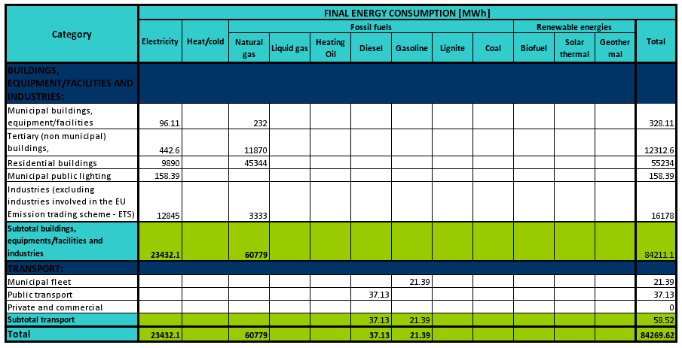

3.5. Energy production and consumption

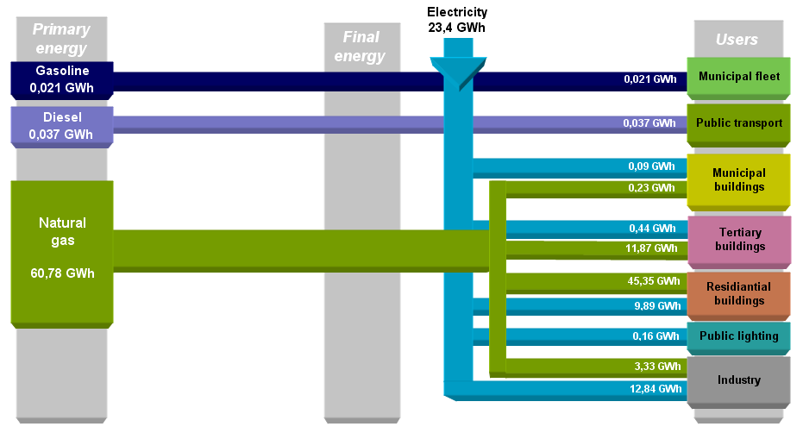
4. CO₂ emissions

By becoming member of Covenant of Mayors Drochia municipality committed to reduce CO₂ emissions in their territory at least by 20 % until year 2020. Overall 28 320 tones of CO₂ emissions were emitted in Drochia municipality in baseline year. Most part of emissions came from electricity – 56 %.
Fig. 5 CO₂ emissions by sectors

In order to achieve goal of Covenant of Mayors – to reduce CO₂ emission until year 2020 at least by 20% - Drochia municipality should reduce CO₂ emissions in their territory by 5 664 tones. Emissions and measures of their reduction in different sectors shortly described below.

4.1. Electricity

In baseline year 23 432 MWh of electricity were consumed in Drochia municipality. Therefore 16 027 tones of CO₂ emissions were emitted in baseline year.

CO₂ reduction

In order to reduce CO₂ emissions in municipality it is necessary to produced local electricity in territory of Drochia municipality. For example if 2 000 MWh of electricity would be produced from renewable energy sources 1 368 tones of CO₂ emissions would be reduced.

Planned projects:
- Renewable energy for the city water supply system. Solar system used for water pumping including installation of solar panels, regulator, controller, water pump. It is planned to reduce CO₂ emissions by 4,82 tones.
- Modernization and development of public lighting. It is expected to reduce energy saving by 50%. After renovation it is expected to reduce CO₂ emissions by 16 tones.

4.2. Heating

In baseline year 6 454 334 m³ of natural gas were consumed in Drochia municipality. Therefore 12 277 tones of CO₂ emissions were emitted.

CO₂ reduction

Municipality should reduce natural gas consumption in its territory in order to reduce CO₂ emissions. Public buildings (such as schools, kindergartens, hospitals etc.) should be used as example to community how to reduce CO₂ emissions.
Fig. 6 CO₂ emissions in public buildings

By changing type of fuel for heat production (from natural gas to renewable energy sources) in those public buildings (figure 6) it would be possible to reduce CO₂ emissions by 951 tones.
Also it is necessary to pay attention to public buildings that used most energy in baseline year in Drochia municipality.
Fig. 7 CO₂ emissions in public buildings

By changing type of fuel used for heating in public buildings, that used most energy, it would be possible to reduce CO₂ emissions by 1 219 tones.

Planned projects:
- Renovation of the kindergarten Nº 1 “Florile Dalbe”. Renovation of the facade and heat insulation of the building envelope. It is planned to reduce CO₂ emissions by 27,9 tones.
- Renovation of the kindergarten Nº 3 „Soare”. Renovation of the facade and heat insulation of the building envelope. It is planned to reduce CO₂ emissions by 6,4 tones.
- Change of a boiler at the kindergarten Nº 3 “Soare”. Installation of a more efficient boiler. It is planned to reduce CO₂ emissions by 3,2 tones.
- Renovation of the kindergarten Nº 5 „Scufiţa Roşie”. Renovation of the facade and heat insulation of the building envelope. It is planned to reduce CO₂ emissions by 15,8 tones.
- Renovation of the kindergarten Nº 8 “Floricica”. Renovation of the facade and heat insulation of the building envelope. It is planned to reduce CO₂ emissions by 24,8 tones.
- Renovation of the kindergarten Nº 9 “Mărţişor”. Renovation of the facade and heat insulation of the building envelope. It is planned to reduce CO₂ emissions by 24 tones.
- Renovation of the City Hall. Renovation of the façade and heat insulation of the building envelope. It is planned to reduce CO₂ emissions by 14,1 tones.
- Renewable Energy – Solar System PV on a Kindergarten No 8 „Floricica”. It is planned to reduce CO₂ emissions by 10 tones.

Most of CO₂ emissions in heating sector came from residential buildings – 9 159 tones. By installing biofuel boilers, heat pumps, solar collectors, renovating old and obsolete residential buildings it would be possible to reduce CO₂ emissions in municipality.
By reducing natural gas consumption in residential buildings sector by 25 % it would be possible to reduce CO₂ emissions by 2 289 tones.

4.3. Transport

2 400 liters of gasoline were consumed in municipal fleet sector and 3 765 liters of diesel were consumed in public transport sector. Therefore 15,2 tones of CO₂ emissions were emitted in transport sector.
There is no official information on fuel consumption in private transport sector.

4.4. Baseline emission inventory

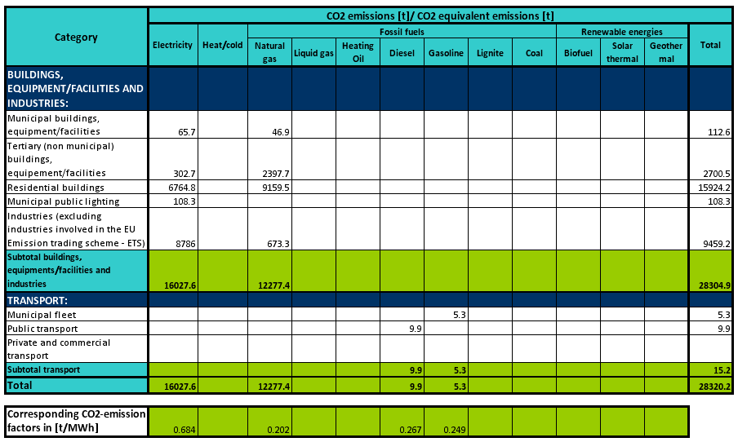
5. SEAP projects
5.1. List of projects

No. | Name and brief description of the project | Project-term  (start-end) | Cost, Lei | Expected energy savings, MWh | Production of renewable energy, MWh | CO₂ reduction, tones
Tertiary buildings
1. | Renovation of the kindergarten No.1 “Florile Dalbe” | 2014 – 2016 | - | 121,6 | - | 27,9
2. | Renovation of the kindergarten No3 „Soare” | 2014 – 2016 | - | 28 | - | 6,4
3. | Renovation of the kindergarten No.5 „Scufiţa Roşie” | 2014 – 2016 | - | 91,8 | - | 15,8
4. | Renovation of the kindergarten No.8 “Floricica” | 2014 – 2016 | - | 107,9 | - | 24,8
5. | Renovation of the kindergarten No.9 “Mărţişor” | 2014 – 2016 | - | 104,4 | - | 24
6. | Renovation of the City Hall | 2014 – 2016 | - | 61,2 | - | 14,1
7. | Change of a boiler at the kindergarten No3 “Soare” | 2014 – 2015 | 250 000 | 14 | - | 2,8
Total |  |  |  | 528.9 | - | 115.8
Renewable energy sources
8. | Project: Renewable Energy – Solar System PV on a Kindergarten No 8 „Floricica”. | 2014 – 2015 | - | - | 50 | 10
9. | Project: „Renewable energy for the city water supply system„ | 2016 | 1 048 495 | - | 7 | 1,32
10. | Production electricity from renewable energy sources (2 000 MWh of annual production) * | 2018 – 2020 | - | - | 2 000 | 1 368
11. | Change of fuel (from natural gas to renewable energy) in part of public buildings * | 2015 – 2019 | - | - | 9 457 | 2 170
12. | Reduce of natural gas consumption in residential buildings by 25% * | 2016 – 2020 | - | - | 10 016 | 2 289
Total |  |  |  | - | 21 530 | 5838.3
Public lighting
10. | Modernization and development of public lighting (Change of old bulbs to LEDs) | 2014 – 2015 | 2 156 146 | 79 | - | 16
Total |  |  |  | 79 | - | 16
OVERALL |  |  |  | 607,9 | 21 530 | 5 970.1

* conception of projects suggested by external energy experts
5.2. Schedule of SEAP projects and CO₂ reduction (in tones)
Projects | 2013 | 2014 | 2015 |  | 2016 | 2017 | 2018 | 2019 | 2020
Renovation of the kindergarten No.1 “Florile Dalbe” |  | 27,9
Renovation of the kindergarten No3 „Soare” |  | 6,4
Renovation of the kindergarten No.5 „Scufiţa Roşie” |  | 15,8
Renovation of the kindergarten No.8 “Floricica” |  | 24,8
Renovation of the kindergarten No.9 “Mărţişor” |  | 28,1
Renovation of the City Hall |  | 16,5
Change of a boiler at the kindergarten No3 “Soare” |  | 2,8
Change of fuel (from natural gas to renewable energy) in part of public buildings * |  |  |  | 2 170
Reduce of natural gas consumption in residential buildings by 25% * |  |  |  |  | 2 289
Renewable Energy – Solar System PV on a Kindergarten No 8 „Floricica””. |  | 10
Renewable energy for the city water supply system |  |  |  |  | 1,32
Modernization and development of public lighting (Change of old bulbs to 704 LEDs) |  | 16
Production electricity from renewable energy sources (2 000 MWh of annual production) * |  |  |  |  |  |  | 1 368

* conception of projects suggested by external energy experts

