Royal Scientific Society
National Energy Research Center

SUDEP South Project

Making Sahab City Green – Green Development at Sahab Municipality

Energy Efficiency& Renewable Energy Development Strategy for Sahab City in Jordan

Prepared For:
Municipality of Sahab

Date of Submission: November, 2015
Contents
1. Introduction 3
2. National efforts in the energy sector 3
3. Sahab City and its situation 6
3.1. About Sahab city 6
3.2. Current Energy situation 6
4. EE & RE strategy 7
4.1. Energy Consumption Baseline for last 2 years 7
4.2. Energy Consumption reduction Target for 10 years 10
5. Energy Saving Measures Summary 13
6. Detailed description of the saving measures 16
7. Awareness and training program 22
8. Desired Added-value elements due to the EE and RE strategy 24

- Introduction
Jordan has very limited primary energy resources and depends to a large extent on the imported petroleum, petroleum products and natural gas from neighbouring Arab countries. Due to economic growth and increasing population affected by the unstable political situation in the neighbouring countries, energy demand is expected to rise by at least 37 percent over the next 25 years, according to the energy outlook report 2014 for the international energy agency. The energy sector (including transportation and industrial energy activities) is by far the major source of Green House Gases (GHG) with emissions of 77% of the total GHG emission of Jordan according to the preliminary results of the Kingdom’s Third National Communication to the United Nations Framework Convention on Climate Change 2014. On the other hand, the overall energy intensity in Jordan is higher than in most Middle East and North Africa (MENA) countries, mainly as a result of relative low end-use energy efficiency. Cost-effective energy conservation opportunities exist in all major energy consuming sectors, and there is considerable scope for demand-side management, renewable energy sources and energy efficiency measures. Accordingly, a coordinated effort to improve the energy efficiency in all consuming sectors was started by the Government of Jordan in 2004 and issued the energy efficiency strategy.
- National efforts in the energy sector
The Energy Strategy sets security of supply and reducing the fiscal burden to the national budget imposed by the national energy bill as the main national priorities. The main objectives in this regard are:
- Exploiting renewable energy sources for increasing the percentage of their contribution to the total energy mix, achieving safe supply there from and promoting investment there to.
- Contributing to environmental protection and achieving sustainable development by promoting the exploitation of renewable energy.
- Rationalizing the exploitation of energy and improving its efficiency in various sectors in conventional electricity generation (through fuel switch) and in electricity distribution (efficiency improvements), a substantial technical potential for GHG reduction exists.

The Renewable Energy and Energy Efficiency Law has been approved in 2012.This law intends to promote private sector investment in renewable energy projects. Also, the Jordan Renewable Energy and Energy Efficiency Fund has been established (JREEEF) according to this Law. The progress in promoting renewable energy, however, is modest. The response to the Government tendering of large scale RE projects under BOT arrangement was poor and small-scale renewable projects progress very slowly also.
The main barriers to renewable electricity development is the lack of long-term certainty on feed-in tariffs, the lack/adequate of available national financing, and the unclear institutional and legal support, including lack of enforcement for renewable energy projects. Another key area for application of renewable energy is solar water heating in the residential sector, which faces a range of barriers (high upfront costs, owner-tenant dilemma, weak enforcement of building codes, and low domestic value added).
On the other hand, the overall energy intensity in Jordan is higher than in most Middle East and North Africa (MENA) countries, mainly as a result of relative low end-use energy efficiency. Cost-effective energy conservation opportunities exist in all major energy consuming sectors, particularly in buildings. There is therefore considerable scope for demand-side management and energy efficiency measures. Accordingly, a coordinated effort to improve the energy efficiency in all consuming sectors was started by the Government of Jordan in 2004 and issued the energy efficiency strategy followed by the Master Strategy for the Energy Sector for the 2007-2020 period which was updated in 2010.
The National Energy Strategy 2007‐2020 has set the objective to improve energy efficiency by 20% by 2020. The Renewable Energy and Energy Efficiency (REEE) law calls for bylaws and political action for energy efficiency. Enabling steps for energy efficiency were defined in the Jordan Energy Efficiency Roadmap 2010 to be implemented through three-year National Energy Efficiency Action Plans. The Roadmap identifies high level policy instrument/measures, calls for a monitoring and reporting system for progress on the energy efficiency target, and establishes an institutional and legal framework. To achieve the Energy Savings potential of 20% identified in the Strategy, an Energy Efficiency Action Plan (NEEAP) was approved by the Ministry of Energy and Mineral Resources in 2012. In parallel, the government has also approved the energy efficiency by-law, establishing a framework for specific energy efficiency regulation, including auditing, appliance labelling, and minimum energy performance standards (MEPS). In this by-law, article (5.a) indicated that any consumer who consumes above 50 tons of equivalent oil (t.o.e) shall be subjected to a mandatory energy audit. Finally, the Jordan Renewable Energy and Energy Efficiency Fund (JREEEF) was established.
In addition, solar water heaters will become mandatory for large buildings. Current building codes in Jordan include standards for energy efficiency. Programs are ongoing to promote green building codes and standards in Jordan, but few buildings so far have complied. Key barriers to energy efficiency remain, including: weak enforcement of existing measures and regulations, lack of knowledge by energy users of the benefits of energy efficiency, lack of coordination between stakeholders in developing energy efficiency projects, high initial implementation cost and high perceived risks, lack of suitable financing mechanisms, and lack of consistent institutional frameworks. There is a lack of attention to monitoring and evaluation of the implementation of policies, incentives and regulation. The lack of dialogue between government and stakeholders decreases the effectiveness of the legislation. As a result, the established policy and regulatory framework has not yet made a significant impact. Only a small number of the identified opportunities in energy efficiency are implemented
At the level of individuals, The Jordanian Electricity Company has undertaken a new decision of allowing individuals to establish renewable sources of electricity; this will be done in collaboration with the governmental guidance to find ways to reduce electricity usage and rely more on renewable electricity sources. It has issued the renewable energy and guidance law number (13) for the year 2012, article 10 b which clarifies in details:
- Procedures of connecting renewable energy sources using special meters.
- Selection criteria for selecting small scale renewable energy systems.
- Connection procedures in case of large renewable energy systems
- Financial procedures in case of connecting renewable energy sources using special meters.
Moreover, this strategy focused on other important aspects such as:
- Tointegrate climate change aspects with emphasis on provisions of this Policy into different grade levels of schools and other relevant components of academic framework;
- To support initiatives aiming at improving climate change related education especially those lead by NGOs and the private sector by facilitating all efforts to securing the required financing and providing technical information available
- Using Media to in raising awareness on climate change amongst different population segments which can increase support and cooperation in implementing climate change mitigation and adaptation policies.
- Sahab City and its situation
  - About Sahab city
Sahab city is one of the poorest communities in Jordan with percentage of poverty that could reach to 54%. Its total area is 12 Km² where (150,000) Jordanian Citizens are living within this limited area in addition to another (40,000) Syrians fled their country and ended up in Sahab. It has the largest two industrial Zones in the kingdom; King Abdullah II Industrial Estate which includes (400) factory, and Industrial estate city which includes (50) factory, where almost (30,000) Jordanian and other nationalities work in these factories. Sahab is located at a strategic industrial and commercial location. It is considered as a commercial gathering location for all surrounding cities and villages. Additionally, it has an international Street connecting the capital with Aqaba in the south and Saudi Arabia and Iraq in the East.
Sahab Municipality was established in 1963. It joined Greater Amman Municipality (GAM) on December, 2006. In 2011, Sahab Municipality became independent on both financial and managerial levels and a municipal council was elected on 2013. An agreement between (GAM) and Ministry Of Municipalities Affairs was signed committing GAM to provide Sahab municipality with all needed services and financial support until the end of 2013, but unfortunately GAM did not fulfill this commitment which put Sahab Municipality in a very difficult situation as it lacks to the sufficient financial and Human resources support.
  - Current Energy situation
Sahab city is facing different challenges in energy and environment such as:
- High debts which create a challenge for implementing any development projects for the city.
- Lack of financial and technical resources to enable Sahab Municipality to implement sustainable development projects in the energy sector whether in energy efficiency or renewable energy fields to reduce energy consumption and financial burdens.
- At the level of Environment: the city witnessed several violations in construction works and relevant consequences as GAM failed to comply with its responsibilities toward Sahab. Additionally, there are factories for Breaks, cutting stones, chemicals and many others which polluted the air and caused several diseases for the citizens, where Sahab is considered now as one of the most polluted cities in Jordan with largest number of Cancer patients according ministry of Environment statements.
- In terms of lighting: the city lacks to enough lighting units in its streets which make the city live in darkness and danger.
On the other hand, Sahab Municipality began moving towards the clean energy sources that reduces the CO₂ emissions and the bill of the electricity demand. Currently, the municipality is included in a renewable energy and energy efficiency project (SUDEP) for some public buildings in sahab, which is funded by EU. The implementation of the RE and EE measures will start at the beginning of the next year.Thisproject will give a good encouragement to continue with remaining buildings and facilities in sahab through the next years.
- EE & RE strategy

  - Energy Consumption Baseline for last 2 years

The overall annual electrical energy consumption for Sahab City and its distributionfor the last 2 years (2013 & 2014) are shown in the figures 1 and 2, which show that the overall annual energy consumption reachesto 38GWh. where the main energy consuming in the citygoes to the residentialand commercial sectors with annual energy consumption of 26.3 GWh and 8.2 GWh, respectively.

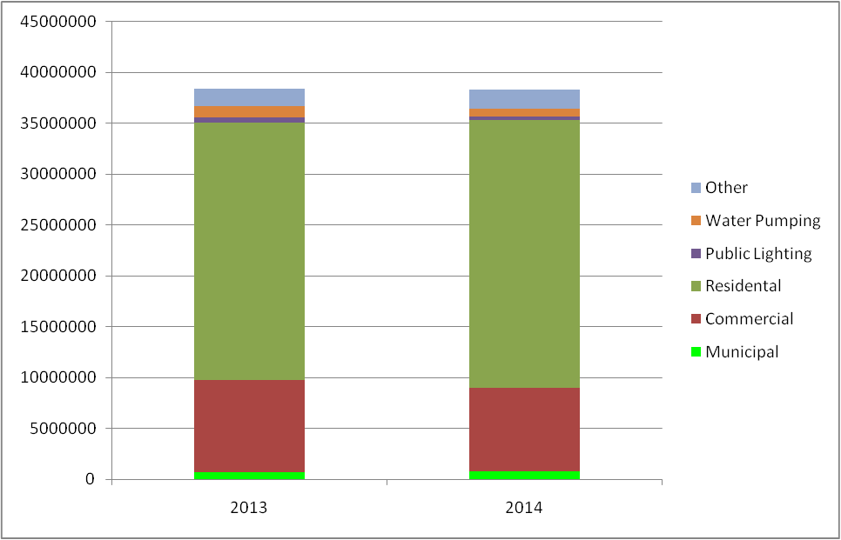
Figure 1: Annual Energy consumption for Sahab City for 2013 & 2014

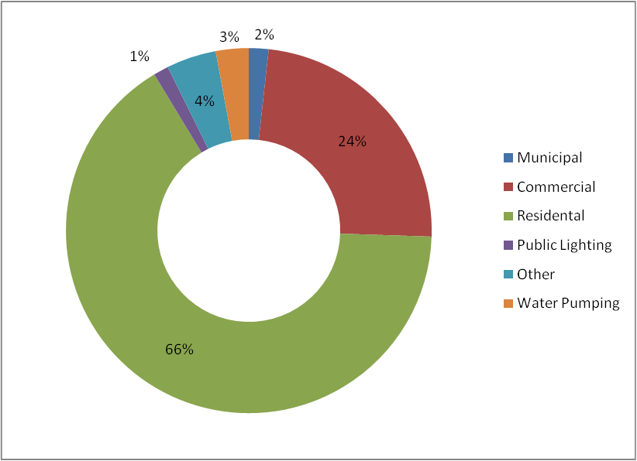
Figure 2: Energy consumption distribution per sector in Sahab city
Figure 3 and 4 show the amount and weight of greenhouse gases emission per sector for year of 2014, which reached to 83,503 ton. Also it is worth mentioning that the amount of waste resulted from Sahab city considered in the CO₂ producing sources in addition to the local transportation. As provided from the responsible staff of Sahab Municipality, Sahab city produces about 85 ton wastes per day, which equals to 31,025ton per year,this amount of waste produces 12,875 ton CO₂ per year, whereas the transportation sector produces around 22,547 ton CO₂ per year, which takes 27% of the total CO₂ emissions in the city.

Figure 3: Annual Green House gases emission for Sahab City for year of 2014

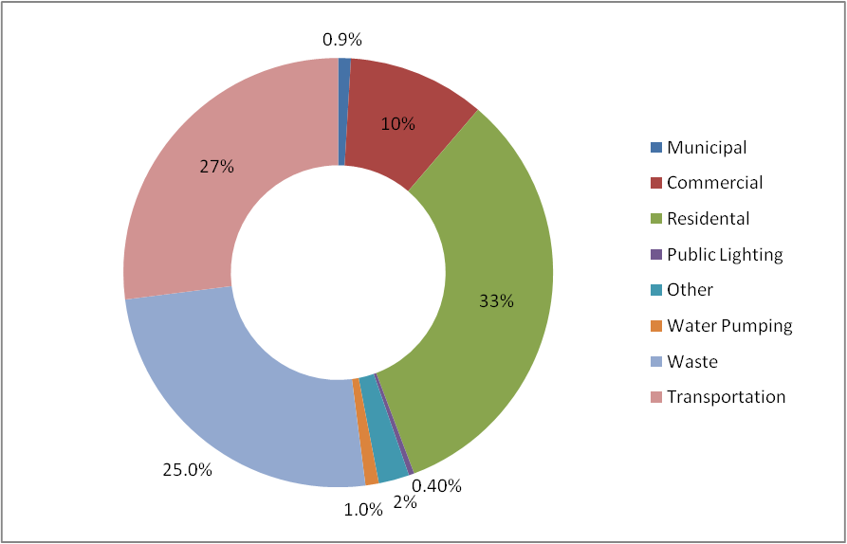
Figure 4: Green House Gases Emission weights distribution per sector

  - Energy Consumption reduction Target for 10 years
The main goal of this strategy is to enhance the capacity of local authorities to develop and implement sustainable energy efficiency & renewable energy Plans in participatory approach with the Mayor and Municipal Council that defines an appropriate governance structure for the effective implementation of this plan. This plan will enable Sahab Municipality to be a Renewable Energy Pilot at the level of Jordan’s Municipalities and will contribute in reducing Sahab’s energy demand.
Table 1 shows the energy consumption and the targeted annual energy consumption reduction for the next 10 years, which shows that the desired energy saving after 10 years reaches to20% of the current energy consumption with CO₂ Emission reduction of 4,939 ton.

Table 1: Energy consumption reduction target for the next 10 years
 |  | Electric Energy Consumption (kWh) | Percentage of reduction (%) | CO₂ reduction (Ton)
Average Annual Consumption for the last two years (2013-2014) |  | 38,343,800 | 0% | 0
Target | First Year (2016) | 37,768,643 | 1.5% | 370
 | Second Year (2017) | 37,193,486 | 3.0% | 741
 | Third Year (2018) | 36,503,297 | 4.8% | 1,185
 | Fourth Year (2019) | 35,813,109 | 6.6% | 1,630
 | Fifth Year (2020) | 35,115,252 | 8.4% | 2,079
 | Sixth Year (2021) | 34,260,185 | 10.7% | 2,630
 | Seventh Year (2022) | 33,416,621 | 12.9% | 3,173
 | Eighth Year (2023) | 32,496,370 | 15.3% | 3,766
 | Ninth Year (2024) | 31,597,208 | 17.6% | 4,345
 | Tenth Year (2025) | 30,675,040 | 20.0% | 4,939

Figure 5and 6 show the amount and weight of CO₂ can be reduced per sector along the strategy period, which the supposed overall CO₂ reduction is 5,768 ton. It is worth mentioning that the CO₂ reduction in the transportation sector in the figures is resulted due to planting about 140,000 trees with type of (Melia Azedarach) in the main streets by the end of 2016 year (according to the available data from Sahab municipality), which reduces about 830 ton CO₂¹ that will be added to the overall CO₂ reduction target.

1: reference : http://www.kyuden.co.jp/en_environment_backnumber_action-report00_08.html

Figure (5):Supposed overall CO₂ reduction amount per sector after 10 years

Figure (5): CO₂ reduction weight per sector

- Energy Saving Measures Summary
Table 2 summaries the saving measures that can be implemented for Sahab city in addition to the implementations duration, which shows that the main energy saving take place by utilizing the renewable energy systems;which arephotovoltaic systems and solar thermal systems with saving of 15% along the next 10 years period. Whereas,the remaining saving is due to replacing the inefficient lightings with efficient ones in parallel to installing motion sensors in the buildings and facilities in order to reduce the lighting operating hours and energy consumptions, with saving of 5% along the strategy period.
Table (2): Summary of Energy saving measure for Sahab City
No. | Saving Measure | Implementation period | Expected savings in energy consumption (%) | 2016 | 2017 | 2018 | 2019 | 2020 | 2021 | 2022 | 2023 | 2024 | 2025
1 | Installing Energy Efficient lighting units | 2016-2023 | 4.00% | 0.50% | 0.60% | 0.65% | 0.65% | 0.50% | 0.40% | 0.40% | 0.30%
2 | Installing Motion Sensors | 2016-2020 | 1.00% | 0.20% | 0.20% | 0.20% | 0.20% | 0.20%
3 | Installing Solar Water Heaters instead of the electric heaters | 2016-2025 | 2.00% | 0.10% | 0.10% | 0.15% | 0.15% | 0.20% | 0.20% | 0.17% | 0.30% | 0.32% | 0.32%
4 | Installing Photovoltaic Panels to generate electricity | 2015-2025 | 13.00% | 0.70% | 0.60% | 0.80% | 0.80% | 0.92% | 1.63% | 1.63% | 1.80% | 2.03% | 2.09%
 | Total |  | 20.00% | 1.50% | 1.50% | 1.80% | 1.80% | 1.82% | 2.23% | 2.20% | 2.40% | 2.35% | 2.41%

Figure 6and 7 summarize all recommended saving measures with its saving weight through the next 10 years.

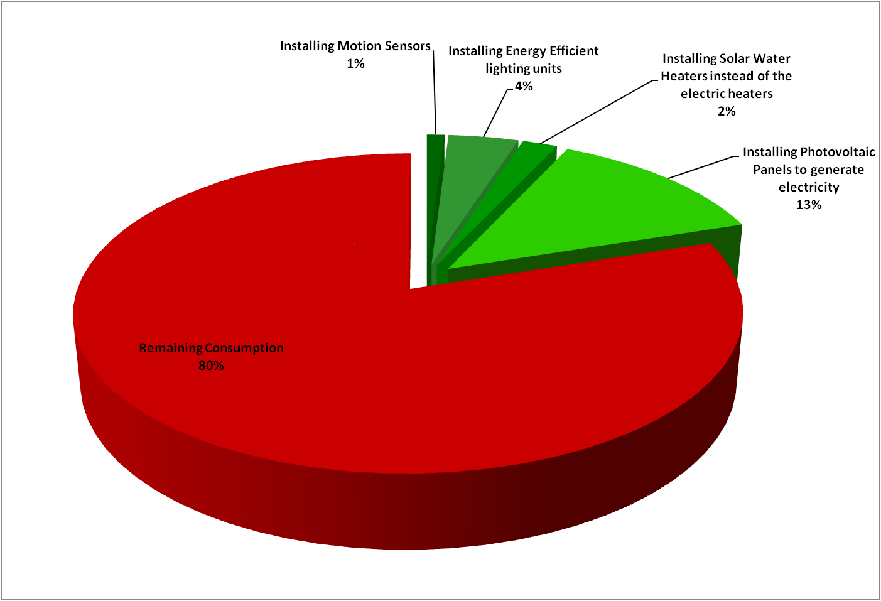
Figure 6: Energy saving measures distribution based on the saving weight

Figure 7: The proposed amount of energy saving in kWh through the next 10 years
- Detailed description of the saving measures
Table 3 shows the technical and financial details of the recommended energy saving measures for Sahab City.

Table (3): Energy saving measures details for Sahab City
Saving Measure | Installing Energy Efficient lighting units
Measure Target | Reducing the overall energy consumption by 4%
Measure description | Replacing all non-efficient lamps with Efficient Lamps
Overall Energy Saving (kWh/year) | 1,533,752
Responsible for implementation | Sahab Municipality
Period of implementation (Years) | 8 Years
Cost of energy unit reduction (JOD/kWh) | 0.6351
Total Investment Cost (JD) | 974,043
Investment Cost (JD/Year) [First year] | 121,755
Investment Cost (JD/Year) [Second year] | 146,106
Investment Cost (JD/Year) [Third year] | 158,282
Investment Cost (JD/Year) [Fourth year] | 158,282
Investment Cost (JD/Year) [Fifth year] | 121,755
Investment Cost (JD/Year) [Sixth year] | 97,404
Investment Cost (JD/Year) [Seventh year] | 97,404
Investment Cost (JD/Year) [Eighth year] | 73,053
Source of Funding | Ministry of Energy and Mineral Resources Funds/ EU Funds
Needed Awareness | Workshops, Brochures, SMS, Social Media
Implementing agency | Local or International suppliers
Description the mechanism of monitoring and evaluation | Periodic verification and monitoring for the desired energy saving by special committees

Saving Measure | Installing motion sensors
Measure Target | Reducing the overall energy consumption by 1.0%
Measure description | Use motion sensors in buildings and facilities for decreasing energy consumption
Overall Energy Saving (kWh/year) | 383,438
Responsible for implementation | Sahab Municipality
Period of implementation (Years) | 5 Years
Cost of energy unit reduction (JOD/kWh) | 0.5358
Total Investment Cost (JD) | 205,456
Investment Cost (JD/Year) [First year] | 41,091
Investment Cost (JD/Year) [Second year] | 41,091
Investment Cost (JD/Year) [Third year] | 41,091
Investment Cost (JD/Year) [Fourth year] | 41,091
Investment Cost (JD/Year) [Fifth year] | 41,091
Source of Funding | Ministry of Energy and Mineral Resources / EU Funds
Needed Awareness | Workshops, Brochures, SMS, Social Media
Implementing agency | Local or International suppliers
Description the mechanism of monitoring and evaluation | Periodic verification and monitoring for the desired energy saving by special committees

Saving Measure | Installing Solar Water Heaters instead of the electric heaters
Measure Target | Reducing the overall energy consumption by 2 %
Measure Description | installing solar water heaters instead of the existed electric water heaters for domestic use
Overall Energy Saving (kWh/year) | 766,876
Responsible for implementation | Sahab Municipality
Period of implementation (Years) | 10 Years
Cost of energy unit reduction (JOD/kWh) | 0.5780
Total Investment Cost (JD) | 443,254
Investment Cost (JD/Year) [First year] | 22,163
Investment Cost (JD/Year) [Second year] | 22,163
Investment Cost (JD/Year) [Third year] | 33,244
Investment Cost (JD/Year) [Fourth year] | 33,244
Investment Cost (JD/Year) [Fifth year] | 44,325
Investment Cost (JD/Year) [Sixth year] | 44,325
Investment Cost (JD/Year) [Seventh year] | 37,677
Investment Cost (JD/Year) [Eighth year] | 66,488
Investment Cost (JD/Year) [ninth year] | 69,813
Investment Cost (JD/Year) [tenth year] | 69,813
Source of Funding | Ministry of Energy and Mineral Resources / EU Funds
Needed Awareness | Workshops, Brochures, SMS, Social Media
Implementing agency | Local or International suppliers
Description the mechanism of monitoring and evaluation | Periodic verification and monitoring for the desired energy saving by special committees

Saving Measure | Installing Photovoltaic systems
Measure Target | Reducing the overall energy consumption by 13 %
Measure Description | Installing Photo Voltaic systems as an alternative source system to partially cover the electricity demand
Overall Energy Saving (kWh/year) | 4,984,694
Responsible for implementation | Sahab Municipality
Period of implementation (Years) | 10 Years
Cost of energy unit reduction (JOD/kWh) | 0.6410
Total Investment Cost (JD) | 3,195,323
Investment Cost (JD/Year) [First year] | 172,056
Investment Cost (JD/Year) [Second year] | 147,476
Investment Cost (JD/Year) [Third year] | 196,635
Investment Cost (JD/Year) [Fourth year] | 196,635
Investment Cost (JD/Year) [Fifth year] | 226,131
Investment Cost (JD/Year) [Sixth year] | 400,644
Investment Cost (JD/Year) [Seventh year] | 400,644
Investment Cost (JD/Year) [Eighth year] | 442,429
Investment Cost (JD/Year) [ninth year] | 498,962
Investment Cost (JD/Year) [tenth year] | 513,710
Source of Funding | Ministry of Energy and Mineral Resources / EU Funds
Needed Awareness | Workshops,Brochures, SMS, Social Media
Implementing agency | Local or International suppliers
Description the mechanism of monitoring and evaluation | Periodic verification and monitoring for the desired energy saving by special committees

Figure8and 9 show the overall investment and its distribution for the above recommended measures through the hall period of the plan, which show that the largest investment goes to the renewable energysystems along the hall period with annual investments range between 169,000 and 582,000 JOD. While the other saving measures take an annual investment between 163,000 and 199,000 JOD.

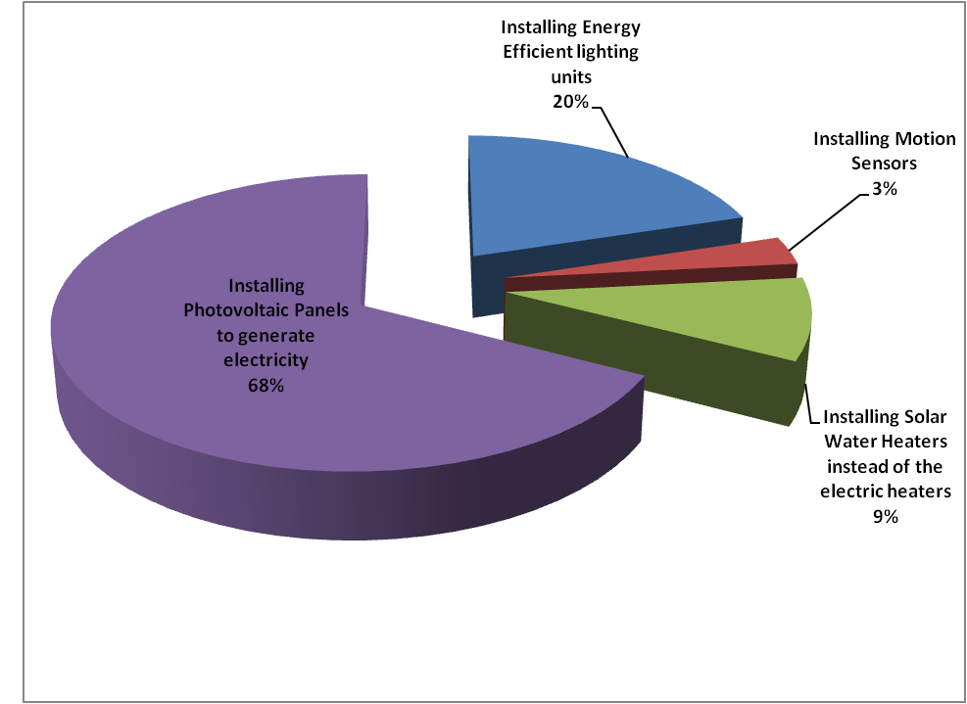
Figure 8: Investment weight distribution for the recommended saving measures

Figure 9: The amount of investments for the recommended saving measures through next 10 years

- Awareness and training program

The following actions and activities summarize the awareness program contents:

- Conduct awareness workshops for the schools and through the masjids and local NGOs that aim at increasing awareness and involvement of the local population and other stakeholders in sustainable energy issues and possible measures and best practices.

The awareness will include:
- Educate the people about climate change negative impacts on our living conditions and the different possible adaptation measures.
- Promote the importance of implementing best practices for green life, and its impact on our health, environment and even on our earth in general. An example for these practices is fixing the AC at idea temperatures in winter and summer, avoid using machines during peak time, and avoid locating the refrigerator in sunny place, purchase smart labelled appliances, and others.
- Educate people about the available tools and lighting units to save energy whether through energy efficiency or renewable energy sources and its positive impact on reducing financial bills, reducing emissions and its negative consequences.
- Distribute promotional items to remind people of such workshop on the form of energy efficiency lighting units kit (except students) to be used at their houses instead of the regular bulbs and encourage them to do simple audit through measuring the difference in bills.
- Develop media campaign to ensure wide communication with people through social media channels.
This will include:
- Sending Mass Text Messages (SMS) to Sahab Citizens’ Mobiles
- Sending Mass emails that include the project educational brochures to the general public.
- Develop an interactive game for students to teach them the best practices and distribute it on DVDs.
- Develop a T.V. spot to be broadcasted on T.V. channels to promote energy saving tools and practices.
- Create a Facebook page and link it to Sahab Municipality page with updated news and activities of the project.
- Create a You-Tube channel for the project and upload the project’s different activities, movies, digital game and T.V. Spots.
- Develop educational and attractive brochures to be distributed during the different workshops.
- Use labels and stickers at schools and public places encouraging responsible actions such as “ turning light off when not in use”.
Simple stickers will be designed in order to be sticked next to lights switches or at entrances and corridors to remind people to turn off the light when not in use or encouraging the use of renewable energy.
- Conduct different training programs to build capacities of Sahab municipality’s employees in the following:
- Enhance financial management skills for the different activities and projects with special focus on Energy projects to ensure proper management of energy technology and optimum savings and rationalization. Additionally, ensure the green concept in projects’ design and procurement.
- Enhance their fund raising skills through teaching them how to identify and approach Donors and available options for fund. Teaching them how to benefit from the CSR of the industrial city located at Sahab, and teaches them how to benefit from available support for Municipalities at International level such as Covenant of Mayors.
- Enhance their technical skills and enable those managing projects, sustainable urban development and energy efficiency, skills and proven understanding, of international cooperation modalities. More understanding for Twining projects and coordination’s at the national, regional and international level.
- Install instructions signs in the companies’ offices which states very clearly energy efficiency best practices as a daily reminder for the employees.
This could include but not limited to:
- fixing the AC at ideal temperatures during Winter and summer,
- avoid using machines during peak time,
- avoid using the personal heaters,
- switch off the lights when not in use,
- close the windows if the AC is switched on,
- Purchase only smart labelled appliances, and others.

- DesiredAdded-value elements due to the EE and RE strategy
The particular added values of this Strategy are as follows:
- Foreseen activities will contribute to the increase in energy efficiency, energy savings and renewable energy sources and to reduction of CO₂ emissions and adapting to climate change.
- Stimulate the local economy and make the best use of locally available resources such as engineering services, and energy auditors, and local vendors
- Gender has been considered in involving women active NGOs in the awareness workshops to be a partner in this activity and to further forge their positive impact on the local women.
- Sahab Municipality became a member of the Convention of Mayors and is benefiting from the provided technical and financial support.

